TAUNTON BIKE CLUB Secretary’s report31 January 2022 via Zoom
We adopted the British Cycling motto for 2021

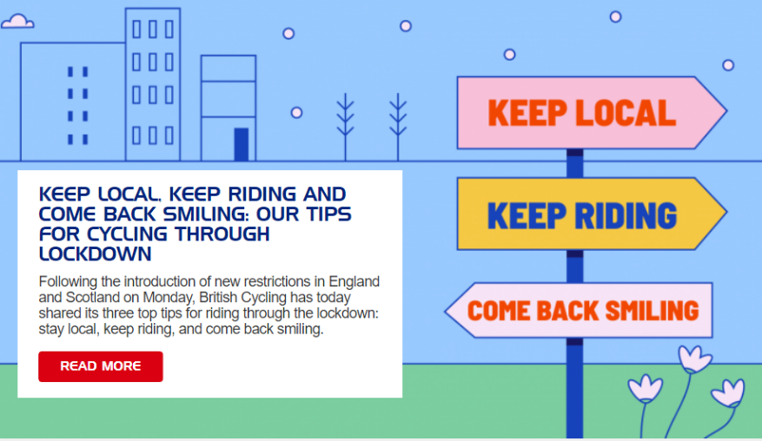

CLUB MARK. Development plan 2018 includes appointing/training a female coach
improving the ratio of girl to boy riders.
2nd award Dec 2021 Run one ride each month in addition to regular coaching sessions
Run one race event in the next 12 months
Send four volunteers on a Level 1 Certificate in Coaching Cycling course and one volunteer on Level 2
Delegate each of the new coaches to one of the weekend coaching sessions to assist with coaching and be mentored by an experienced coach

LEADRES Level 2 coach Brian, Bryn, Dave, Jonathan
Level 1 coach Rob, Lisa, Dan
Level 2 MTB ride leader Jonathan
Junior leader Archie
Club Welfare Gill (Dave Topham to replace in 2022)

ACTIVITIES Coronavirus lockdowns have had a major impact on all sporting activities.
We delivered 20 activities in 2021. (compared with 18 activities in 2020) .
Most were multiactivity events held at Silk Mills park and ride held on alternate Sunday mornings. There were 3 rides only

Attendance 50 Riders participated in 2021. (M:F=40:10) (53 riders participated in 2020)

12 riders 10+ events (same number as 2020)
18 riders 5-10 events
12 riders 2-4 events
8 riders came to 1 event only (13 riders in 2020)

Active Club Members: 32 paid up members in Dec 2021 (24 in 2020)
Leaders and parent helpers do not pay a membership fee

Website Using the free version of TidyHQ. Limited number of ‘contacts’ allowed. Parents are the email contacts for riders.
Complies with GDPR
Registering and payments for events is done online (cost 40 pence/booking)

