Whole Community Approach to Children’s Well-being at Cascade with Brett Kipling
Thursday June 27th 1pm – 3pm

Attendees: Zoe, Susie Stead, Ebony Parker, Christine Walter, Michel Todd, Erica Byrne, Bonnie Arnold, Louise Colliver, Merrill Ridgley, Faye Rolland, Monique Christie, Ash Baxter, Liv Walter, Odile Welke, Christine Neethling, Jordaan Neethling, Lisa Jeitz, Austin Jeitz, Heidi Walter, Gypsy Byrne
Apologies: Katie Witt, Kirsten Raszyk, Simeon Roberts, Daphne Stols

Today was our third meeting with Brett Kipling since last year. We met at the Cascade Rec where the staff, 3 student representatives, P and C members and members of the wider community came together for the first time.

Brett ran us through the data that he collected in his meetings with each of the separate groups and it was great to see the values that we all held in common.

Below you will see the points that we discussed during our meeting:

- The significance of our school logo
- Dunnart – native to the area
- Fuschia Gum – found in the local bushland
- We need to make this significance known to the community
- Shared Vision- how does it look from the outside? We as a community know how it looks but how about visitors? A Google search of “Cascade” comes up with approximately 4 lines and nothing about what we value as a community.

- Community Values
- Kindness; Life Skills; Happiness; Pride; Contentment; Respect; Resilience; Confidence; Learning; Health; Achievement; Perseverance

- Student Values
- there were a lot in a word cloud but the most significant one was “Friends”

- Staff Values
- Resilience; Caring; Safety; Respect; Health; Learning; Life Skills

Where to next?
- We broke off into three groups with a Senior Student in each where we created a list of our 5 most important values.
- We were brought back together, combining our lists
- Each person was given 5 red dots to vote on their most important value/s from that list.
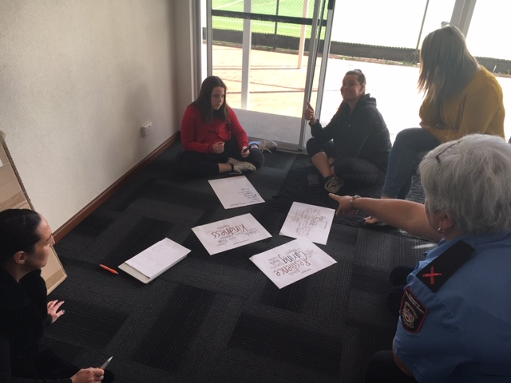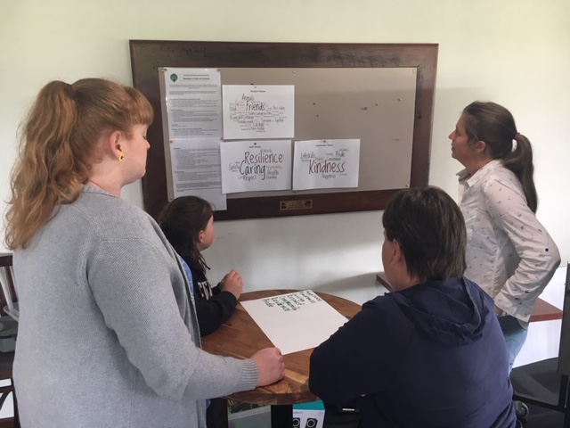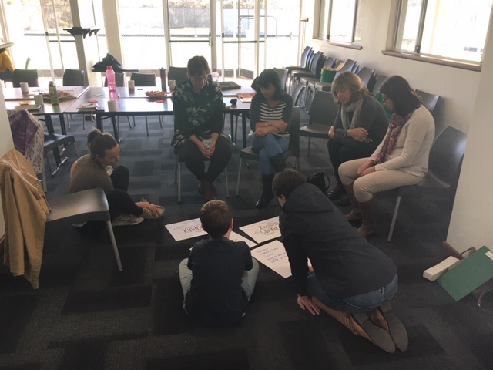
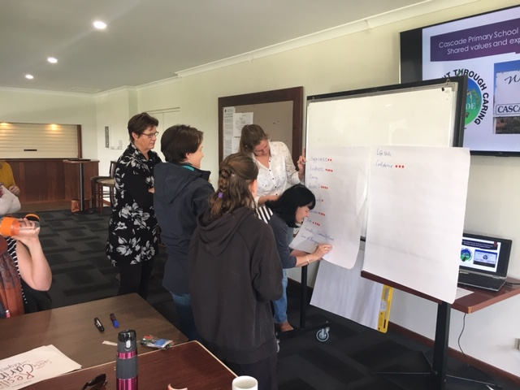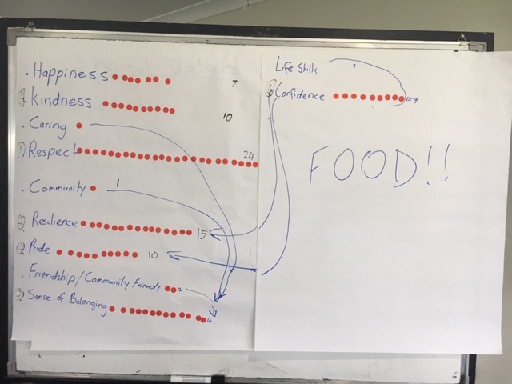
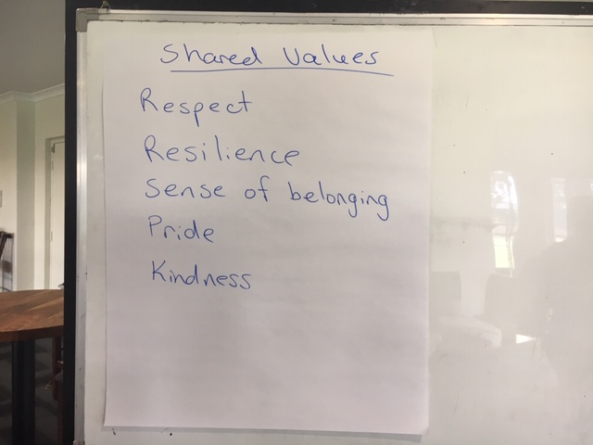

…and the top 5 most important values were:
- RESPECT
- RESILIENCE
- SENSE OF BELONGING
- PRIDE
- KINDNESS

The next steps:
- How are these values reflected in our community?
- Create an action plan
- School staff are having 2 Professional Development days related to the use of common language incorporating these five values.

A big thank you to Brett for giving his time and expertise in helping us come up with these values that are important to our community. Also for offering continued assistance if we feel we need it.

