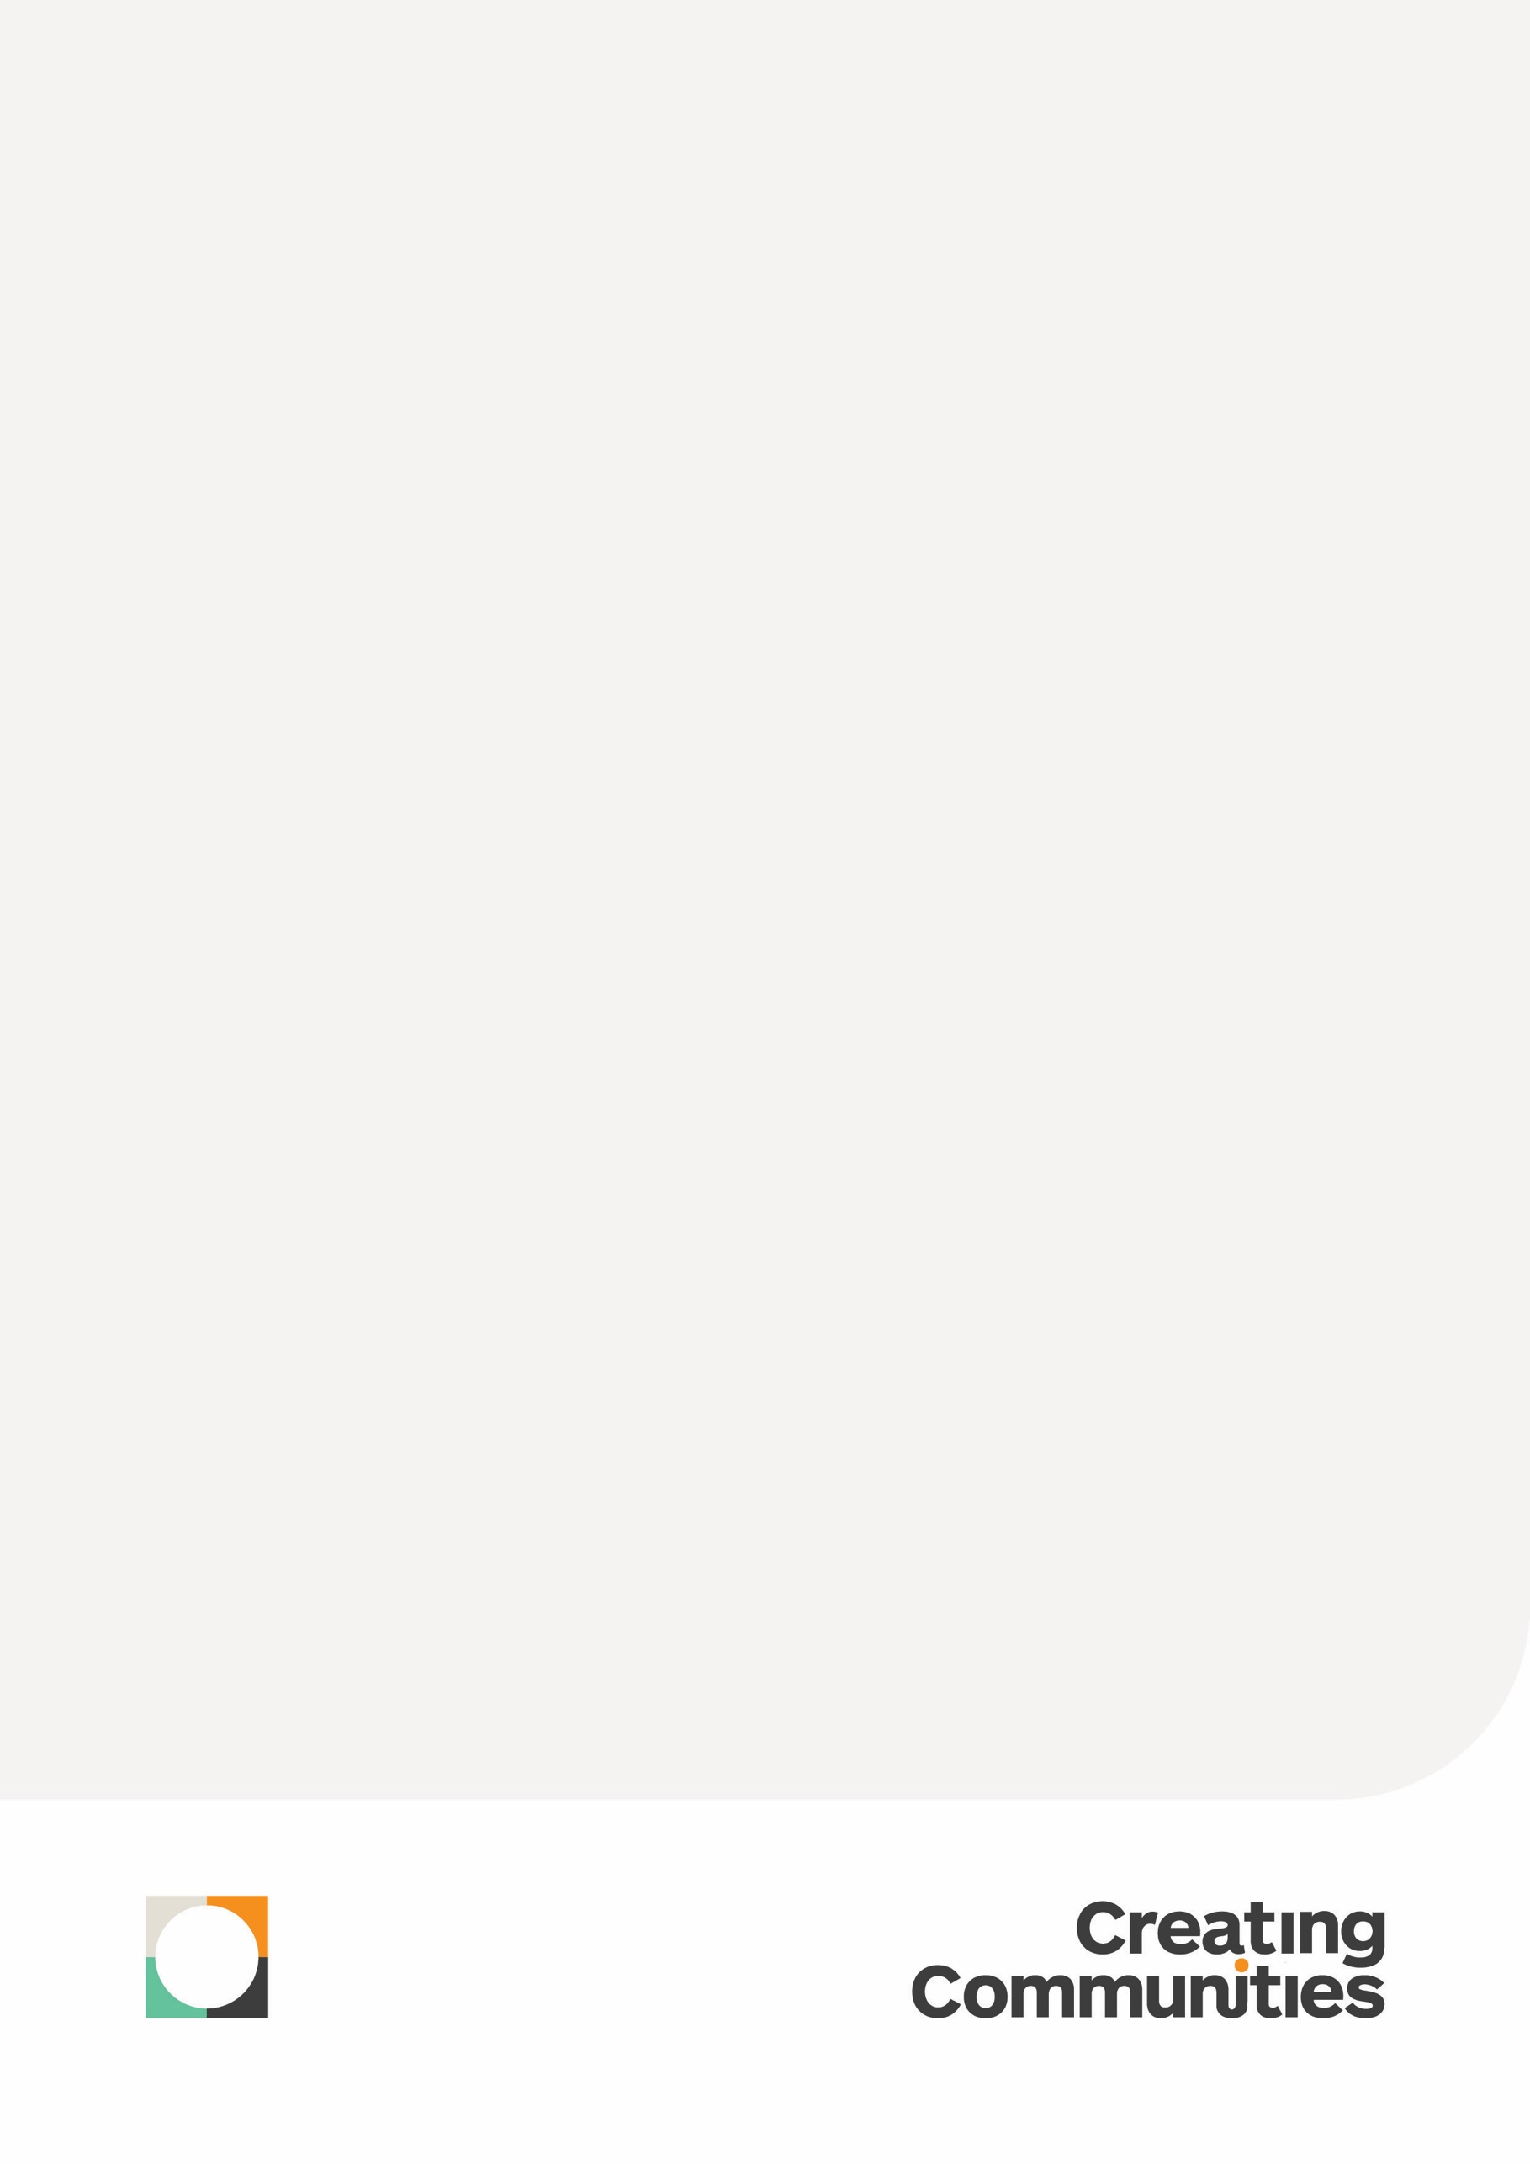

Bob Hawke College

Business Plan Review

Engagement Consultation Report
25.08.23

Report details
PREPARED FOR |  | Bob Hawke College
CONTACT DETAILS |  | John Burke  Principal
PHONE |  | 0427 083 997
EMAIL |  | john.burke@education.wa.edu.au
PREPARED BY |  | Creating Communities Pty Ltd
PROJECT TEAM |  | Andrew Watt  Director  Lia Ursich  Engagement Consultant  Tore Bule-Turner  Intern
ADDRESS |  | 100 Jersey Street, Jolimont WA 6014
PHONE |  | 8 9284 0910
EMAIL |  | Andrew@creatingcommunities.com.au
date |  | 31 July 2023

DISCLAIMER
The information contained in this document is confidential, privileged and only for the information of the intended recipient and may not be used, published or redistributed without the prior written consent of Creating Communities Australia Pty Ltd. The opinions expressed are in good faith and while every care has been taken in preparing these documents, Creating Communities Australia Pty Ltd makes no representations and gives no warranties of whatever nature in respect of these documents, including but not limited to the accuracy or completeness of any information, facts and/or opinions contained therein. Creating Communities Australia Pty Ltd, the directors, employees and agents cannot be held liable for the use of and reliance of the opinions, estimates, forecasts and findings in this document.
This document has been prepared by Creating Communities. ©Creating Communities. All rights reserved.
For information or permission to reprint, please contact Creating Communities at:
Email info@creatingcommunities.com.au Phone +61 8 9284 0910
Mail 100 Jersey Street, Jolimont, WA 6014 Web www.creatingcommunities.com.au

document control
version | purpose | Change | Author | date
1 | [draft] |  | CCA ([LU]) | 25 07 23
2 | Draft | Addition focus groups entered in of parents and students | CCA JP & LU & AW | 25 08 23

Report details 2
1. Introduction 4
2. Methodology 5
3. Executive Summary 7
4. Detailed Findings 15
5. Appendices 52

Introduction

In June 2020, John Burke, Principal of Bob Hawke College engaged Creating Communities to assist in the engagement and development of the College’s 2021-2023 Business Plan.
Since the Business Plan was developed there has been significant changes including, student enrolment increases; an associated increase in staff numbers, the development of new facilities (some awaiting completion), along with COVID-19 intervening during that time.
In June 2023, John Burke approached Creating Communities to help the College inform the review of the Business Plan by means of staff, student, and community engagement, with findings being used to help inform the development of the College’s 2024-2026 Business Plan.
This report presents the process and outcomes of the engagement process.

Methodology

Staff & BOArd Workshop
Workshop was held on Monday 17th July 2023 and at Bob Hawke College, with 135 participants attending. The majority were staff members of the College, with three members of the College board also attending.
Attendees were presented with a slide deck that provided further details into the current business plan and the key information including the vision and values, what an effect school business plan looks like, the engagement and planning process, review of the strategic priorities, and review of the strategies.
There were two (2) interactive activities within the workshop, with each comprising of a series of questions on a group worksheet.

Activity one (1) – Strategic Priorities Review
Participants were asked the following against each of the three strategic priorities.
Are the existing Strategic priorities still relevant for 2024-2026? If yes why?, if no, why not?
Are there any changes you would make to the priorities (e.g, is there anything missing; are some of the priorities no longer relevant) if yes, why? If no, why not?

Activity two (2) – Strategy Review
Participants were asked to note against each of the priorities:
- Which strategies were fully implanted, partially implemented or not yet commenced.
- Should the strategy be carried over into the next plan (yes or no)
What new strategies should we include in the 2024-2026 plan?

The staff workshop was advertised internally through the college.

Student Workshop
The Student Workshop was held on Tuesday 15 August 2023 at 9:00am – 10:30am at Bob Hawke College, with 43 students attending.
Attendees were presented with a slide deck that provided further details into the current business plan and the key information including the vision and values, what an effect school business plan looks like, the engagement and planning process, review of the strategic priorities, and review of the strategies.
Activity One (1)
Participants were to note on different colour post it notes describing a single idea that responds to:
- What are the best things about Bob Hawke College?
- What are the things that aren’t working well at Bob Hawke College?
Activity two (2)
Participants were asked to discuss and record their responses to the question: What are the things that are working well at Bob Hawke College and needs to be retained in the next three years?
Activity three (3)
Participants were asked to discuss and record their responses to the below to the question: What actions need to be taken to improve Bob Hawke College in the next three years? In relation to: Teaching, Learning, Leadership, School Culture, Community Connections and Other.
The student workshop was advertised internally through the college.

Community Workshop
The Community Workshop was held on Tuesday 15 August 2023 at 4:00pm – 5:30pm at Bob Hawke College, with 12 community members attending.
Attendees were presented with a slide deck that provided further details into the current business plan and the key information including the vision and values, what an effect school business plan looks like, the engagement and planning process, review of the strategic priorities, and review of the strategies.

Activity one (1)
Participants were to use different colour sticky notes to describe a single idea that responded to:
- What are the best things about Bob Hawke College?
- What are the things that aren’t working well at Bob Hawke College?

Activity Two (2)
Participants were asked to discuss and record their responses to the below two questions in relation to Teaching, Learning, Leadership, School Culture, Community Connections and Other:
- What are the things that aren’t working well at Bob Hawke College?
- What actions need to be taken to improve Bob Hawke College in the next three years?

Activity three (3)
Participants were asked to discuss and record their responses to describe what they thought- are the most important priorities for the college to focus on over the next three years.

The community workshop was advertised internally through the college.

Executive Summary
The below provides an overarching view of the key themes that came out of the engagement for all workshops. As different questions were asked between the staff and board workshop and the student, parent and community workshops these have been split into their respective sections below.

Staff and Board Workshop Feedback
The below table represents the key themes that came out of the engagement for activity one for the staff and board workshop in relation to:
- Are the existing Strategic Priorities still relevant for 2024-26?
- Are there any changes you would make to the priorities?

Strategy | Are the existing Strategic Priorities still relevant for 2024-26? | Are there any changes you would make to the priorities? | Priority fully implements, partially or not yet commences
Best Practice Teaching, Learning and Leadership | - There is opportunity for students and staff still in relation to these priorities including continual personal development  - The priorities are still current and relevant  - Its our core business  - It builds relationships with country and with students | - Additional priorities to be included in future such as Interdisciplinary learning, positive pathways and PLC that aims to support teaching  - Separate priorities of teaching and learning from leadership  - Review staffing and roles including additional library staff, education assistants, numeracy and literacy coordinator  - Additional support, including more professional development, more time allocated to teachers to implement the priorities and being more up to date with current technology (i.e AI)  - Reinforcement and prioritise building relationships and rapport with students  - Prioritise student voice  - Development of best practice programs and pathways  - Implement positive pathways beyond school | The majority of strategies in the plan have been either fully or partially implemented, with only one strategy remaining that has not yet commenced. This strategy involves establishing a College-funded post-graduate tertiary pathway to support the development of the College as a learning organisation.  Participants recommended carrying over all strategies related to best practice teaching, learning and leadership into the next plan. Additionally, new strategies were proposed for integration/replacement, pathways, practices and processes, and best practice.
Inclusive Culture | - Providing an inclusive learning / school environment that encourages all students to reach their full potential, including year 11 and 12 in the plan and the teaching and learning of individuals  - Diversity and inclusion of culture including cultural and important events  - College values and beliefs | - The Aboriginal Cultural Standards Framework needs to be reprioritised and reflecting/addressing cultural diversity and inclusion  - Changes to school processes and structure including clarity on school process, clear understanding of roles and embedded culture of inclusive governance and decision making  - Recognising by having diversity and equity statement visible to all staff and students  - Make specific changes to the strategy “Develop a social-emotional learning” program from years 7 – 10 that supports the development of a positive College Culture  - Need to finalise and implement the positive behaviour approach strategy  - Make specific changes to the strategy – “Develop integrated and comprehensive support for staff and student care and wellbeing” specifically noting that staff wellbeing is needed  - Education and training of staff especially SLP education and other specific training for staff (i.e autism)  - Implementing Universal Design Learning  - Review / update the strategy “Develop a sustainable and effective crew structure” | A majority of the strategies outlined were partially implemented, with two exceptions. The strategies to "Develop and implement a diversity and equity statement" and "Develop and implement an Indigenous Reconciliation Statement" was reported not being implemented by most participants.  .  On the other hand, the strategy to "Embed a culture of inclusive governance and decision making between the College, the College Board, and the Parents and Citizens Association" was reported as fully implemented by most participants.  For future planning, it is recommended that all strategies related to creating an inclusive culture be carried over into the next plan. Additionally, new strategies should be considered in areas such as integrating or replacing existing strategies, enhancing pathways, and improving practices and processes.
Community Connections | - Student integration into the community including guiding students towards becoming a positive member of the community  - Real life learning including work-place learning  - Providing holistic support for students  - Growing tertiary relationships | - Enhance external partnerships and collaboration  - Various suggested changes the strategy “Engage Students in positive citizenship activities including community services and volunteering” - See detailed findings section for specific changes  - Add in Staff roles including a community engagement officer, VET Coordinator and initiatives like IDL  - Various suggested changes the strategy “Establish a sustainable framework (environmentally, socially and economically to support the establishment of a sustainable College Community” - See detailed findings section for specific changes  - Various suggested changes the strategy “Create and develop the parent/community cloud expertise program” - See detailed findings section for specific changes  - Internal partnerships and collaboration such as developing connection with our students as a house  - New strategies such as building a College Alumni (more suggestions in the details findings section)  - Continue to develop strong relationships with vocational and business organisations | Most of the strategies were partially implemented, with only one strategy “Develop strong relationships with vocational and business organisations“ having less than half of the participants reporting it as not commenced.  The participants highlighted the importance of carrying over all strategies related to Community Connections into the next plan.  Additionally, New strategies were noted relating to the integration of strategies or replacing them, pathways and practices and processes.

Student, Parent and Community feedback
The below table represents the key themes that came out of the engagement for activity one across the student and parents and community workshops in relation to what the best things about Bob Hawke College is, what are the things that aren’t working well and what is working well.

 | Students | Parents and Community
What are the best things about Bob Hawke College | - The culture and the student experience at the College is positive -with the school seen as being inclusive and welcoming  - Staff efficacy including the staff are supportive and the teachers are helpful/supportive  - The facilities and resources available  - Pedagogy including with learning focussed on relevant learning topics equipping students for the future  - The system of blended learning | - Staff at the school being supportive  - School systems including the Compass app, establishment of a student equity fund, excellent and committed student board  - Bob Hawke College is a welcoming and inclusive school and willing to be open to new ideas  - Bob Hawke College provides a good student experience including a good onboarding system for students joining mid-year, choices of clubs and proving a range of opportunities for students of diverse interests and skills  - Communication from the school is good  - The school facilities such as the expansion of the school, the landscaping and general facilities
What are the things that aren’t working well at Bob Hawke College | - There are faults and inadequacies with the facility including congestion / traffic moving through periods, and new buildings taking too long to be completed  - A need to focus on school values and culture and provide clarity on events so as not to preference minority over majority  - Issues with specific student programs including Crew not working if people don’t like their teacher/ people in crew  - There is poor communication including of specific guidelines / restrictions for event planning  - Student experience including negative student behaviour and student leadership positions being too niche | - Some parents feeling they aren’t engaged well with and don’t get to meet the subject teachers during parents/teacher meetings  - Online learning with multiple learning platforms for students to navigate, and the sense of too much emphasis on “online learning”  - Gaps in facilities and services including not enough working microwaves to heat food, no native based area, lack of quite spaces / well being spaces for students  - Management of the students including a lack of consequences for distracted students, issues with management of student inclusion.  - Issues with communication channels not being clear what used for what  - Specific communication issues newsletter not being mobile friendly; clarity needed around the content created by students; inconsistency in communications by different staff members
What is working well at Bob Hawke College and needs to be retained in the next three year? | - Student experience including student voice and providing lots of opportunities  - Leadership, culture and relationships including inclusion, the school values and leadership being open to improvements  - Physical aspects of the school including transport and the school being modern  - Teaching and learning including the curriculum, class selection for different abilities and learning opportunities  - Teaching staff are supportive and caring | Insufficient data

The below table represents the key themes that came out of the engagement for activity two where parents and community members were asked to not what are the things that are working well and what action needs to be taken in relation to teaching, learning, leadership, school culture, community connections and other. Students were asked to comment on what actions need to be taken to improve.

Key Area | What are the things that are working well at Bob Hawke College? | What actions need to be taken to improve Bob Hawke College?
 | Parents and community only | Students | Parents and community
Teaching | - Staff qualities and approaches including improved consistency and dedicated staff  - Programs and content for students including explicit HASS options, 3-way goal setting and crew | - Adjustment to the level of direction provided to students including less reliance of online//blended learning and less self-paced learning  - Changes to teaching content and timing including English, HASS model across all subjects and ensuring that pathways set you up for exams  - Improvements in teaching competency and resourcing  - Improving communication especially the use of Compass | - Improvements to online/blended learning  - Better teacher engaging with students and families
Learning | - Learning content and approaches including inquiry topics and kids independent learning  - Routines and celebrations including Acknowledgement / Welcome to country | - Adjusting the teaching styles such as a balance of self-paced and direct teaching  - Improve communication with students including communicate learning opportunities better  - Provide more engaging activities and content (i.e., better videos, sporting event)  - Improve school process including better process for choosing electives, one system to submit work | - Adjustments to online learning by streamlining online platforms  - Provide hands on learning  - Pedagogy including actioning priority one of the business plan
Leadership | - The school is responsive  - Bob Hawke College fosters a positive environment  - Relationships with other staff  - Leadership style is welcoming, provides security and stability  - Relationships with Students | - Improvement on how student leadership is facilitated  - More opportunities to be heard  - Improve communication about student leadership to other students | - Proposed initiatives such as a Berry Street Education model, build on well-being aspects.  - Provide stability with less staff changes in and out of leadership roles.
School Culture | - Initiatives directed at fostering culture such as Crew  - Priorities and commitments including promoting inclusivity and equity  - Manifestation of schools culture including being culturally inclusive | - Adjust processes and staff actions including creating a more controlled environment and opportunity to include student voice  - Events and traditions including increase supervision of controversial days (wear purple day), create more community events and traditional events.  - Foster more inclusive attitudes such as addressing ableism, improving LGBTQ+ awareness, bullying workshops | - Setting students up for success by offering transition support, improving the learning how to learn in year 7, providing explicit learning  - Reduce student anxiety including teachers creating a safe space, mitigating stress and anxiety and incorporating of measures to deescalate anxiety in students  - Facilitate student connection and sense of belonging with more social events, larger spaces for celebrations and mentorship between year groups
Community Connections | - Lots of P&C School initiated social events  - Parent info session are invaluable  - Regular social media updates | - Improve communication within the school including better communication with students and parents (compass / emails)  - Changes to events such as more community events hosted by the school and more local guest speakers  - Building relationships with external stakeholders such as local businesses to speak to the students, and connections with out schools (i.e. Perth Modern, local primary schools) | - Events that involve a broader range of people including more social events for parents  - Improvements to communication channel such as email communication ensuring you note which child and chich class the communication is related to  - Opportunities for student community interaction with more community services for students, more opportunities for integrated learning and parents to meet within crew groups
Other |  | - Improve communication with students by creating realistic expectations around inclusivity  - Increase awareness about school services (i.e. therapist)  - Facilities/equipment provided to students and how they are used such as providing students with laptops, extending library open hours, supply of tissues and sanitiser in classrooms etc.  - Changes / additions to the student uniform by introducing a more fashionable uniform (crewneck, leavers jacket)

Detailed Findings
This section provides the detailed findings of activities undertaken during the workshops.

Priority One Review - Best Practice Teaching, Learning and Leadership

Activity One
Question 1: Are the existing Strategic Priorities still relevant for 2024-2026?
In groups, participants discussed whether the existing strategic priorities were still relevant for 2024-2026.
100% of all those in attendance agreed that the existing Strategic Priorities are still relevant for 2024 – 2026.
In groups, participants discussed why or why not the existing strategic priorities were still relevant for 2024-2026
The top three (3) common responses overall related to:
- Further opportunity for students and staff in relation to these priorities, including the continual personal development and providing the best opportunity for career pathways after school for students. (7)
- The priorities relating to best practice teaching, learning and leadership are still current and relevant (6)
- It being our Core Business (6)
Responses are presented below according to theme. The number in brackets represents the frequency of the response.

Primary Theme | TOp Responses
There is opportunity for Students and Staff still in relation to these priorities(7) | - Continual Personal Development (2)  - Ensuring students benefit from the School.  - By giving staff and students opportunity  - Provide the best opportunity for career pathways after school.  - Teaching and learning needs to suit the changing cohorts and individual needs.  - To Educate our students.
The priorities are still current and relevant (6) | - Current  - Relevant  - This is what it is all about  - Well established/thorough reporting  - Constantly evolving  - Language change to reflect established practice/progress
It’s our Core Business (6) | - It's our core business (6)
It builds relationships (4) | - Relationships with Country  - Relationships with Students  - lead by example  - Everyone should be supporting each other
Positive Strategies and Programs (3) | - Student Voice is done really well (2)  - Clubs are a positive for learning and leadership
Best Practice (2) | - We want Best Practices  - Self-reflective and responsive to continue best practice
Other Comments | - New Challenges  - Remove leadership

Question 2: Are there any changes you would make to the priorities?
In groups, participants discussed if there were any changes that they would make to the priorities.
The top three (3) common responses overall were in relation to:
- Additional Priorities (21) including IDL is needed and implementing positive pathways beyond school.
- Changes to specific priority items (12)
- Staffing and Roles (11) including additional staff and new roles.
Responses are presented below according to theme. The number in brackets represents the frequency of the response.

Primary Theme | TOp Responses
Additional Priorities (21) | - Interdisciplinary Learning (IDL) is needed/as a deliverable and PL theme (8)  - Implement positive pathways beyond school (2)  - PLC that aims to support teachers in this can be over generalised/focus on one strategy to improve each year (2)  - Addition of individual focus  - Apply principles of universal design in the planning for and support of all students  - College based performance  - Create structures, processes and resources to support core business  - Design process  - Develop / establish tertiary pathways for teachers  - Reflection of student achievement data  - Student career development policies  - Use school wide language relating to IDL learning
Changes to specific priority items (12) | - Separate priority (ie: Teaching and Learning from Leadership) (2)  - Develop best practice, selective music and visual arts programs - add this one to 5 (Identify a range of innovative and contemporary curriculum pathways and opportunities for all students)  - Ensures individual high student achievement  - Identify a range of innovative and contemporary curriculum pathways and opportunities for all students - stays and change to identify and develop  - Integrate science, technology, engineering, the Arts and mathematics (STEAM) authentically across learning areas - Stays  - Is Universal Design still relevant?  - Leadership could be separated out into separate priority  - Merge the following - (Develop an exceptional program to support students who are identified as talented and gifted) with (Identify a range of innovative and contemporary curriculum pathways and opportunities for all students and Develop best practice, selective music and visual arts programs)  - Refine learning and teaching program which suit research  - Remove STEAM  - Change the wording to talk about the growth of the program and ACP Increase (develop an exceptional program to support students who are identified as talented and gifted)
Staffing and Roles Needed (11) | - Additional Library Staff  - Education Assistant  - ID Coordinator (ie 0.2FTE)  - Mentors and coaches to support personal and leadership growth  - Need someone with a portfolio for co-curricular/community service learning  - Numeracy and literacy coordinator - looking across the curriculum  - Retention of quality staff needed  - Review yearly staff universal design planning for and supporting student  - Role / Point person for data analysis  - Sustainability leadership positions for Students  - T&L Coordinator to look over latest research relevant to each faculty
Additional Support (10) | - More professional development needed (2)  - More time allocated to teachers to implement priorities (2)  - Cater for diverse needs  - Develop a college-wide approach  - Full implementation of these strategies across different learning areas is tricky  - More current with Technology (i.e. how we use AI for students and also reduce workload for teachers)  - More support for college funded post graduate tertiary pathways  - Need additional space for year 11 and 12 students
Reinforcement of specific priorities (7) | - Prioritise building relationships and rapport with students (2)  - Apply the principles of universal design in the planning for and support of all students - stays  - Continuation of IDL  - Develop a College-wide approach to instruction that is informed by research in cognitive science, the practice of master teachers, and evidence based approaches - stays  - Focus on refining and consolidation of existing strategies  - Keep implementing language
Engagement with Students (7) | - Prioritise Student Voice (i.e.on committees) /develop Student Voice (3)  - Prioritise building relationships and rapport with students (2)  - Many students don't cope with self-paced lessons  - Small classes to be able to deliver great teaching to all students
Pathways and Programs (6) | - Develop best practice programs and pathways (2)  - Implement positive pathways beyond school (2)  - Implement the range of innovative and contemporary curriculum pathways  - No selective music program
Other Comments and Feedback | - How is this measured?  - Revise and reflect and improve on approach to instruction  - Seek feedback on effectiveness  - Specifics to house leaders  - We feel like a lot of these strategies are well supported by the school, but when it comes to items ranked *2* it’s a matter of how they implemented to be effective, tricky balance with workload, number of strategies etc

Activity Two
In groups, participants discussed which strategies under the best practice teaching, learning and leadership priority had been fully implemented, partially implemented or not yet commenced and whether or not they should be carried over into the next plan and to list any new priorities.
Majority of the strategies were noted as fully or partially implemented. The only strategy that over half of participants felt was not commenced yet was ´Establish a College-funded post-graduate tertiary pathway to support the development of the College as a learning organisation´.
Participants noted that all strategies under the best practice teaching, learning and leadership priority should be carried over into the next plan.
New strategies were noted relating to strategy integration/replacement, pathways, practices and processes and best practice.
The below table (Table 1) shows all strategies relating to Best Practice, Teaching, Learning and Leadership in order of those that are fully implemented through to those not yet commenced.

Table 1 Best Practice, Teaching, Learning and Leadership strategy implementation.
Strategy Implementation Group Responses
Strategies | Fully | Partially | Not Commenced
Align a workforce plan to ensure the attraction and development of highly capable staff who embrace and adapt to modern educational approaches and innovation | 85% | 15% | 0%
Develop an exceptional program to support students who are identified as talented and gifted | 79% | 21% | 0%
Develop best practice, selective music, and visual arts programs | 71% | 29% | 0%
Implement a system of reporting student achievement to parents that includes student goals, academic  progress and achievement, and social-emotional development | 60% | 40% | 0%
Develop a diverse range of co-curricular learning and personal development opportunities for students | 53% | 47% | 0%
Create a pathway for formal and informal student leadership | 50% | 50% | 0%
Develop a strategy to identify staff leaders and ensure all current and future leaders are continually supported to grow professionally | 46% | 54% | 0%
Prioritise student voice in decision-making processes and whole-of-college direction | 44% | 56% | 0%
Identify a range of innovative and contemporary curriculum pathways and opportunities for all students | 43% | 50% | 7%
Create an outstanding library that meets the learning, research and literary needs of students and provides a safe social-emotional space. | 36% | 64% | 0%
Apply the principles of universal design in the planning for and support of all students | 29% | 71% | 0%
Develop a College-wide approach to instruction that is informed by research in cognitive science, the practice of master teachers, and evidence based approaches | 29% | 71% | 0%
Establish an innovative approach to the integration of emerging technologies to enhance learning, College culture and communication | 29% | 71% | 0%
Integrate science, technology, engineering, the Arts and mathematics (STEAM) authentically across learning areas | 27% | 40% | 33%
Establish a College-funded post-graduate tertiary pathway to support the development of the College as a learning organisation | 9% | 36% | 55%

The below table (Table 2) shows all strategies relating to Best Practice, Teaching, Learning and Leadership in order of those that should be carried over into the next plan.

Table 2 Best Practice, Teaching, Learning and Leadership strategy to be carried over int the next plan
Should this strategy be carried over into the next plan?
Strategies | Yes | Maybe | No
Develop an exceptional program to support students who are identified as talented and gifted | 100% | 0% | 0%
Develop a diverse range of co-curricular learning and personal development opportunities for students | 93% | 0% | 7%
Create a pathway for formal and informal student leadership | 93% | 0% | 7%
Establish a College-funded post-graduate tertiary pathway to support the development of the College as a learning organisation | 93% | 0% | 7%
Develop a strategy to identify staff leaders and ensure all current and future leaders are continually supported to grow professionally | 92% | 0% | 8%
Apply the principles of universal design in the planning for and support of all students | 87% | 7% | 7%
Implement a system of reporting student achievement to parents that includes student goals, academic  progress and achievement, and social-emotional development | 87% | 7% | 7%
Integrate science, technology, engineering, the Arts and mathematics (STEAM) authentically across learning areas | 87% | 7% | 7%
Develop a College-wide approach to instruction that is informed by research in cognitive science, the practice of master teachers, and evidence based approaches | 87% | 0% | 13%
Develop best practice, selective music and visual arts programs | 87% | 0% | 13%
Identify a range of innovative and contemporary curriculum pathways and opportunities for all students | 87% | 0% | 13%
Create an outstanding library that meets the learning, research and literary needs of students and provides a safe social-emotional space. | 86% | 0% | 14%
Establish an innovative approach to the integration of emerging technologies to enhance learning, College culture and communication | 86% | 0% | 14%
Align a workforce plan to ensure the attraction and development of highly capable staff who embrace and adapt to modern educational approaches and innovation | 85% | 0% | 15%
Prioritise student voice in decision-making processes and whole-of-college direction | 81% | 13% | 6%

The below table (Table 3) lists the potential new strategies organised into key topic areas.

Table 3 List of potential new strategies
Topic Area | Potential New strategy
Best Practice | - Share best practice (especially as a QTS School) with state network through school relationships, mentoring etc (develop a college wide approach to instruction that is informed by research in cognitive science, the practice of master teachers, and evidence based approaches)  - Merge - develop best practice, selective music and visual arts programs with develop an exceptional program to support students who are identified as talented and gifted
Strategy Integration / Replacement | - Integrate science, tech, engineering, the arts and mathematics (STEAM) authentically across learning areas - Needs oversight by a coordinator style position + liaison between departments at the planning stage  - Integrate science, tech, engineering, the arts and mathematics (STEAM) authentically across learning areas - should include SEL (Social Emotional Learning)  - IDL Strategy - Embed IDL authentically across all subjects  - Replace (Integrate Science, Technology, Engineering, The Arts and Mathematics (STEAM) authentically across learning areas with IDL and STEAM could fit in here.
Processes/Policy | - Cut back on online delivery of lessons  - Induction of new staff into college wide teaching and learning approaches (Roll out of mentor program for new staff)  - Streamline the reporting process for teachers and students/parents  - Instructional sessions on how and what students can access - lifelong librarianship skills developed for our students  - Develop and Implement visible Student Council  - Need to add extra supports ED students who don’t cope  - Language policy - to be developed and implemented
Pathway and Practices | - Develop pathway for formal and informal staff leadership  - Develop a practice to start Maqhit term 1, year 7 - with some sort of screening identify candidates across the whole year 7 cohort  - Create a pathway for formal and informal student leadership - visible across the whole school  - Assessment Policy ASAP  - Establish a college-funded post graduate tertiary pathway to support the development of the College as a learning organisation / Create a pathway for formal and informal students leadership, develop a strategy to identify staff leaders and ensure all current and future leaders are continually supported to grow professionally - new priority and each of these expanded to things wea are doing and coming up (Coaching etc)

Priority Two Review – Inclusive Culture

Activity One
Question 1: Are the existing Strategic Priorities still relevant for 2024-2026?
In groups, participants discussed why or why not the existing strategic priorities were still relevant for 2024-2026
100% of all those in attendance agreed that the existing Strategic Priorities are still relevant for 2024 – 2026.
The top four (4) common responses overall related to:
- Providing an Inclusive learning / School Environment (16)
- Diversity and Inclusion of Culture (12)
- College values and beliefs (6)
- Other Priority Areas (6)
Responses are presented below according to theme. The number in brackets represents the frequency of the response.

Primary Theme | TOp Responses
Providing an Inclusive learning / School Environment (16) | - Environment to encourage all students to reach their full potential. (2)  - Inclusion of year 11 and 12 in the plan (2)  - Teaching and learning of individuals (2)  - Holistic approach to inclusion  - Lack of streaming has helped  - More Student Voice  - Multiple learning areas involved.  - Neurodiversity  - Ongoing learning  - Peer Circles  - Respect and understanding of every individual  - Sense of belonging  - support our students with disabilities and additional needs
Diversity and Inclusion of Culture (12) | - Diversity of cultures (5)  - Inclusive of Cultural and important events (NAIDOC Week, Bullying No Way, Harmony, RU OK Day) (4)  - More ATSI Focus, inclusion and reconciliation (2)  - Growing CALD community
College values and beliefs (6) | - Part of our values and core beliefs (5)  - All students and staff need to feel safe
Other Priority Areas (6) | - Behaviour is a priority  - Increased importance in college (Health and PE)  - Limited access of H&PE externally  - Students need to learn this  - There are still year groups to come  - Work in Program to be considered
General / Other Comments | - Logical way  - Needs within the college  - Specific staff roles filled  - Students and staff  - Uniqueness

Question 2: Are there any changes you would make to the priorities?
In groups, participants discussed if there were any changes that they would make to the priorities.
The top three (3) common responses overall were in relation to:
- Enhance Inclusive Culture (13)
- The need for Diversity and Inclusion (11)
- Changes to School Processes and Structure (10)
Responses are presented below according to theme. The number in brackets represents the frequency of the response.

Primary Theme | TOp Responses
Enhance Inclusive Culture (13) | - Enhance inclusive culture (4)  - Aboriginal Cultural Standards Framework needs to be reprioritised (3)  - Reflecting/addressing cultural diversity and inclusion as it relates to specific cultural groups (e.g. Bhutanese) (2)  - Development and implement an Indigenous reconciliation statement - Development and Implement is very relevant  - Embed a culture of inclusive governance and decision making between the College, the College Board and the Parents and Citizens Association  - Have the reconciliation statement visible to all staff and students  - Progress / Action of Reconciliation plan
Changes to School Processes and structure (10) | - Clarity around SEN Reporting Process  - Clarity on school process  - Clear understanding of roles  - Clearer structures to support students and their needs  - Embedded a culture of inclusive governance and decision making between the College, the College Board and the P&C  - Encourage pride in job  - How do we specifically create a sustainable model (ie: Structure, measurement and evaluation)  - Include staff voice  - Increase access to support as college increases in size both internally and externally
The need for Diversity and Inclusion (11) | - Have diversity and equity statement visible to all staff and students (4)  - Can we add House colours to add inclusivity  - Continual growth of current connected activities for the whole school  - Feel valued being part of team  - Include experiences outside of college  - inclusion between diverse groups  - More support for students  - Need to be more specific about growing CALD community
Make specific changes to: Develop a social-emotional learning program from Years 7 – 10 that supports the development of a positive College culture (6) | - "Change wording to include years 7 - 12 instead of years 7 - 10 for point "Develop a social-emotional learning program from Years 7 – 10 that supports the development of a positive College culture”. (3)  - Change "Develop a social-emotional learning program from Years 7 – 10 that supports the development of a positive College culture" to read Continue and Provide  - Change "Develop a social-emotional learning program from Years 7 – 10 that supports the development of a positive College culture" to read Refine and Deliver  - Change "Develop a social-emotional learning program from Years 7 – 10 that supports the development of a positive College culture" not with Develop
Behaviour Management (7) | - Finalise and implement positive behaviour approach (3)  - Consistency across the college (Positive Behaviour Approach, Common Language, Universal Understanding)  - PBA to be further developed.  - Remove positive behaviour time constraint  - Explicit policies around bullying
Make specific changes to: Develop integrated and comprehensive support for staff and student care and wellbeing (5) | - Staff well-being is needed (3)  - Split student and staff well being into two separate points  - Staff care wording to change to responsive
Education and Training of staff (5) | - SLP Education and other specific training for staff (i.e. Autism) (3)  - Non-teaching staff roles in inclusive teaching and learning and how non-teaching can and do support students and teachers  - Staff understanding of gifted and talented kids
Teaching and Learning styles (5) | - Universal Design Learning (4)  - Acknowledge EALD inclusion linked to best practice
CREW (4) | - Develop a sustainable and effective CREW structure still needs development/ CREW is a priority, but it is rushed (3)  - Focus on upper school
Make changes to: Develop a sustainable and effective CREW structure (3) | - Develop a sustainable and effective CREW structure - change to "Continue to deliver a…." and "structure" to "program"  - Develop a sustainable and effective CREW structure - change to "Continue to provide a…."  - Gather student feedback on CREW
Make changes to: Develop a whole-of-College positive behaviour approach framework to support the health and wellbeing of all students | - Change wording to implement and embed for "Develop a whole-of-College positive behaviour approach framework to support the health and wellbeing of all students"  - Develop a whole-of-college positive behaviour approach framework to support the health and wellbeing of all students - change this from "develop “to Implement and review"
Make changes to: Become being a culturally inclusive school with reference to the Aboriginal Cultural Standards Framework | - "Add student board” to "Become being a culturally inclusive school with reference to the Aboriginal Cultural Standards Framework"
General / Other Changes / Other Comments | - Develop and Implement  - Do all teachers know students at ER?  - Include Social / Emotional learning in all learning areas (not just CREW)  - It is not very clear in how we are building inclusiveness?  - Shine MTSS References  - Performance Based Assessment  - Resilience focus  - Respond to challenge / failures in practice or trends through formative years

Activity Two

In groups, participants discussed which strategies under the Inclusive Culture priority had been fully implemented, partially implemented, or not yet commenced and whether or not they should be carried over into the next plan and to list any new strategies.
Majority of the strategies were partially implemented. The only strategies that had majority of participants noting that they had not commenced where “Develop and implement a diversity and equity statement” and “Develop and implement an indigenous reconciliation statement”.
The only strategy that had majority of participants noting that it was fully implemented was “Embed a culture of inclusive governance and decision making between the College, the College Board and the Parents and Citizens Association”.
Participants noted that all strategies under the Inclusive Culture priority should be carried over into the next plan.
New strategies were noted relating to strategy integration/replacement, pathways and practices and processes.
The below table (Table 4) shows all strategies relating to Inclusive Culture in order of those that are fully implemented through to those not yet commenced.

Table 4 Inclusive Culture strategy implementation.
Strategy Implementation Group Responses
Strategies | Fully | Partially | Not Commenced
Embed a culture of inclusive governance and decision making between the College, the College Board and the Parents and Citizens Association | 79% | 21% | 0%
Develop a social-emotional learning program from Years 7 – 10 that supports the development of a positive College culture | 38% | 56% | 6%
Develop a sustainable and effective CREW structure | 31% | 69% | 0%
Become being a culturally inclusive school with reference to the Aboriginal Cultural Standards Framework | 20% | 60% | 20%
Develop a whole-of-College positive behaviour approach framework to support the health and wellbeing of all students | 13% | 88% | 0%
Develop integrated and comprehensive support for staff and student care and wellbeing | 13% | 88% | 0%
Develop and implement a diversity and equity statement. | 7% | 20% | 73%
Develop and implement an indigenous reconciliation statement | 0% | 33% | 67%

The below table (Table 5) shows all strategies relating to Inclusive Culture in order of those that should be carried over into the next plan.

Table 5 Inclusive Culture to be carried over int the next plan
Should this strategy be carried over into the next plan?
Strategies | Yes | No
Develop a whole-of-College positive behaviour approach framework to support the health and wellbeing of all students | 100% | 0%
Develop integrated and comprehensive support for staff and student care and wellbeing | 100% | 0%
Develop a social-emotional learning program from Years 7 – 10 that supports the development of a positive College culture | 100% | 0%
Develop a sustainable and effective CREW structure | 100% | 0%
Develop and implement an indigenous reconciliation statement | 100% | 0%
Become being a culturally inclusive school with reference to the Aboriginal Cultural Standards Framework | 100% | 0%
Embed a culture of inclusive governance and decision making between the College, the College Board and the Parents and Citizens Association | 87% | 13%
Develop and implement a diversity and equity statement. | 93% | 7%

The below table (Table 6) lists the potential new strategies organised into key topic areas.

Table 6 List of potential new strategies
Topic Area | Potential New strategy
Strategy Integration / New Strategy | - Develop a social-emotional learning program for year 11 and 12 so it is inclusive - adding different culture - more towards adulthood  - Develop a social-emotional learning program from years 7 - 10 that supports the development of a positive college structure - extend to year 12  - Develop and implement a plan/program to identify and support EALD needs  - Develop and implement a diversity and equity statement - + action plan  - Develop and implement a diversity and equity statement - supplement statement with action plan  - Develop and implement a diversity and equity statement - maybe language like: equity statement that addresses various forms of inequity through empowering young people and adults to co-create thriving, safe, healthy and just communities (Casel.org)  - Develop a whole-of-college positive behaviour approach framework to support the health and wellbeing of all students - developed in a way that it is specific for all teachers including new teachers - classroom teachers, evaluation how is it working for teachers, - continue to clarify and give as many specific examples of teachers roles who we pass onto (understanding of evolving roles as college grows) - communication and knowing where.  - Utilise more regular assemblies using CREW time or timetable time, regular refreshes of PBA expectations via assembly time  - CREW -more staff training - more continuity and project based learning, its too disjointed. Needs staff ownership
Pathways and Practices | - Introduce mentoring with upper/lower students  - Roll out of whole-school programs - e.g. PBA, RMP  - Provide opportunities to support staff wellbeing  - Provide a workable structure of support for students needing social thinking support  - Offer specific courses / programs for students with disabilities – e.g. ASDAN, work placement through service providers such as Edge Employment Solutions, Foundations Units (for upper school students)  - Compass development to allow easier access of information  - Embedded a culture of inclusive governance and decision making between the College, the College Board and the P&C - add student participation in decision making  - Evacuation plan for students in a wheelchair who is on the 1st or 2nd floor  - Improving physical environment of school and classrooms, especially catering to students in wheelchairs - e.g. wheelchair appropriate desks, improving safety of ramps, operational lifts  - Strategies for safe use of lifts, this greatly affects mobility for staff and students  - Universal design to be included in priority 2
Processes | - Checklist for new staff of the where to go for all procedures, systems, docs, with specific time allocated to have that opportunity to know how best to follow organisational procedures and support all students.  - Develop a consistent approach to case management that is communicated and embedded in the college community
Other | - Updated uniform - students would like a crew neck jumper (Like a sweat shirt) instead of a knitted jumper plus some cannot afford the jacket)

Priority Three Review – Community Connections

Activity One
Question 1: Are the existing Strategic Priorities still relevant for 2024-2026?
In groups, participants discussed why or why not the existing strategic priorities were still relevant for 2024-2026
The majority of all those in attendance agreed that the existing Strategic Priorities are still relevant for 2024 – 2026 (98%). There were a few participants that felt that not all existing strategic priorities were still relevant in which they questioned if these strategic priorities needed to be specified on the business plan.
The top three (3) common responses overall related to:
- Student integration into the Community (12) including guiding students toward becoming a positive member of the community.
- Real Life Learning (7)
- Providing holistic Support for Students (4)
Responses are presented below according to theme. The number in brackets represents the frequency of the response.

Primary Theme | TOp Responses
Student integration into the Community (12) | - Guiding students towards becoming a positive member of the community (7)  - Centre of Subiaco Community (2)  - Continue to focus on KPI's (e.g. Community Service / Volunteering)  - Lean on external and local facilities  - Links students to relevant services
Real Life Learning (7) | - Linking learning to real life (3)  - Work place Learning (3)  - Connections developed further than in just learning areas
Providing holistic Support for Students (4) | - Supporting students to build environments that support them holistically (physical, emotional needs, mental health etc) (2)  - Being able to deliver opportunities for a broad range of students  - Whole School connection in general
Growing Tertiary Relationships (3) | - Growing tertiary relationship (3)
Student Behaviour | - Learning appropriate behaviour on Public Transport
Other Comments / Feedback | - Accessibility and Responsive  - Belongingness  - Could these goals be added to the subtext for Priority 2  - Do they need to be specified on the Business Plan?  - Relevance  - They seem more operational than strategic.  - Priority 3 supports priority 1 and 2  - Point 3 - "Establish a sustainability framework (environmentally, socially and economically) to support the establishment of a sustainable College community" would be split across a few priorities
Question 2: Are there any changes you would make to the priorities?
In groups, participants discussed if there were any changes that they would make to the priorities.
The top three (3) common responses overall were in relation to:
- External Partnerships and Collaboration (13), including further promotion of various school partnerships and more establishment with Universities and TAFE.
- Make changes to strategy “Engage students in positive citizenship activities including community service and volunteering (e.g., Subiaco Youth Council).” (6)
- Staff and Roles (6) including new roles such as a community engagement officer and VET coordinator.
Responses are presented below according to theme. The number in brackets represents the frequency of the response.

Primary Theme | TOp Responses
External Partnerships and Collaboration (13) | - Further promotion of various school partnerships (3)  - Addition of refine language: Engage students in positive citizenship activities including community service and volunteering (2)  - University/TAFE more establishment of partnerships (2)  - Connections with primary schools within the network can be strengthened  - Creating partnerships with wider schools/  - Develop and maintain: Develop partnerships with broader education community  - Need very specific services providers  - Opportunities for individual departments to make connections  - Stay relevant to future courses/education
Make specific changes to: Engage students in positive citizenship activities including community service and volunteering (e.g., Subiaco Youth Council). (6) | - Community service missing, no volunteering compulsory  - Community service program  - Empowering students to actively contribute/participate in their communities  - Formalise the community service  - Implementing community service hours collection for students  - More opportunities needed for volunteering
Staff and Roles (6) | - Community engagement officer  - Initiatives like IDL, there should be time allocated to a teacher/person to ensure that IDL can be implemented effectively  - Some of the goals seem to apply to specific role/JDFs rather than whole school body  - VET Coordinator may help drive opportunities within crew  - Continue to support Annies wonderful work  - Requires leadership and time allocated to it
Make specific changes to: Establish a sustainability framework (environmentally, socially and economically) to support the establishment of a sustainable College community | - Implement and review framework for sustainability - still relevant  - Keep: Establish a sustainability framework to support the sustainable College community  - Sustainability - continue to have a whole of school approach that is valued/strategy  - Sustainability action plan to be implemented
Make specific changes to: Create and develop the parent/community ‘Cloud’ expertise program (4) | - "Develop" the parent cloud after creation  - More exposure, education on parent resourcing within the school  - Parents develop and implement parent/community cloud  - Rolling out parent cloud to staff
Internal Partnerships and Collaboration (4) | - Develop connection with other students as a house (2)  - Assemblies either as houses, upper, lower school  - Develop collective goals/ rewards as a house through activities
New Priorities & Strategies (4) | - Build alumni (2)  - Add another priority related to cultural community connection  - Mentoring student to student
Continue: Develop strong relationships with vocational and business organisations (3) | - Continue: Develop strong relationships with vocational and business organisations (3)
Inclusive Community (3) | - Build inclusive community settings and connections  - Improve comprehensiveness of services for inclusiveness  - Recognition of school leaders not just by staff but also larger portions of the students
Priority 3 is still relevant / ongoing (2) | - Priority 3 is ongoing  - Priority 3 is still relevant
Other Comments / Feedback | - More sustainability focus on transport  - Priority 3 needs to be changed to incorporate student agency  - Wide spectrum of needs between students  - Provocation - add QTS  - The implementation of these strategies will be visible as the school grows  - These are operational and sit under priority 2

Activity Two
In groups, participants discussed which strategies under the Community Connections priority had been fully implemented, partially implemented, or not yet commenced and whether they should be carried over into the next plan and to list any potential new strategies.
The majority of the strategies were noted as partially implemented. The only strategy that had just under half of the participants noting it was not commenced was Develop strong relationships with vocational and business organisations. Participants noted that all strategies under the Community Connections priority should be carried over into the next plan.
New strategies were noted relating to the integration of strategies or replacing them, pathways and practices and processes.
The below table (Table 7) shows all strategies relating to Community Connections in order of those that are fully implemented through to those not yet commenced.

Table 7 Community Connections strategy implementation.
Strategy Implementation Group Responses
Strategies | Fully | Partially | Not Commenced
Establish a sustainability framework (environmentally, socially and economically) to support the establishment of a sustainable College community | 27% | 73% | 0%
Create and develop the parent/community ‘Cloud’ expertise program | 21% | 71% | 7%
Develop strong relationships with vocational and business organisations | 20% | 40% | 40%
Develop authentic partnerships with the broader education  community, including primary partner schools, secondary networks  and the tertiary sector | 13% | 73% | 13%
Engage students in positive citizenship activities including community service and volunteering (e.g., Subiaco Youth Council) | 13% | 67% | 20%
The below table (Table 8) shows all strategies relating to Inclusive Culture in order of those that should be carried over into the next plan.

Table 8 Community Connections to be carried over int the next plan
Should this strategy be carried over into the next plan?
Strategies | Yes | No
Develop a whole-of-College positive behaviour approach framework to support the health and wellbeing of all students | 100% | 0%
Develop integrated and comprehensive support for staff and student care and wellbeing | 100% | 0%
Develop a sustainable and effective CREW structure | 100% | 0%
Develop and implement an indigenous reconciliation statement | 100% | 0%
Develop a social-emotional learning program from Years 7 – 10 that supports the development of a positive College culture | 92% | 8%

The below table (Table 9) lists the potential new strategies organised into key topic areas.

Table 9 List of potential new strategies
Topic Area | Potential New strategy
Strategy Integration / Additional | - Create a 'leadership' priority to split priority 1  - Establish a sustainability framework (environmentally, socially and economically) to support the establishment of a sustainable College Community - needs to be reworded - measure success, develop some performance indicators  - Streamline the parent cloud, implement  - Possibly remove positive citizenship activities and replace with "Develop Strong Community Relationships" - could be connected via the parent cloud  - Parents / staff access / education on "cloud" use guidance and benefits
Pathways and Practices | - Student agency and community engagement in year 10 and 11  - Career development strategy - career coaching rule - building relationships for staff and parents etc. - recognition of businesses - vocational ed work experience, policy developed - to be fully prepared to take the step beyond school into further education of employment, training or enterprise  - Focus on sustainable travel - independence - walk/bike/train
Processes | - Support staff to participate and contribute to community (eg Clubs) - enable and leverage from parents and others in the community to reduce staff load

Student Workshop

Activity 1
Question 1: What are the best things that are working??
Attendees discussed what are the best things that are working at Bob Hawke College. Below are the top themes and responses combined from the student workshop.
The top three best things that are working at Bob Hawke College are:
- Culture and the student experience (23)
- Staff efficacy (9)
- Facilities and resources (8)

PRIMARY Theme | Top Responses
Culture and the student experience (23) | - Bob Hawke College is an inclusive School (12)  - Bob Hawke College is welcoming (2)  - The friendly environment (1)  - Encouragement of active student voice (1)  - Encouragement of student participation (1)  - Happiness (1)  - There are many opportunities available for Students (1)  - Bob Hawke College has amazing clubs and programs (1)  - Strong sense of Community (1)  - Openness to parents and students (1)  - Peer circles (1)
Staff efficacy (9) | - The staff are supportive (4)  - The teachers are helpful/supportive (2)  - The staff always help (1)  - The teachers care for the students (1)  - The teachers listen (1)
Facilities and resources (8) | - Amazing facilities (1)  - Flexi Space is good (1)  - New facilities (1)  - The buildings (1)  - The school facilities (1)  - The school facilities are well designed (1)  - The canteen food is well priced (1)  - High quality resources available for all learning areas (1)
Pedagogy (3) | - Modern approach to learning (1)  - Relevant learning topics that equip students for the future (1)  - The system of blended learning, promoting, self-accountability in education (1)

Question 2: What are the things that aren't working?
Attendees discussed what are the things that aren’t working at Bob Hawke College. Below are the top themes and responses combined from the student workshop.
The top three things that aren’t working at Bob Hawke College are:
- Facility faults or inadequacies (11)
- School values and culture (5)
- Issues with specific student programs (5)

PRIMARY Theme | Top Responses
Facility faults or inadequacies (11) | - Congestion / traffic moving through periods (2)  - The new building taking too long to be completed (2)  - Crowded canteen areas (1)  - Fire alarms going off repeatedly (1)  - Lack of study areas (1)  - Confusing classroom numbers (1)  - School is slightly overcrowded (1)  - Treatment/Care of facilities and buildings (i.e., Toilets) (1)  - Lack of lockers (1)
School values and culture (5) | - Lack of focus on School Values (1)  - Catering for minority over majority (1)  - Not being provided inclusivity plans (1)  - There is a struggle with creating culture/tradition through events (1)  - Lack of interest for "topical days" (i.e., Wear it Purple Day) (1)
Issues with specific student programs (5) | - Crew can be a waste of time (2)  - Crew does not work if people don't like their teacher or people in their crew (1)  - After School sports programs (1)  - The Admin Music Program needs to plan better (1)
Poor communication (4) | - Lack of communication of specific guidelines / restrictions for event planning (3)  - Uncertainty of what upper school will look like (1)
Planning and scheduling (3) | - Assignments are due at the same time (1)  - Lack of time between classes to get there on time (1)  - Study breaks don't work for neurodivergent children (1)
Student experience (3) | - Some students’ behaviour (i.e., very bad, disrespectful) (1)  - Student leadership positions being too niche (1)  - Lack of variety with the school uniform (1)
Pedagogy and staff efficacy (3) | - Blended learning for each subject (i.e., English) (1)  - Lack of Student - Teacher engagement (1)  - Self-paced learning with students not completing work (1)

Activity 2
Question 1: What is working well at Bob Hawke College and needs to be retained in the next three years?
Attendees discussed what is working well at Bob Hawke College and needs to be retained in the next three years. Below are the top themes and responses combined from the student workshop.
The top three things that are working well at Bob Hawke College and needs to be retained in the next three years are:
- Student experience (25)
- Leadership, culture and relationships (18)
- Physical aspects of the school (17)

PRIMARY Theme | Top Responses
Student experience (25) | - Student voice (4)  - Lots of opportunities (3)  - Canteen food (2)  - Student leadership (2)  - Active student participation (1)  - Ball/Disco for year 10/12 (1)  - Celebrating cultures (1)  - Celebrating NAIDOC (1)  - Connection with Mueller Park (1)  - Conversation cafes (1)  - Extracurricular activities (1)  - House groups are good (1)  - Receiving feedback (1)  - Sports carnival (1)  - Student Central Office and Staff (Flows well, information, staff are lovely) (1)  - Variety of clubs (1)  - Wear it Purple Day (1)  - Wide range of events (1)
Leadership, culture, and relationships (18) | - Inclusion (3)  - School values (3)  - Open to improvements (2)  - Active encouragement for student leadership (1)  - Adaptability (1)  - Community Connections with local MPs (1)  - Connections with Primary Schools(1)  - Involving students in decision making (1)  - Flexibility (1)  - Inclusion plans (1)  - Inclusion Values (1)  - Open to feedback from parents (1)  - Strong leadership (1)
Physical aspects of the school (17) | - School transport (4)  - Modern school (2)  - Bell volume (1)  - Brain break room (1)  - Classroom view (1)  - Clean classrooms (1)  - Flags (1)  - Flexi space (1)  - Library (1)  - Nature (1)  - Safe environment (1)  - state of the art facilities (1)  - The oval (1)
Teaching and learning (12) | - Course Counselling (1)  - Curriculum (1)  - Different classes for different abilities (1)  - Class selection (1)  - Flexibility in learning (1)  - HASS (1)  - Health (1)  - Homework amount (1)  - Learning opportunities (1)  - maths pathway (1)  - Self-paced learning (1)  - Wide range of courses for all years (1)
Teaching staff (8) | - Supportive teachers (1)  - Student-Teacher relations (1)  - Positive teacher involvement (1)  - Keeping teachers positive (1)  - Ms Ingleson (1)  - teacher learning (1)  - Transparency between teachers and students (1)  - Teachers care about student Mental Health (1)

Activity 3
Question 1: Teaching: What actions need to be taken to improve Bob Hawke College in the next three years?
Attendees discussed what actions need to be taken to improve Bob Hawke College in the next three years in relation to teaching. Below are the top themes and responses combined from the student workshop.
The top three actions that need to be taken to improve Bob Hawke College in the next three years in relation to teaching are:
- Adjustments to the level of direction provided to students (11)
- Changes to teaching content and timing (6)
- Improvements in teacher competency and resourcing (5)

PRIMARY Theme | Top Responses
Adjustments to the level of direction provided to students (11) | - Less reliance online/blended learning (5)  - Less self-paced learning (2)  - Teachers should teach directly (2)  - Balance between self-paced learning and direct teaching (1)  - Adjust assessments to suit flexible self-paced learning (1)
Changes to teaching content and timing (6) | - English (2)  - HASS model across all subjects (1)  - Ensure that Pathways set you up for exams (i.e., Year 10 Maths Pathways) (1)  - Different class times for different year groups (1)  - Adjust assessments to suit flexible self-paced learning (1)
Improvements in teacher competency and resourcing (5) | - Review teachers (1)  - Rude substitute teachers (1)  - Teacher training on how to deal with ableism (1)  - Relief teachers need to be knowledgeable on subject (1)  - More class time for work teachers (1)
Improvements to communication (2) | - Compass Parent Portal needs to be used correctly (1)  - Consult students on due dates (1)

Question 2: Learning: What actions need to be taken to improve Bob Hawke College in the next three years?
Attendees discussed what actions need to be taken to improve Bob Hawke College in the next three years in relation to learning. Below are the top themes and responses combined from the student workshop.
The top three actions that need to be taken to improve Bob Hawke College in the next three years in relation to learning are:
- Adjust teaching styles (7)
- Improve communication with students (6)
- Provide more engaging activities and content (4)

PRIMARY Theme | Top Responses
Adjust teaching styles (7) | - Balance of self-paced and direct teaching (1)  - Close monitoring of self-paced learning (1)  - Learning needs to be more fluid and consistent (1)  - Less self-paced learning (1)  - More teacher involvement (1)  - Spread out activities over the week (1)  - Teachers to not waste time in class (1)
Improve communication with students (6) | - Communicate learning opportunities better (e.g., HASS trip, mock trials, workshops etc.) (2)  - Teachers checking in with students to ensure they're on track (1)  - Encourage improvement (1)  - Provide more clarity on the curriculum (1)  - Provide more clarity on year 10 electives (1)
Provide more engaging activities and content (4) | - Better videos (1)  - Better inquiry questions (1)  - Make learning more fun (1)  - More sporting events (1)
Improve school processes (4) | - Better process for choosing electives (1)  - Better transition period between primary school and high school (1)  - Better transition periods between classes (1)  - One system to submit work (1)

Question 3: Leadership: What actions need to be taken to improve Bob Hawke College in the next three years?
Attendees discussed what actions need to be taken to improve Bob Hawke College in the next three years in relation to leadership. Below are the top themes and responses combined from the student workshop.
The top three actions that need to be taken to improve Bob Hawke College in the next three years in relation to leadership are:
- Improve how student leadership is facilitated (6)
- More opportunities to be heard (4)
- Improve communication about student leadership to other students (4)

PRIMARY Theme | Top Responses
Improve how student leadership is facilitated (6) | - Protocols between staff, students, board and house leaders (1)  - have a clearer plan for the future of student leadership (1)  - Provide students the opportunity to work with the School Board more rather than P&C (1)  - P&C feels like a waste of time (1)  - More concise leadership meetings for house leaders (1)  - All representing same values (1)
More opportunities to be heard (4) | - Provide more opportunities for voices to be heard (i.e., More Conversations Café's) (3)  - More student action and ability to implement change (1)
Improve communication about student leadership to other students (4) | - Clearer communication (i.e., student board and house leaders) (2)  - Better advertising for student leadership (1)  - More promotion (1)
New leadership structures/roles (4) | - Co-captains (1)  - College captains (1)  - Have 1-3 students to represent senior years (1)  - Head boy/head girl (1)
Clear responsibility and accountability (3) | - Be more effective and efficient (1)  - Be more specific for everyone's and responsibilities (1)  - Clearer leadership roles for houses (1)
Change scope of the roles of student leadership (2) | - More productive events (1)  - Older students help address issues with younger students (1)

Question 4: School Culture: What actions need to be taken to improve Bob Hawke College in the next three years?
Attendees discussed what actions needs to be taken to improve Bob Hawke College in the next three years in relation to school culture. Below are the top themes and responses combined from the student workshop.
The top three actions that need to be taken to improve Bob Hawke College in the next three years in relation to leadership are:
- Adjust processes and staff actions (5)
- Events and traditions (5)
- Foster more inclusive attitudes (4)

PRIMARY Theme | Top Responses
Adjust processes and staff actions (5) | - Creating a more controlled environment (i.e., elevator) (1)  - More advertising (1)  - System around line-waiting in the canteen (1)  - Opportunity to include student voice (i.e., formal/event planning) (1)  - More time to get to class (1)
Events and traditions (5) | - Increase supervision on controversial days (i.e., wear purple day) (1)  - Establishing traditions (1)  - More community events (i.e., lunchtime events) (1)  - Create better atmosphere in school (i.e. music on Friday) (1)  - More traditional events (1)
Foster more inclusive attitudes (4) | - Address ableism (1)  - Improve LGBTQ+ awareness (1)  - Bullying workshops (1)  - Reviewing values relating to inclusivity (1)
Physical aspects of the school which influence culture (3) | - Create an inclusive space (1)  - Create safe spaces for students to talk (1)  - More ways to get around the school (1)
Adjustments to uniform (2) | - Different uniforms for lower and upper school (1)  - Blazer for formal events (1)

Question 5: Community Connections: What actions need to be taken to improve Bob Hawke College in the next three years?
Attendees discussed what actions need to be taken to improve Bob Hawke College in the next three years in relation to community connections. Below are the top themes and responses combined from the student workshop.
The top three actions that need to be taken to improve Bob Hawke College in the next three years in relation to community connections are:
- Improved communication within the school (9)
- Changes to events (9)
- Relationships with external stakeholders (7)

PRIMARY Theme | Top Responses
Improved communication within the school (9) | - Better communication with students and parents (i.e. use compass and emails) (3)  - More transparency about how the community influences the school (2)  - Encourage students to check punctual notifications (1)  - More communication with current year 10s (1)  - Notification of upcoming events (1)  - Provide more information about upper school events (i.e. ball, exams) (1)
Changes to events (9) | - More community events hosted by the school (i.e. family movie night, green and gold day) (3)  - More local guest speakers (3)  - Clearer and better organised events (1)  - Increase student participation/engagement in school events (1)  - Musical was great (1)
Relationships with external stakeholders (7) | - Connect with local businesses to speak to students (3)  - Improve connections with other schools (i.e. Perth Modern, local primary schools) (2)  - Consult community on events (1)  - Strengthen connection with local community (1)
Changes rules which govern interactions (1) | - Allow year 11s and 12s outside on breaks (1)
Infrastructure to facilitate connections (1) | - One more bus (1)

Question 6: Other: What actions need to be taken to improve Bob Hawke College in the next three years?
Attendees discussed what actions need to be taken to improve Bob Hawke College in the next three years in relation to other items. Below are the top themes and responses combined from the student workshop.
The top three actions that need to be taken to improve Bob Hawke College in the next three years in relation to community connections are:
- Improve communication with students (9)
- Facilities/equipment provided to students and how they're used (8)
- Changes / additions to the student uniform (3)

PRIMARY Theme | Top Responses
Improve communication with students (9) | - Create realistic expectations around inclusivity (4)  - Increase awareness about school services (i.e., therapist) (3)  - Filter compass by year levels (1)  - Reward good/desirable behaviour (1)
Facilities/equipment provided to students and how they're used (8) | - Provide students with laptops (1)  - Create more room in the canteen (1)  - Extend library open hours (1)  - Increase supply of tissues and sanitiser in the classroom (1)  - Create a quiet space for studying (1)  - Canteen should sell food before/after school (1)  - Marked directions for high congestion areas in schools (i.e., building 3-4 stairs) (1)  - Increase supervision at the lift (1)
Changes / additions to the student uniform (3) | - Introduce more fashionable uniform options (i.e., crewneck) (2)  - Leaver’s jacket (1)
Adjust rules that apply to students (2) | - Allow students to use toilet freely (1)  - Don't ban gum (1)

Community Workshop

Activity 1
Question 1: What are the best things about Bob Hawke College?
Attendees used different colour sticky notes to responded to the question; what the best things about Bob Hawke College are. Below are the top themes and responses combined from the student workshop.
The top three best things about Bob Hawke College are:
- Staff at the school (11)
- School systems (6)
- School culture (5)

PRIMARY Theme | Top Responses
Staff at the school (11) | - Staff are supportive (2)  - EA Support (1)  - Having John Burke at the helm (1)  - Having Kate Reid interact with students who need learning plans (1)  - Authentic Crew teacher engagement with students (1)  - Staff are engaged and enthusiastic (1)  - Checking in from Camp Coordinator (1)  - Checking in from the nurse (1)  - Teaching staff are responsive (1)  - Psychologist (1)
School systems (6) | - Compass App (1)  - Assistance for inclusion of extraordinary injuries (1)  - Establishment of student equity funds (1)  - Excellent and committed student board (1)  - The School uniform is easy to wash (1)  - The School uniform is smart (1)
School culture (5) | - Bob Hawke College is a welcoming school (2)  - Bob Hawke College is inclusive (1)  - The school is willing to be open to new ideas (1)  - The school provides a space to be innovative (1)
Student experience (4) | - Good onboarding for students joining mid-school year (1)  - Choice of clubs (1)  - The school provides a range of opportunities for students of diverse interests and skills (1)  - Well supported year 7 transition experience (1)
Communications from the school (4) | - Good communication (1)  - Communication between school and parent (1)  - Staff are responsive to emails (1)  - Information sessions for parents and students on relevant and valuable topics (1)
Facilities at the school (3) | - The expansion of the school (1)  - The school has beautiful landscaping and outdoor areas (1)  - The School has great facilities (i.e. Art, Manual Art, Science labs) (1)
Academic offering for the students (2) | - The new latest subjects to learn (i.e., 3D printing, robotics) (1)  - Variety of topics to choose from (i.e., HASS, English) (1)

Question 2: What are the things that aren't working well at Bob Hawke College?
Attendees used different colour sticky notes to responded to the question; what are the things that aren’t working well at Bob Hawke College are. Below are the top themes and responses combined from the student workshop.
The top three things that aren’t working well at Bob Hawke College are:
- Poor facilitation of parent involvement (11)
- Online learning (9)
- Gaps in facilities and services (8)

PRIMARY Theme | Top Responses
Poor facilitation of parent involvement (11) | - Lack of parent engagement (3)  - We don't get to meet subject teachers during parent/teacher meetings (2)  - Confusion on where and how parents access student resources (1)  - lack of clarity on the role of a parent supporting young people (1)  - Improve email communication (i.e., who are the emails for - which child, which class) (1)  - Lack of direct communication with teachers (1)  - No "open" classrooms (1)  - Open days are not very inviting (1)
Online learning (9) | - Multiple learning platforms for students to navigate (5)  - Too much emphasis on "online" learning (2)  - Blended learning does not equal universal design for teaching and learning (1)  - OneNote lessons (1)
Gaps in facilities and services (8) | - Not enough working microwaves to heat lunch (2)  - There is no native based area (2)  - Can students pay by credit card in the canteen (1)  - Waiting times at canteens (1)  - The wellbeing space in student central is small (1)  - Lack of quiet spaces on Campus (1)
Management of the students (4) | - Lack of consequences for distracted students (1)  - How to home study is not explicitly taught (1)  - Lack of management of student inclusion (i.e., managing bullying) (1)  - Lack of options for students not in the music program to be involved in the choir (1)
Issues with communication channels (3) | - The newsletter is not mobile friendly (1)  - Website is outdated (1)  - Lack of clarity regarding the content created by students (1)

Activity 2
Question 1: Teaching: What is working well at Bob Hawke College?
Attendees discussed what is working well at Bob Hawke College in relation to teaching. Below are the top themes and responses combined from the student workshop.
The top two things that are working well at Bob Hawke College in relation to teaching are:
- Staff qualities and approaches (3)
- Programs and content for students (3)

PRIMARY Theme | Top Responses
Staff qualities and approaches (3) | - Improved consistency (i.e., Quality of Teaching) (1)  - Dedicated Staff that are enthusiastic and approachable (1)  - Quality of Staff (1)
Programs and content for students (3) | - Explicit HASS options (1)  - 3-way Goal Setting (1)  - Crew is valuable (1)
Teaching tools (1) | - Online platform for teaching (1)

Question 2: Teaching: What Actions need to be taken to improve Bob Hawke College??
Attendees discussed what actions need to be taking to improve Bob Hawke College in relation to teaching. Below are the top themes and responses combined from the student workshop.
The top three actions that need to be taken to improve Bob Hawke College in relation to teaching are:
- Improvements to online / blended learning (4)
- Teacher engagement with students and families (3)
- Pedagogy (3)

PRIMARY Theme | Top Responses
Improvements to online / blended learning (4) | - Blended learning to be less focused on online (1)  - Blended learning to be more inclusive (1)  - Online courses to be on a single platform (1)  - Develop strategies to explain how to engage, explore, expand, and apply learning through online delivery (1)
Teacher engagement with students and families (3) | - Ability to meet with subject teachers formally (1)  - Maximise student learning and engagement (1)  - More checking in with students (1)
Pedagogy (3) | - Reflect on the science of teaching and learning research (1)  - Introduce and continue with experiential learning (1)  - Increase support to assist catching up and/or flexibility due to unavoidable absence (1)

Question 3: Learning: What is working well at Bob Hawke College?
Attendees discussed what is working well at Bob Hawke College in relation to learning. Below are the top themes and responses combined from the student workshop.
The top two things that are working well at Bob Hawke College in relation to learning are:
- Learning content and approaches (3)
- Routines and celebrations (2)

PRIMARY Theme | Top Responses
Learning content and approaches (3) | - HASS (1)  - Inquiry Topics (1)  - Kids are independently learning (1)
Routines and celebrations (2) | - Acknowledgement / Welcome to Country (1)  - Fabulous use of "Acknowledgement of extraordinary together" (1)
Expectations of students (1) | - Good expectation of content required to learn for subjects (1)

Question 4: Learning: What Actions need to be taken to improve BHC?
Attendees discussed what actions need to be taking to improve Bob Hawke College in relation to learning. Below are the top themes and responses combined from the student workshop.
The top three actions that need to be taken to improve Bob Hawke College in relation to learning are:
- Adjustments to online learning (3)
- Hands on learning (3)
- Pedagogy (2)

PRIMARY Theme | Top Responses
Adjustments to online learning (3) | - Simplification of number platforms used for delivery of lessons (1)  - Provide a balance of Online and instructional/explicit direction (1)  - Streamline online platforms (1)
Hands on learning (3) | - Don't rely on "passive" learning and scrolling (1)  - Use multiple fine and gross motor skills (1)  - Provide hands on assistance to kids when required (1)
Pedagogy (2) | - Action priority one of the current business plan (1)  - Less emphasis on Inquiry (1)
Teach study skills (1) | - Provide learning on how to learn/study techniques (1)
More focus on the school's values (1) | - Focus on values (i.e., choose a value per month and focus on this) (1)

Question 5: Leadership: What is working well at Bob Hawke College?
Attendees discussed what is working well at Bob Hawke College in relation to leadership. Below are the top themes and responses combined from the student workshop.
The top five things that are working well at Bob Hawke College in relation to leadership are:
- Responsiveness (4)
- Fostering a positive environment (3)
- Relationships with other staff (3)
- Leadership style (3)
- Relationships with students (3)

PRIMARY Theme | Top Responses
Responsiveness (4) | - Actions are quickly taken to mitigate risks (1)  - Always helping (1)  - Always improving (1)  - Student Services (1)
Fostering a positive environment (3) | - First Nation focus (1)  - Promotion of History and Story of the School, Land and Community (1)  - Leadership have worked together to create a warm, welcoming school environment (1)
Relationships with other staff (3) | - Access to leadership (1)  - Visibility of leadership (1)  - Knowledge of who to approach (1)
Leadership style (3) | - Leadership is welcoming (1)  - Leadership provides security (1)  - Leadership provides stability (1)
Relationships with students (3) | - Supporting students’ mental well-being (1)  - Crew Teacher / Student relationship (1)  - Crew Teacher / Student relationship (1)
Quality of leadership appointments (2) | - Senior Leadership Team (i.e., John, Kera, Adrian) (1)  - Great leadership (1)

Question 6: Leadership: What Actions need to be taken to improve BHC?
Attendees discussed what actions need to be taking to improve Bob Hawke College in relation to leadership. Below are the top themes and responses combined from the student workshop.
The top three actions that need to be taken to improve Bob Hawke College in relation to leadership are:
- Proposed initiatives in the school (4)
- Stability (2)
- Communication with families (2)

PRIMARY Theme | Top Responses
Proposed initiatives in the school (4) | - Adopt a Berry Streed Education Model (1)  - Build on well-being aspects with an integration of practices (i.e., Mindfulness, meditation) (1)  - Staff & Student Services need to be approachable/supportive when students enter (1)  - Work experience opportunities for year 9 & 10's (1)
Stability (2) | - Less staff changes in and out of leadership roles (1)  - Ongoing commitment in leadership (1)
Communication with families (2) | - provide parents/carers an avenue to connect directly with the teachers (1)  - Student Services active follow up (i.e., flagging issues with parents for integrated support) 1

Question 7: School Culture: What is working well at Bob Hawke College?
Attendees discussed what is working well at Bob Hawke College in relation to school culture. Below are the top themes and responses combined from the student workshop.
The top two things that are working well at Bob Hawke College in relation to school culture are:
- Initiatives directed at fostering culture (10)
- Priorities and commitments (6)

PRIMARY Theme | Top Responses
Initiatives directed at fostering culture (10) | - Crew (2)  - Camp (1)  - Allowing student voice (1)  - Peer mentoring circles (1)  - Providing safe spaces for students (1)  - School clubs (1)  - Social and emotional learning program (1)  - Support network (i.e., Mental Health, Psychosocial, other needs) (1)  - The emails about students being "extraordinary together" (1)
Priorities and commitments (6) | - Promoting inclusivity and equity (2)  - Caring and wellbeing focus (1)  - Commitment to perception and safety (1)  - Commitment to inclusive environment (1)  - Commitment to inclusive behaviours (1)
Manifestations of the school's culture (2) | - Culturally inclusive (1)  - A welcoming culture (1)

Question 8: School Culture: What Actions need to be taken to improve BHC??
Attendees discussed what actions need to be taking to improve Bob Hawke College in relation to school culture. Below are the top themes and responses combined from the student workshop.
The top three actions that need to be taken to improve Bob Hawke College in relation to school culture are:
- Setting students up for success (5)
- Reduce student anxiety (5)
- Facilitate student connection and sense of belonging (4)

PRIMARY Theme | Top Responses
Setting students up for success (5) | - Transition support (i.e., those entering upper school, Uni, VET) (2)  - Improve the 'learning how to learn" in year 7 (1)  - Provide explicit learning (1)  - More support with increased student numbers (1)
Reduce student anxiety (5) | - Teachers creating a safe space (i.e., ask questions, make mistakes) (3)  - Mitigate stress and anxiety in relation to line requirements (1)  - Measures to deescalate anxiety in students (i.e., therapy dogs, sensory rooms, music therapy etc) (1)
Facilitate student connection and sense of belonging (4) | - More social events (i.e., Year 10 dinner dance, social events, discos, cruises) (1)  - Produce a yearbook for/by year 12 leavers (1)  - Larger spaces for celebrations (i.e., socials, sport events) (1)  - Mentorship between year groups (1)

Question 9: Community Connection: What is working well at Bob Hawke College?
Attendees discussed what is working well at Bob Hawke College in relation to community connection. Below are the top themes and responses combined from the student workshop.
The top response to what is working well at Bob Hawke College in relation to teaching are:
- Lots of P&C School initiated social events (2)

PRIMARY Theme | Top Responses
All responses (4) | - Lots of P&C School initiated social events (2)  - Parent info sessions are invaluable (1)  - Regular updated on social media (1)

Question 9: Community Connection: What Actions need to be taken to improve Bob Hawke College?
Attendees discussed what actions need to be taking to improve Bob Hawke College in relation to community connection. Below are the top themes and responses combined from the student workshop.
The top four actions that need to be taken to improve Bob Hawke College in relation to school culture are:
- Events involving a broader range of people (5)
- Improvements to communication channels (3)
- Opportunities for student-community interaction (3)
- Initiatives within the school (3)

PRIMARY Theme | Top Responses
Events involving a broader range of people (5) | - More social events for Parents (2)  - Bob Hawke College to host interschool events (1)  - Provide more opportunities for participation in interschool events (1)  - Provide specific information sessions (1)
Improvements to communication channels (3) | - Improve email communication (i.e., who are the emails for - which child, which class) (2)  - Improve the newsletter to be "mobile friendly" (1)
Opportunities for student-community interaction (3) | - More community services for students (1)  - More opportunities for integrated learning experiences (1)  - Parents to meet within Crew Groups (1)
Initiatives within the school (3) | - Buddy Program (1)  - Build a sense of belonging (1)  - Produce a yearbook for/by year 12 leavers (1)

Activity 3
Question 1: Describe what you think are the most important priorities for the college to focus on over the next 3 years?
Attendees discussed and recorded what they thought were the most important priorities for the college to focus on over the next three years. Below are the top themes and responses combined from the student workshop.
There was only one response to this question noted below.

PRIMARY Theme | Top Responses
All responses (1) | - Build on that sense of belonging for students and families (culture, inclusion, values and priorities) (1)

Appendices

Appendix A: Staff Workshop Agenda
Appendix B: Staff Workshop Slide deck
Appendix C: Staff Workshop worksheets (blank)
Appendix D: Student Workshop Agenda
Appendix E: Student Workshop Slide deck
Appendix F: Student Workshop worksheets (blank)
Appendix G: Community Workshop Agenda
Appendix H: Community Workshop Slide deck
Appendix I: Student Workshop worksheets (blank)

Appendix A: Staff & Board Workshop Agenda

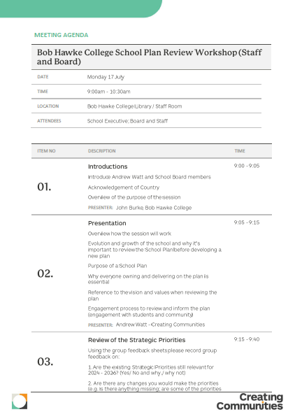

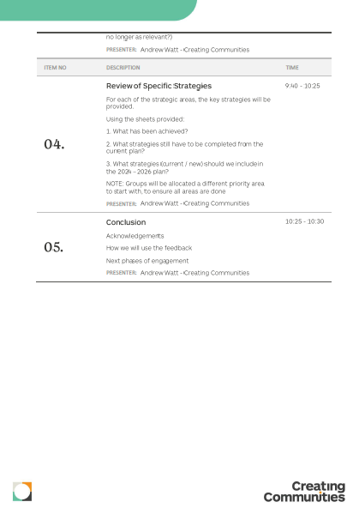

Appendix B: Staff Workshop Slide deck

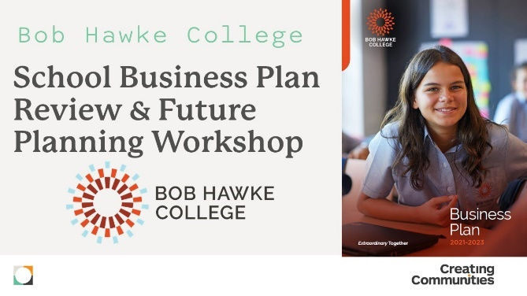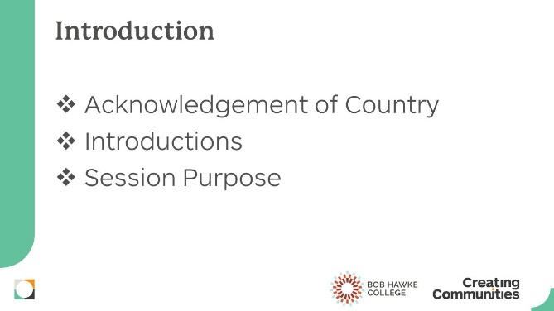

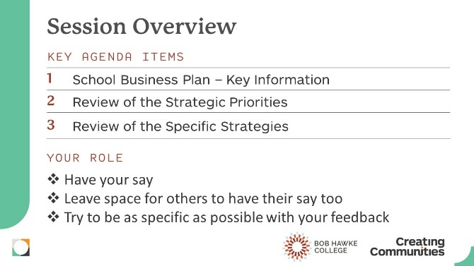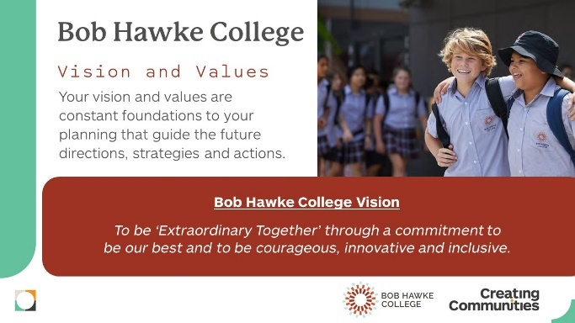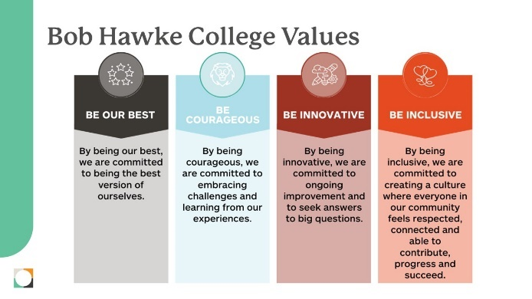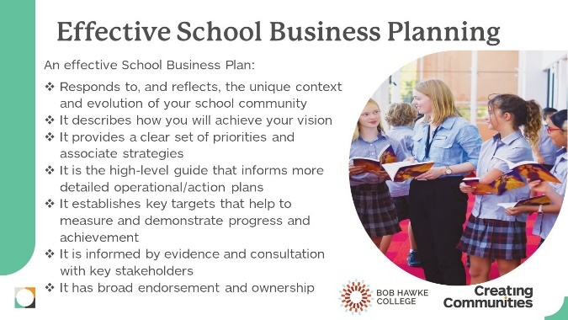
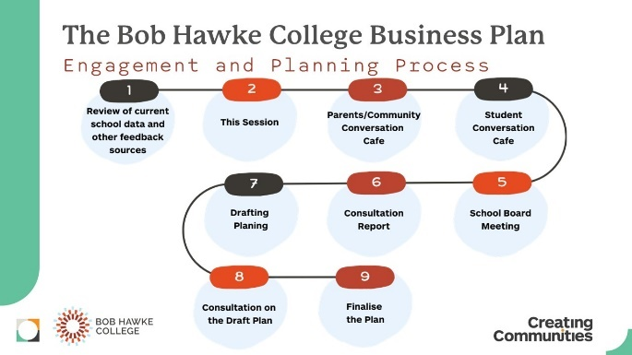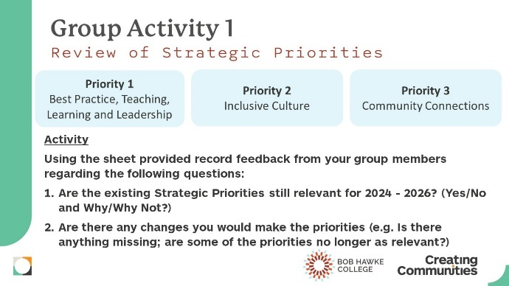
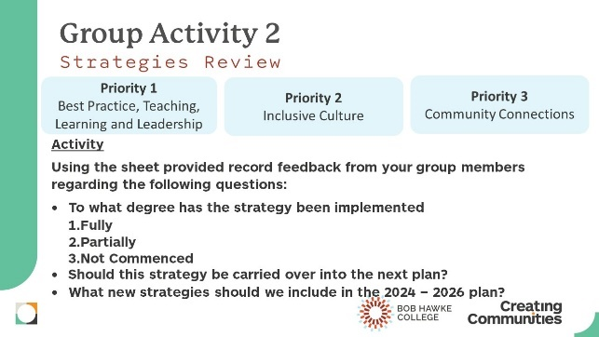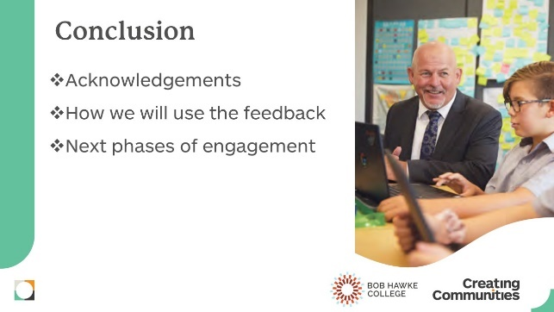
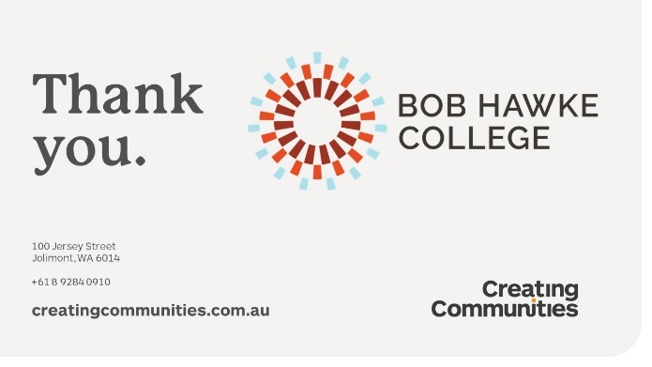

Appendix C: Staff Workshop worksheets (blank)
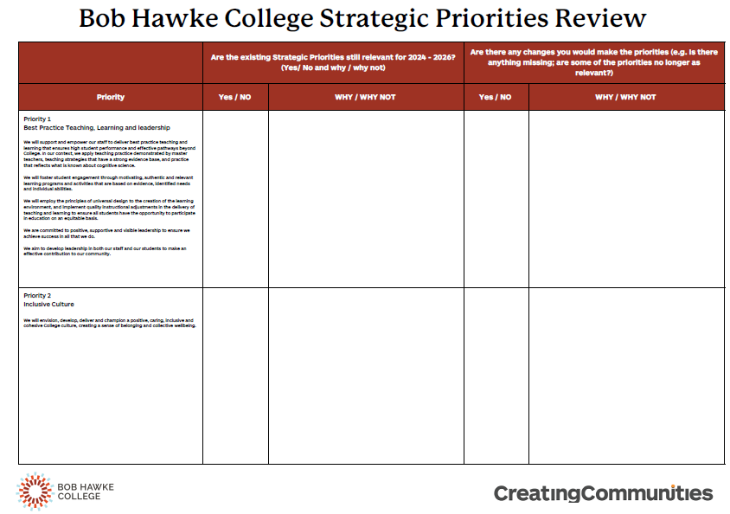

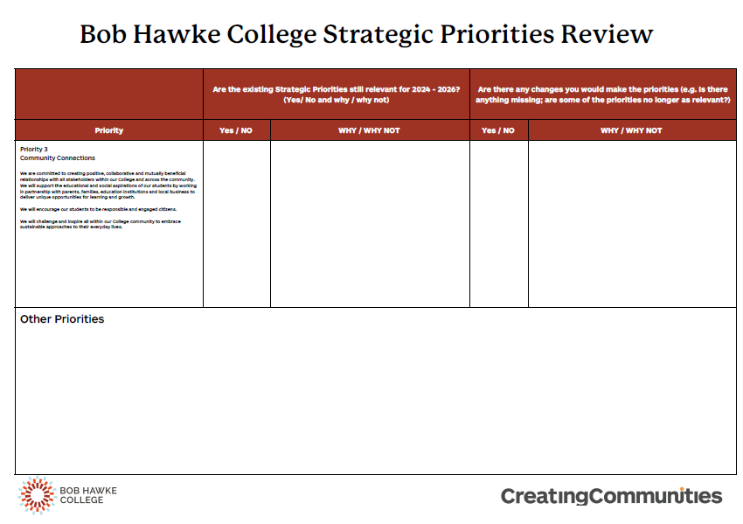

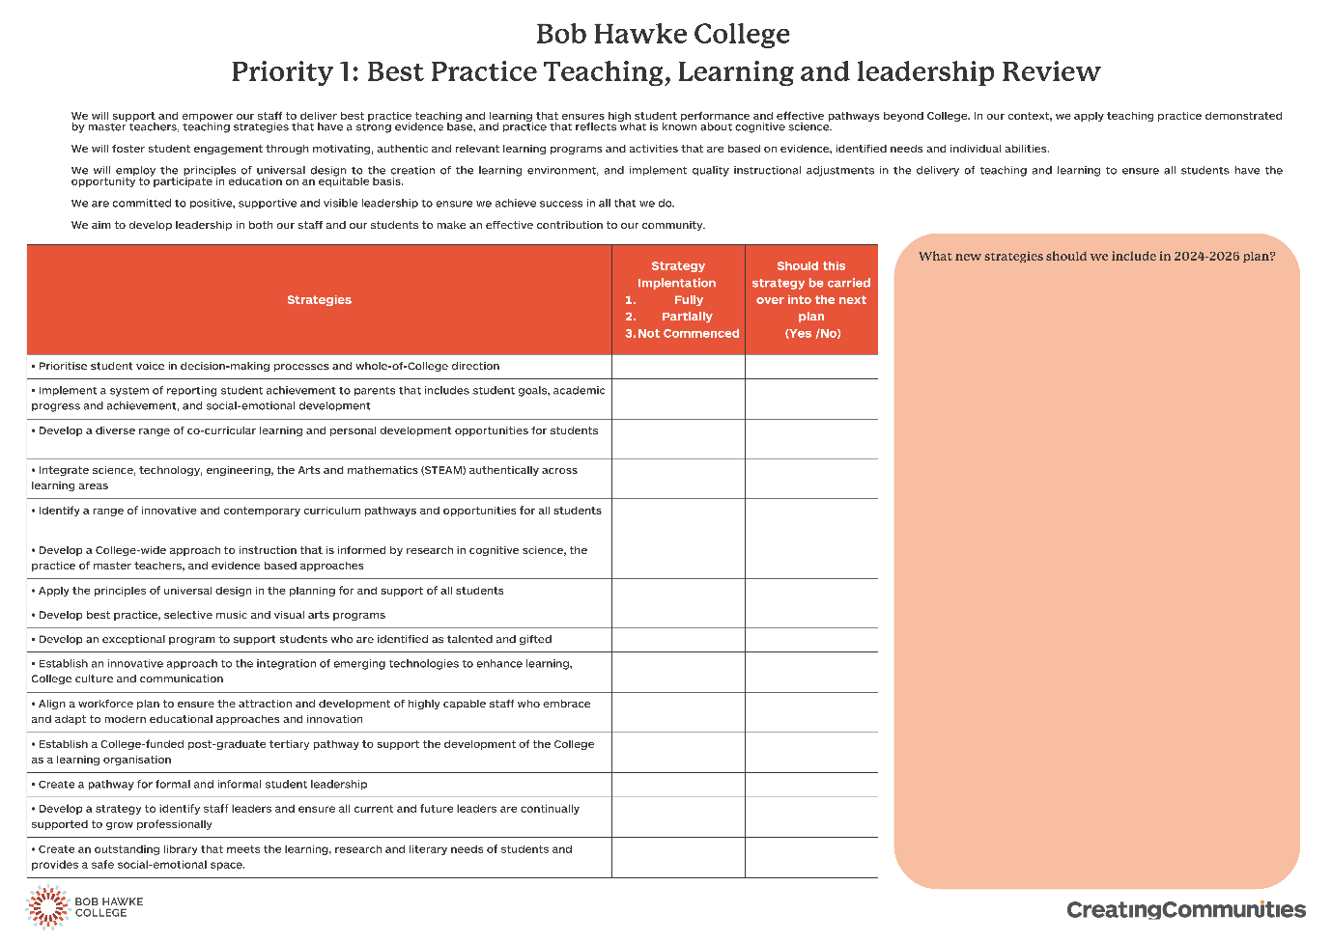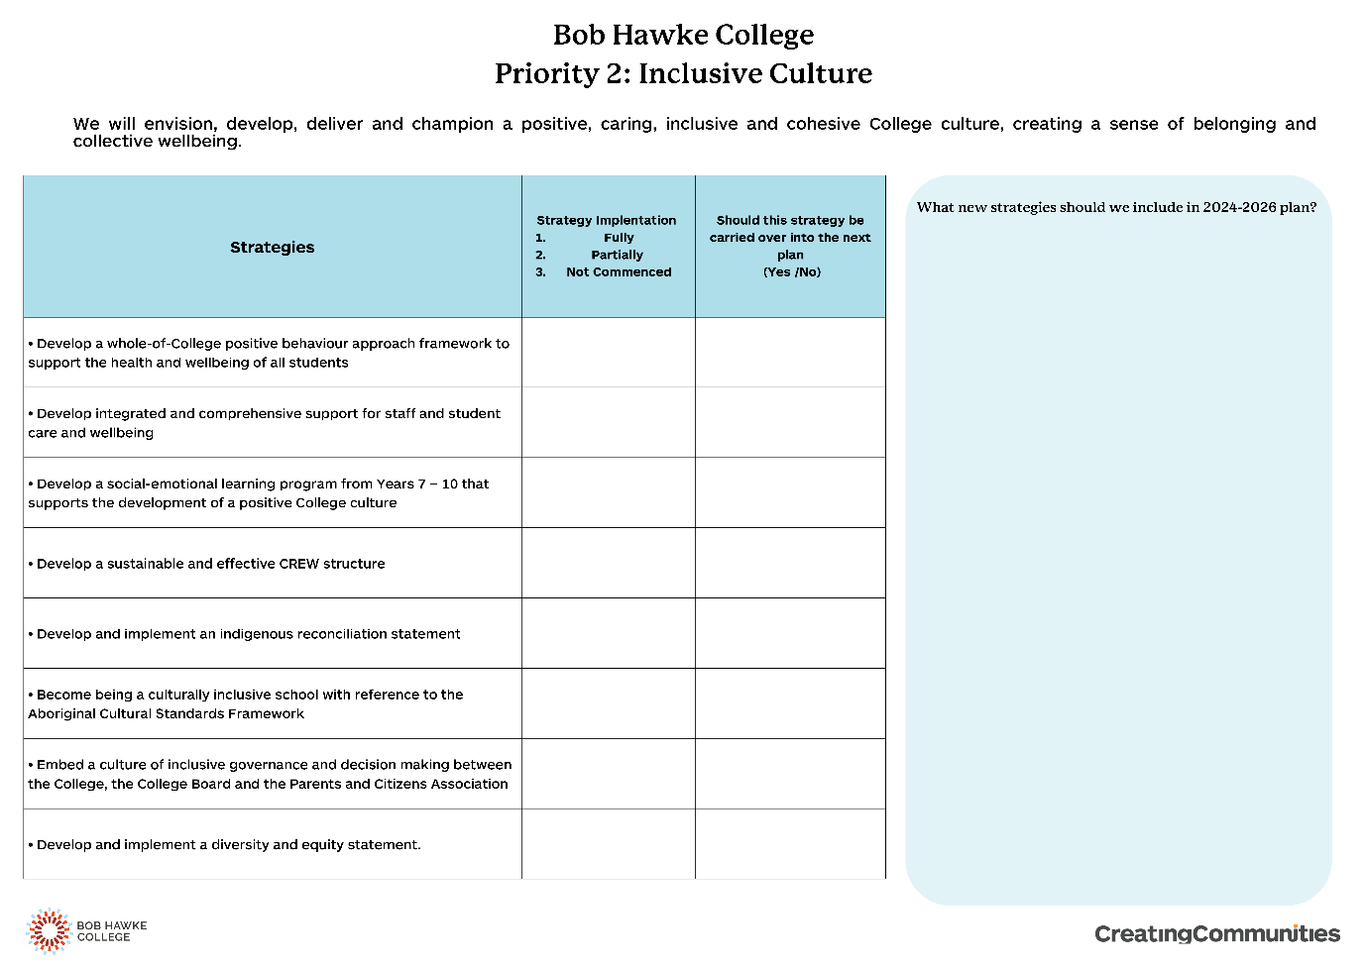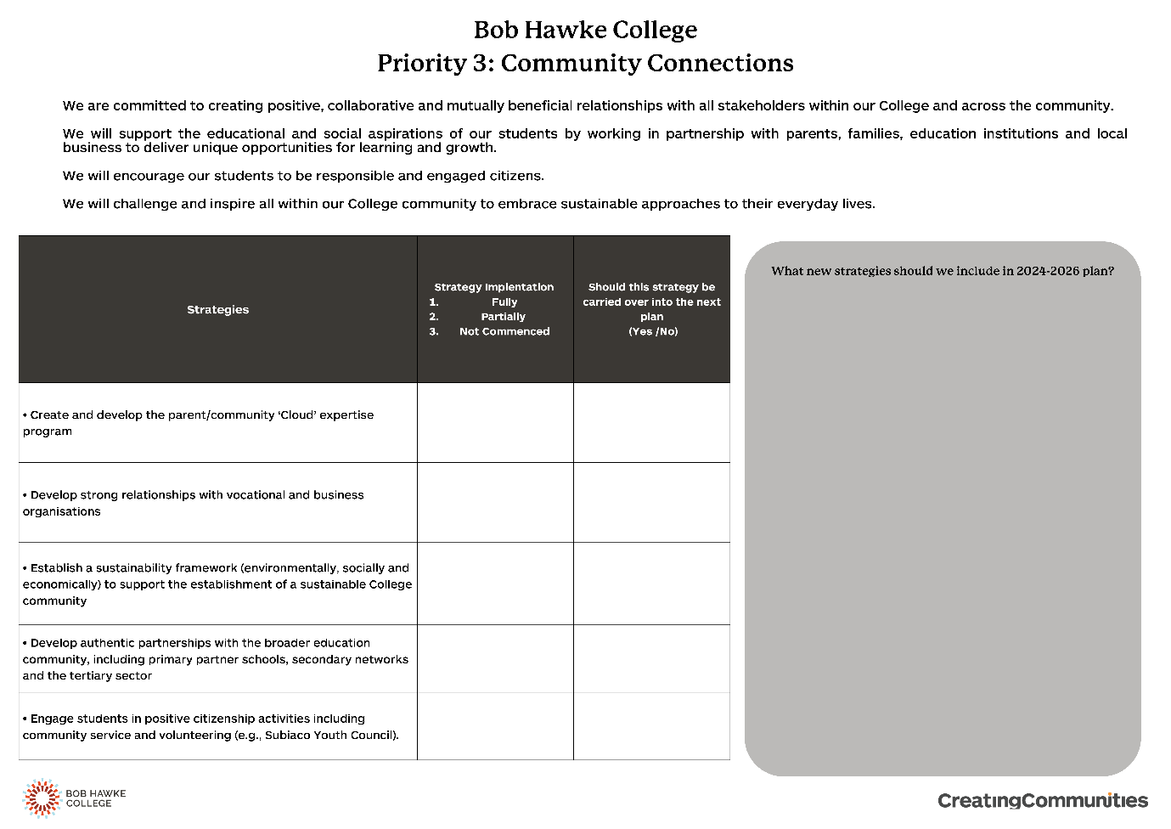

Appendix D: Student Workshop Agenda
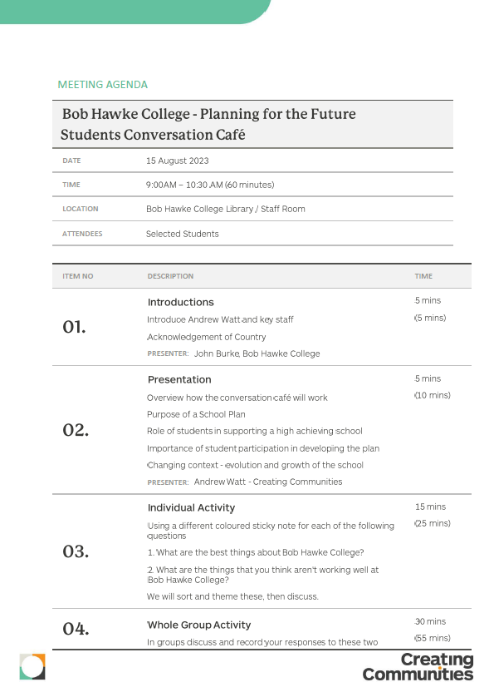

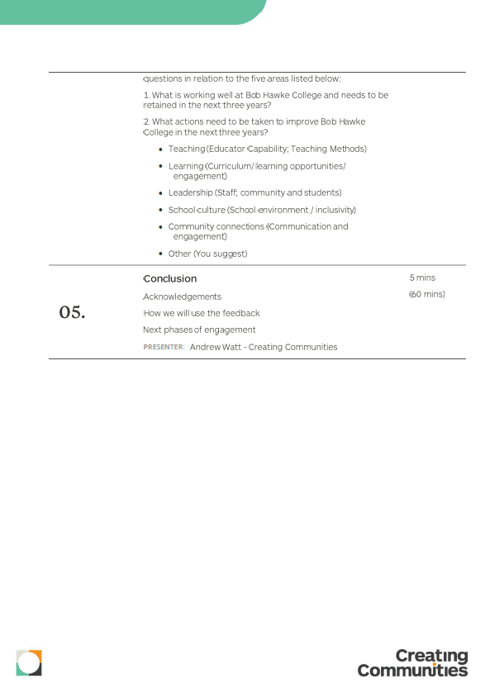

Appendix E: Student Workshop Slide deck

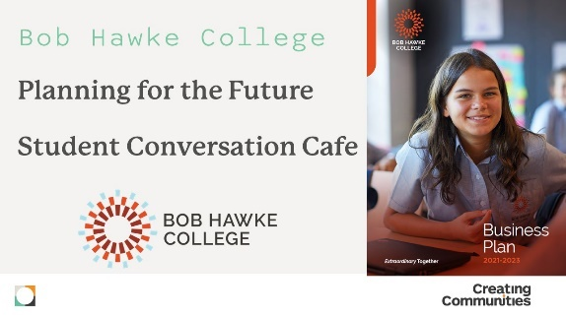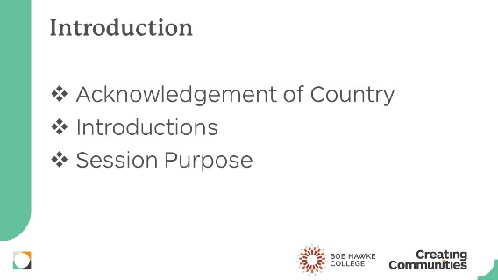
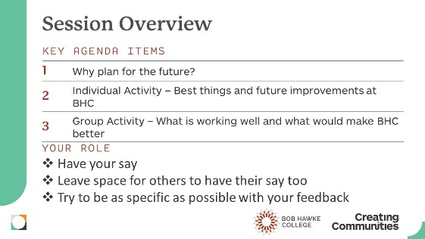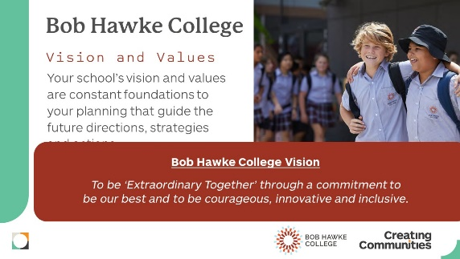

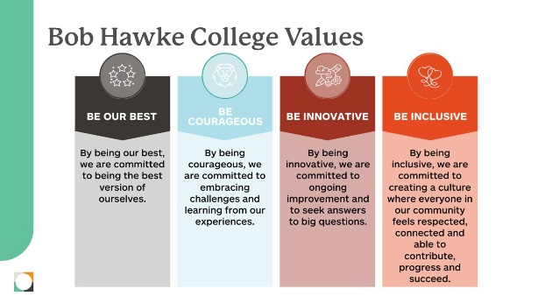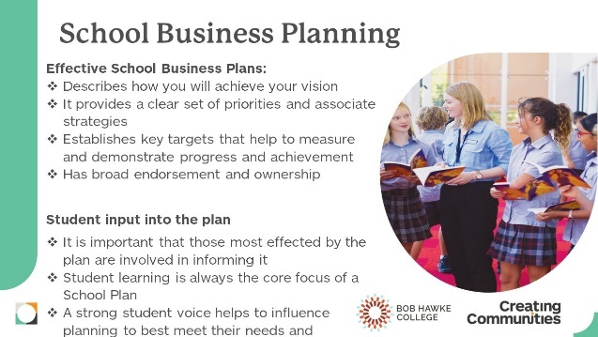

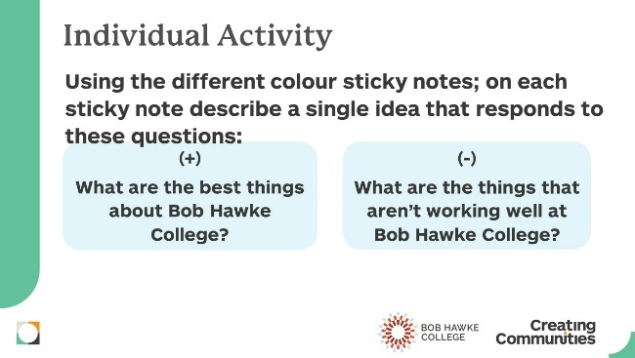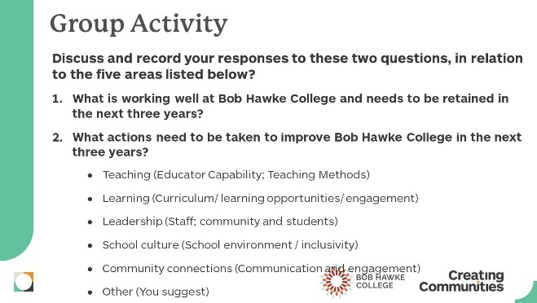

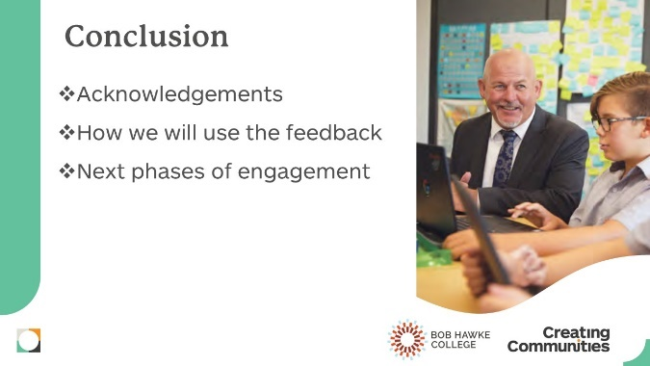

Appendix F: Student Workshop worksheets (blank)

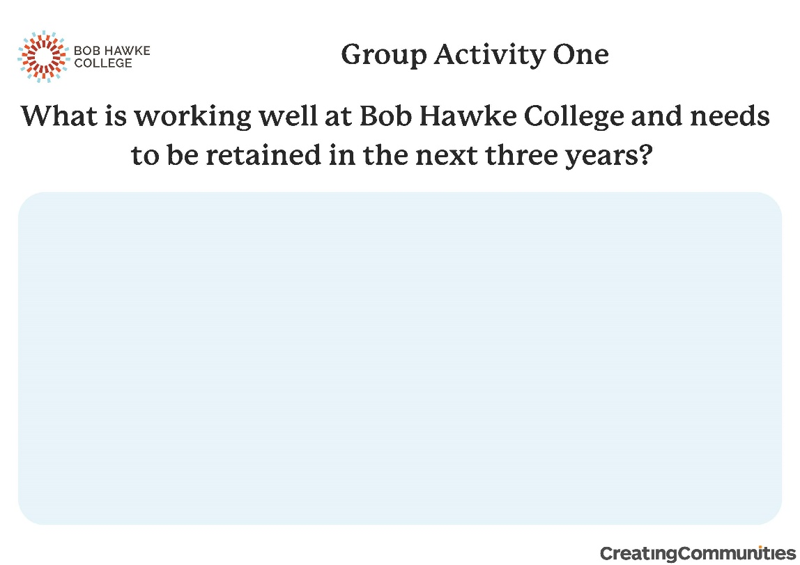
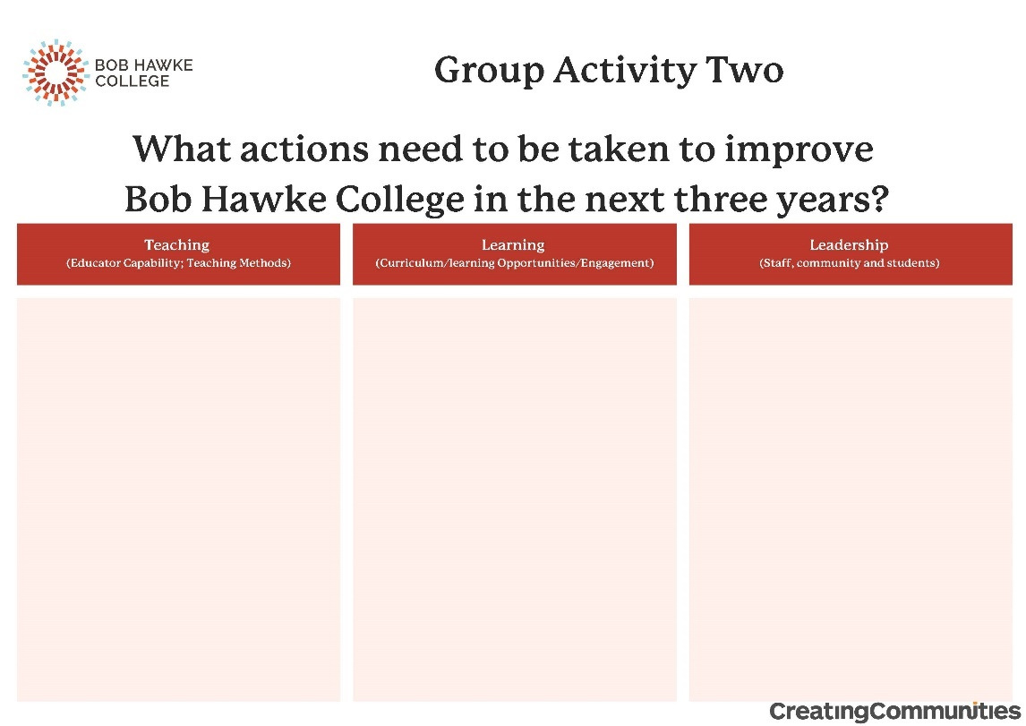
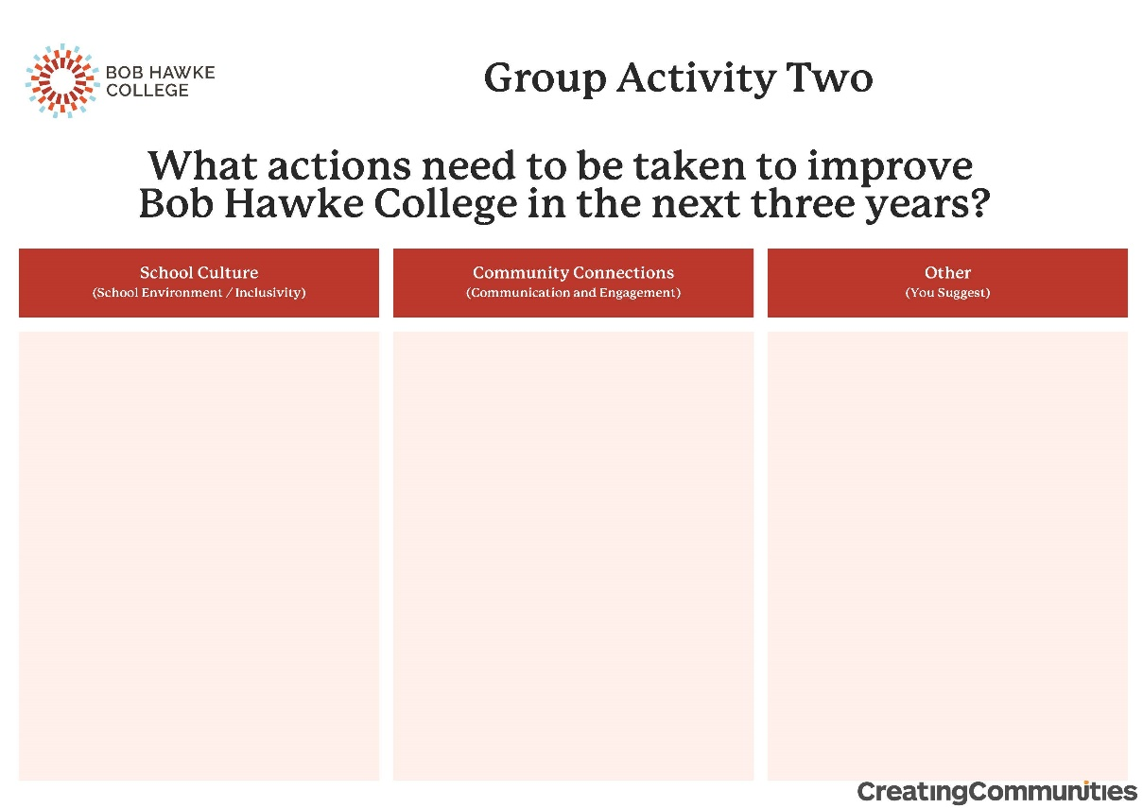

Appendix G: Community Workshop Agenda

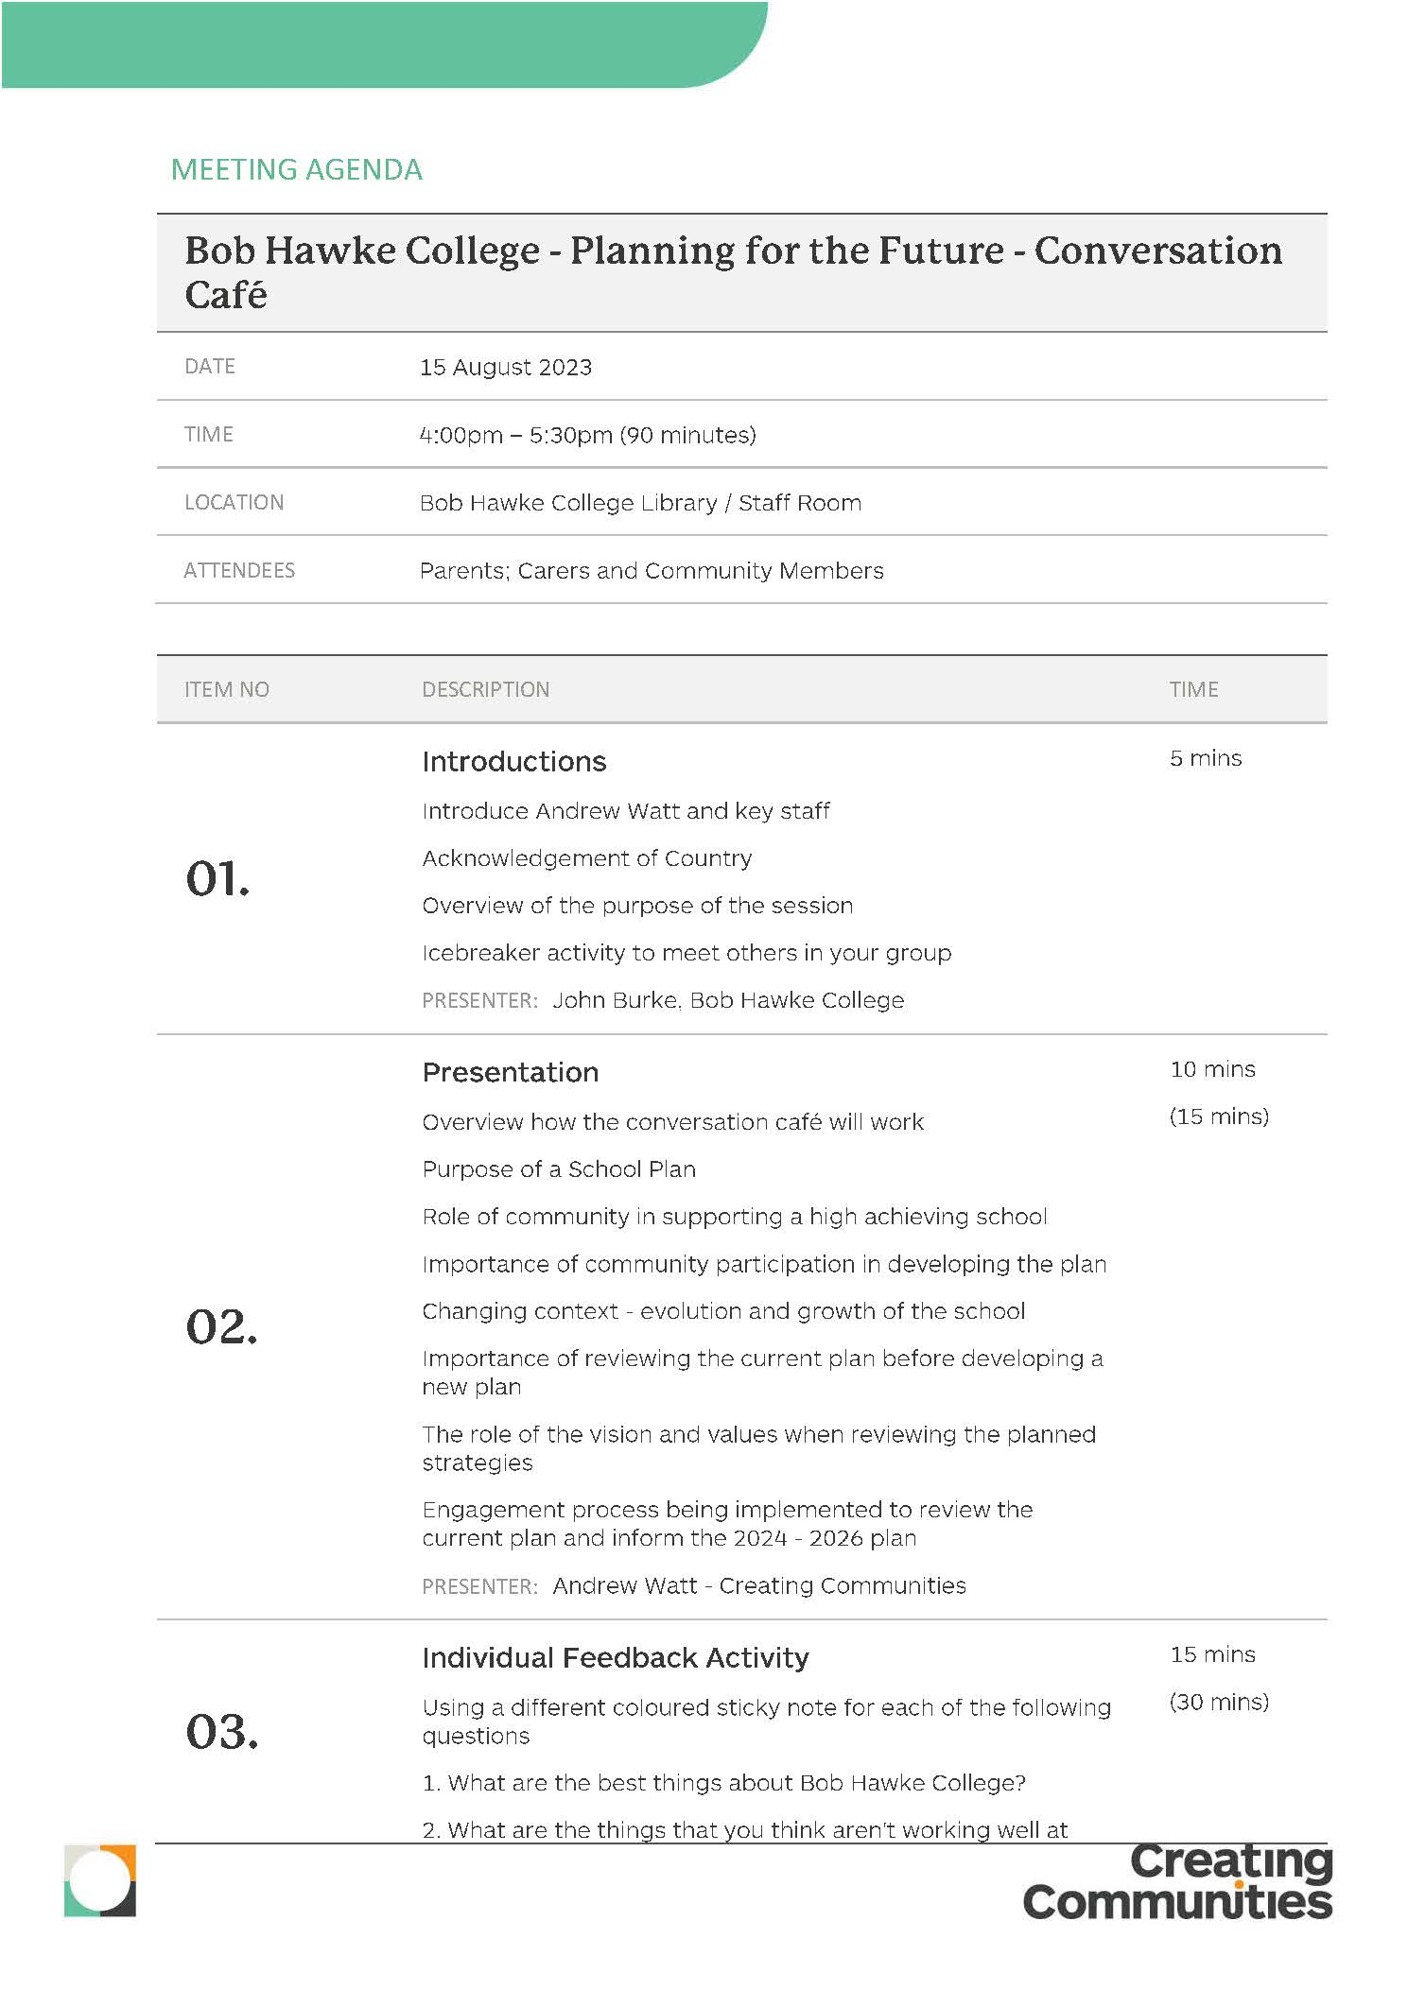
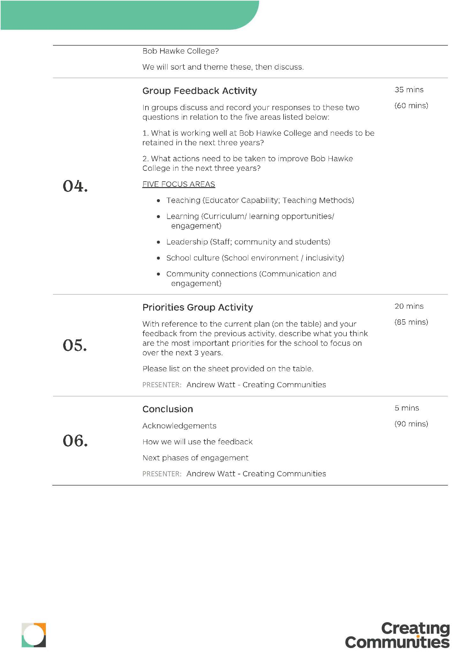

Appendix H: Community Workshop Slide deck

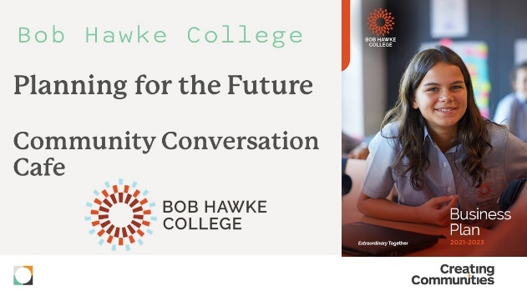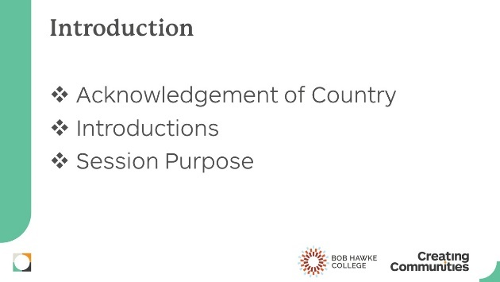

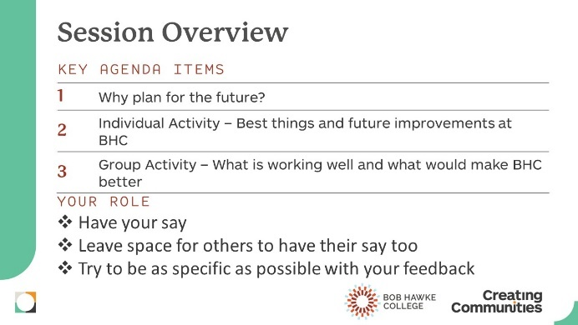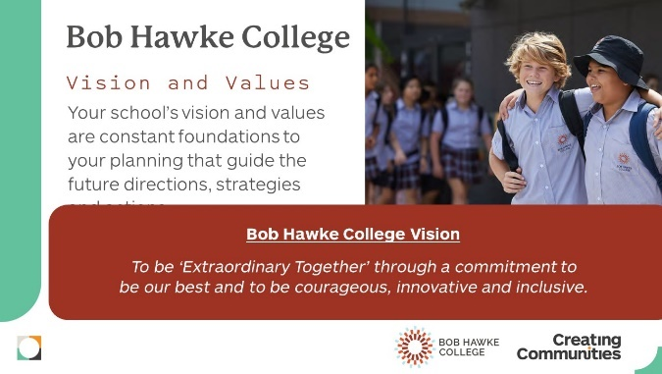

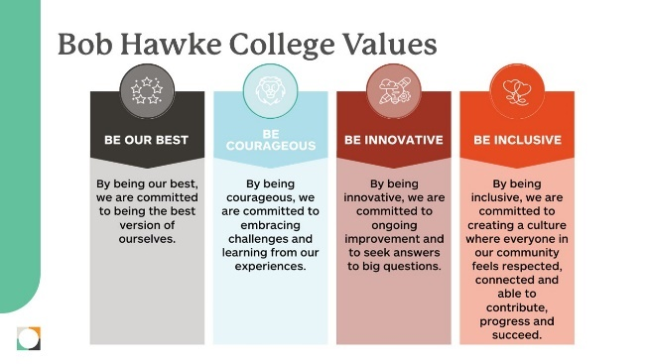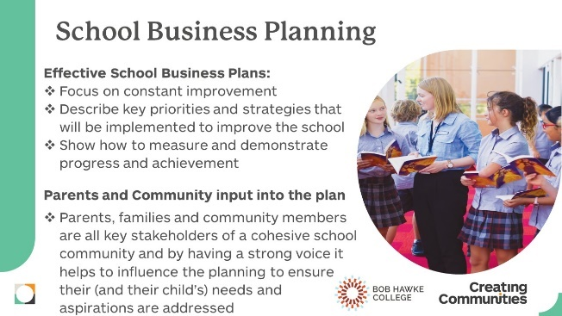

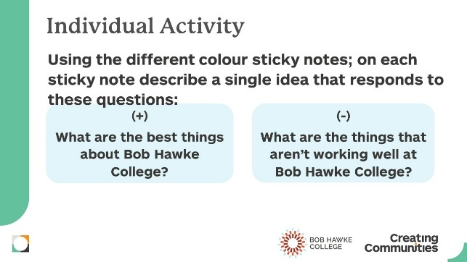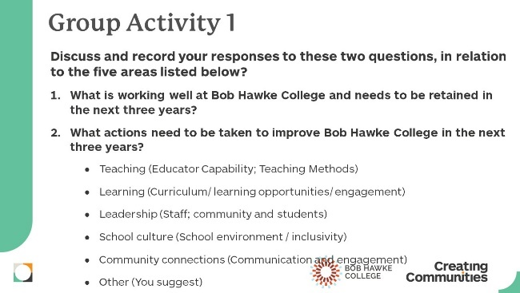

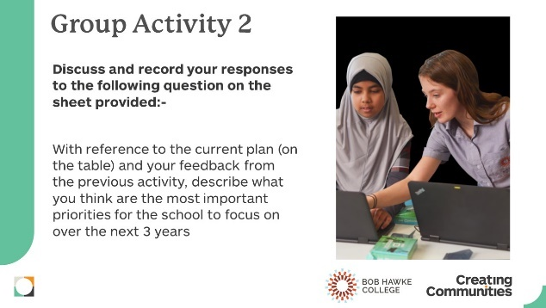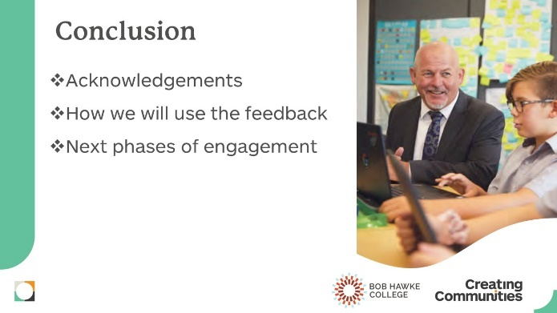

Appendix I: Community Workshop worksheets (blank)

