Sub-Committee: Fathering Project
Date: 18 October 2022
Prepared by: Mal Harrison

General Updates.
- Due to limited interaction and support, I have determined to suspend all further activities of the fathering Project until further notice. I will be stepping down from this role and at the next AGM, from the P and C. This will require new leadership of the group to continue.

- Financial Item: No fee is requested to date.

- What’s app group is still operational with 49 members. The admin of this can be passed on to the next group, if a team is established. Nicholas Duffy and Michael Cheng are also admin on the group.

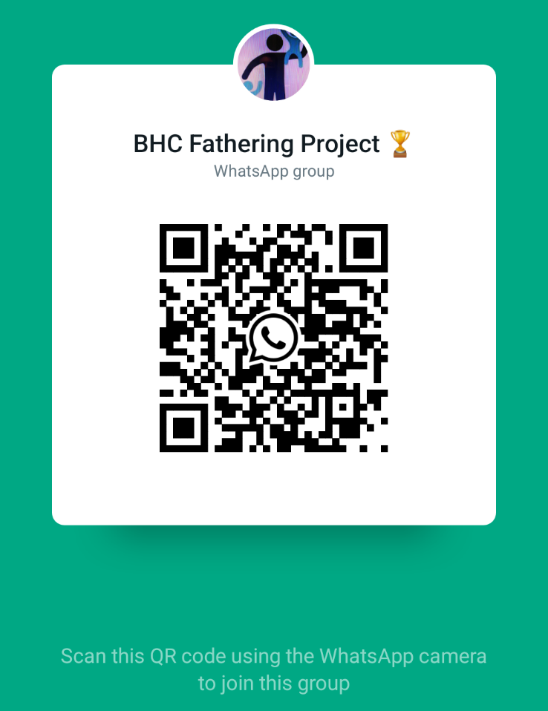

Regards

Mal

