Treasurers Report – Term 2 2025

We’ve had quite a busy term 2 this year with quite a few events.
Fundraising from the following events has helped with fundraising an additional $6,042.58 for the P&C.
Funds raised are as follows:
Easter Raffle $2,424.90
Election Day BBQ and Cake stall $3,084.36
Mother’s Day stall $586.32
In preparation for the Glow Disco, we have paid deposit for DJ and we have also expensed a get well gift for Mrs Zadow.
For the period March 2025 to May 2025:

Bank balances from Westpac (as of 02/06/25)
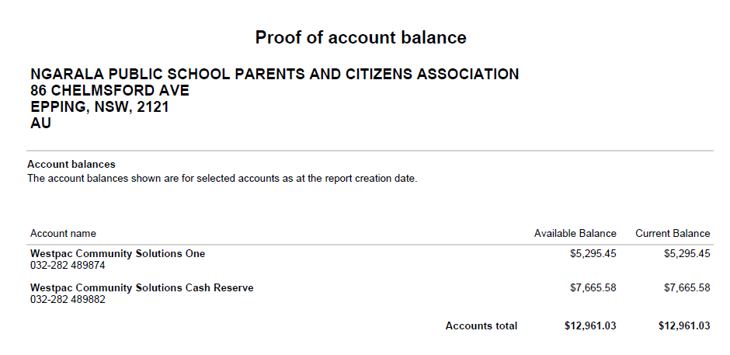
Variance is due to bank balance due to the following:
Cash box $100.00
Merchant fees charged 02/06/25 $16.13

