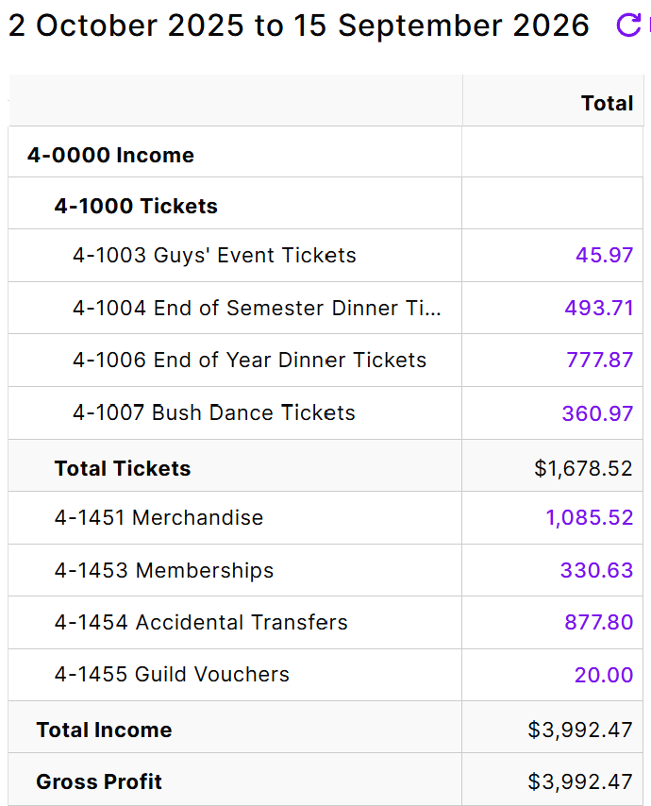
Merchandise: We made a slight loss on hoodies, as we subsidised them to make them cheaper. As of writing this, we have collected orders for shirts but have not paid for them.
Memberships: We made less than last year, possibly due to people confusing the ‘Expression of Interest’ option for membership on our website with actual memberships


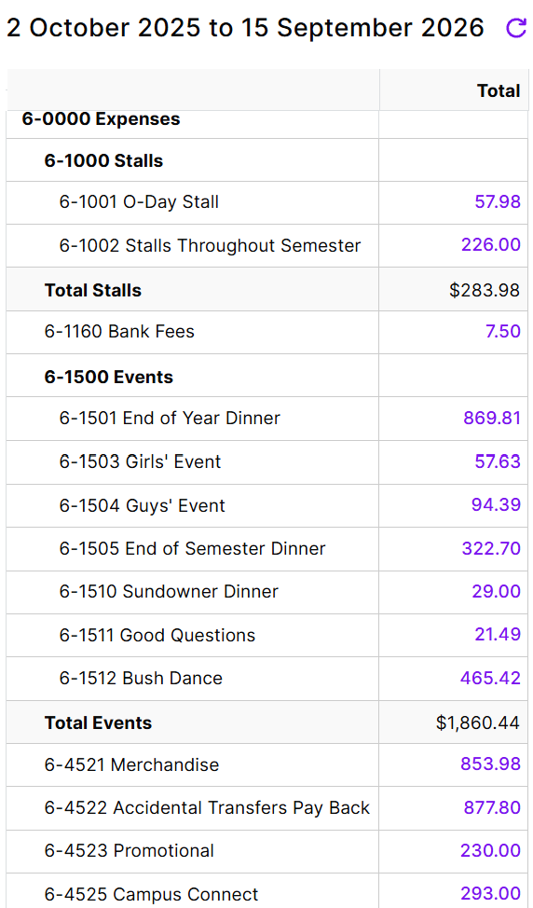

Stalls: Our expenses comprised of tea and coffee supplies for stalls
Events: We decided not to charge tickets for the girls and some of the guys event, which meant that we made a loss on both of these events.
Promotional: Fliers and stickers advertising CCU and our events
Campus Connect: promotional fliers and materials advertising campus connect events

Net Cash Position

-
Last year’s loss:

