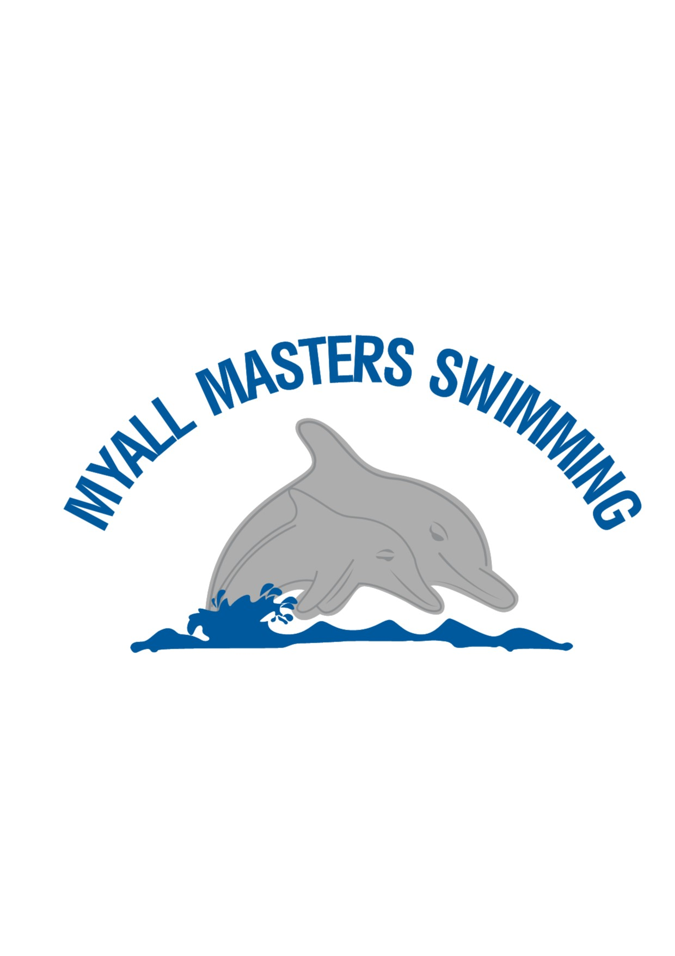

Myall Masters Swimming Club Annual Training Plan
2025-2026 season

Myall Masters Swimming Club Annual Training Plan
2025-26 Season
PURPOSE- The purpose of this plan is to:-
- Provide members with information about our club and how it functions.
- To inform members of our training plan and invite them to be part of the planning process.
- To support individual coaches to deliver their training sessions so that we are working in a coordinated fashion towards meeting swimmers and club goals.
This document is a living document with the intention that we can as a club respond to changes dynamically. It is supported by Masters Swimming NSW/ Australia documents as attached.
OUR HISTORY
“Myall Masters Swimming (MM) held its first swim session to gauge interest in forming a club on the 4th November 2004
The Inaugural AGM was held on the 8th November 2004 with all positions filled. Leon Bobako was elected as President and Rhonda Bobako as Secretary.
Myall Masters commenced with 36 full members with, from memory, a few more added as the season went on. Great lakes Council allocated 3 lanes for training on Monday nights 5.30pm to 7pm.
The Club’s 1st interclub Swim Meet was held on the 8th February 2014 our 10th year as Myall Masters Swimming Club.” Leon Bobako 2023

OUR CLUB
Myall Masters is a participating club within Masters Swimming NSW and Masters Swimming Australia.
In the 2024-25 swimming season we had 33 swimming members plus a number of social members. We have 3 training sessions per week. Our main training session is held on Monday evenings. We host an Annual Branch Point (BPS) meet as part of the Masters NSW BPS series. Members enjoy a range of social opportunities with our year culminating in a presentation evening to celebrate our season of swimming together.
A number of our members enjoy competing at Masters swimming carnivals, though given our short swimming season and distance from major centres we are not a highly competition focused club. We encourage club wide participation in our local carnival with most members able to contribute to this event making it the major goal for our training program. Members also swim at summer meets within our region and also at State and National events. And very occasionally at international events.
A number of our members also participate in other swimming related activities including open water swimming, triathlon and surf lifesaving.
Our membership is community connected through the many social, community service and sporting groups within Tea Gardens/Hawks Nest. Including Golf, Pickle ball, Yoga, Cycling, Progress Association, Surf Lifesaving, Community Radio, Church groups, Pearls and Lions club etc.

OUR POOL
MM trains at the 25m Tea Gardens swimming pool. The pool is an open air, 6 lane facility. It is unsurveyed, meaning FINA records cannot be recognised. We have access to 4 lanes for training on Monday nights. There is all-ability access via a swim up ramp and also stairs. Hot Showers were novel in 2024 and made a positive impact on our enjoyment of the pool last season. Blankets and solar heating are available to extend the season. The pool is council owned and managed by Hughes Swimming. The pool is open from spring till autumn, usually opening in the October school holidays until mid April, seven days per week.

OUR SWIMMERS
Our swimmers are aged between their 20s and 80s. Mostly we could be described as middle-aged. We vary in experience. We have adult learners, people who have uncovered a passion for swimming later in life, people who swam in junior squads and have returned to swimming as adults, many are lifelong swimmers. There are members who have never raced, some who will do a lap at our local carnival and those that thrive in competition. We applaud and celebrate them all!
Our plan is designed to meet the needs of our average club swimmers with much effort made to individualise training to meet the current needs and goals of our swimmers. Sessions are planned for three groups (as per Swimming Australia, “Swimmer Characteristics” attached.) Lanes are allocated accordingly.
Lane2 Fitness swimmers Sets are based on 25m to 50m reps. Total distances 1000m to 1200m. Mostly freestyle
Lanes 3-4 Stroke Development Sets are based on 25m to 100m reps. Total distances 1800m to 2000m. Freestyle, Breastroke and Backstroke
Lane 5 Competition Swimmers Sets are based on 25m to 200m reps. Total distances 2000m to 2400m. All strokes

OUR SESSIONS
Monday evening is our main session together where we focus on skill and fitness development. We work our way through a progressive plan for the season acknowledging that many off our members have little access to swim training over the winter. Monday sessions are led on pool deck by our coaches scheduled on a rotating roster. Wednesday morning is a short sharp sprint session led by a coach who also swims. Friday is a social swim night with a variety of programmes available for swimmers to choose from with a focus on distance.
Monday Evening 5 -6pm Coached Session 3 Levels Skill Development
Wednesday Morning 8:30- 9:30am Programmed Session All Levels Speed Session
Friday Evening 5-6 pm Endurance All levels Self -guided /social session focused on distance

OUR MANAGEMENT
MM have an executive committee including three club member representatives that govern the activities of our club. Non- committee positions are task based roles that report to the committee
Committee Positions | 2025-26 | Member Roles | 2025-26
President | Adrian Reynolds | Public Officer | Mal Motum
Vice-President | Linda Stubbs | Publicity Officer | Christine Dunning
Secretary | Joanne Collins | Social Coordinator | Kerrie Patterson
Treasurer | John Estens | First Aid (Safety) Officer
3 Member Representatives | Kerrie Patterson  Stephen Rees  Christine Dunning | Club Captain | Shane O’Connor
 |  | Meet Coordinator | Stephen Rees
 |  | Head Coach | Sharon Taylor
 |  | Facebook/media | Sharon Taylor
 |  | Qualifications Recorder | Adrian Reynolds
 |  | Member Protection Officers | Sue Estens  John Dunning

OUR SKILLS
Our club has a number of volunteers who have undertaken training as competition officials. Volunteers maintain their skills to officiate at our own carnival and to reciprocate at other Master’s swimming carnivals. Among the positions we have current capacity are: - Chief Time Keeper, Marshall, Inspector of Turns, Time Keeper and Warm-up Lane Supervisor. We encourage members to participate and become involved in the wider swimming community.
In 2023/24 swimmers entering a carnival were asked to nominate a timeslot to volunteer for timekeeping. A cohort of our swimmers and volunteers underwent training in timekeeping to be able to contribute to our carnival and also to participate more broadly. It is anticipated we will reproduce this training at least bi annually.
CPR/FIRST AID. Coaches undertake CPR training as part of their accreditation process and are required to maintain currency. We also have swimming members who maintain these competencies in other fields such as surf-lifesaving, fire brigade etc.
Our qualifications recorder maintains a register of skills held by members and their currency.
Members and partners contribute a richness of “non-swimming” skills and knowledge that we could not manage without including administration, repairs and maintenance, organisation, announcing, media, catering, hosting, setting up public address systems, lifting and carrying.
OUR COACHES
Our club has a team of coaches they have a range of experience and interests, personal styles and approaches. We hope this keeps our sessions varied and interesting. We rotate through a roster for the main coaching session on Mondays. Programmed sessions on Wed and Friday are delivered by coaches with a special interest in that session with others filling in as required.
In 2023/24 it became a requirement for all coaches of Masters Swimming Australia affiliated clubs delivering pool deck instruction to complete an accredited coaching course. All of our current coaches have completed this rigorous program and subscribe to continuous professional development
About our Coaches: -
Leon Bobako | Accredited Coach, Founding Member | Long term coach and head coach. Lifelong competitive swimmer. International medal holder and nationally experienced swimmer. | Specialties- sprinting, breastroke, butterfly.
Christine Dunning | Accredited Coach 2024/25 | Extensive Aust Swim experience, lifelong swimmer | Specialties- Learn to Swim
Stephen Rees | Accredited Coach 2022/23 | Joined MM in 2020, previous club captain and carnival organiser. | Specialties- backstroke, middle distance, open water.
Sharon Taylor | Accredited Coach 2021/22. Head coach 2023/24 | Masters swimmer since 1998. Attended State, national and international meets. | Specialties- individual medley, surf swimming.

Professional Development
Coaches are required to maintain a record of professional development to maintain/attain accreditation. Attached are the following documents to support coaches.
- Levels of Coach Engagement
- Coach Updating Log
- Club coach guidelines for accreditation

THIS PLAN
This plan has two points of focus; the Myall Masters carnival in February and the Masters National carnival in April. Regardless of whether members determine to swim the Nationals, these two points on the calendar divide our season into two broad segments for the purpose of goal setting and incremental swimmer development.
Within these 2 blocks are 3 phases prior to our carnival then a small recovery followed by another phase of build up to the National carnival. Our calendar includes opportunity for participation in other carnivals particularly where we have strong links regionally, eg Cessnock, Port Macquarie.
This season we potentially have 26 weeks of swimming at our local pool. Our first session is likely to be Monday 6th October, Easter Monday falls on the 6th April. Christmas is a Thursday with boxing day on a Friday, so we shouldn’t lose too many days due to public holidays.
We will have 2 main blocks of training. One of 18 weeks to prepare for our carnival and another to recover and plan for Nationals usually held in April. Block one will be broken into 3 phases of six weeks each. Swimmer testing will be incorporated into each phase to allow swimmers with an interest in performance to measure their progress and set progressive goals.
Whilst we know many of our members try to keep up a level of fitness with cross training and seeking out of town or open water swimming opportunities it is inevitable that we all experience considerable de-conditioning in the break. Our plan is careful in reintroducing squad training incrementally to avoid injury and rebuild fitness safely. Our first 6 weeks is titled “factory reset”. It is aimed at reconditioning swimmers after the winter break and reinforcing good technique as we progress in intensity of training through the summer.
One of the goals of developing this training/ coaching plan is to encourage consistency in our coaching approach given we have a team of different coaches rotating through a roster. The phases in our program have goals mapped out from which an individual coach develops a session. We utilise a standardised proforma to guide coaches in allocating time to balance technique and fitness aspects of swim training. Within this framework we encourage the application of individual knowledge and the coaching flair of our individual coaches.
Last season we spent considerable effort developing a suite of programs that we can draw upon this season.
In the previous two seasons our squad indulged coaches in progressively learning our suite of drills. As a result we felt that last season many swimmers made substantive leaps in their technique. As most of our squad now know those drills we expect that they will be well equipped to launch in to making even bigger gains this season. With less time and frustration in learning hard stuff and more time in doing we’re looking forward to a fruitful and enjoyable time together
Over this last winter, 2025, a number of swimmers have been able to attend semi regular swim sessions at Raymond Terrace pool with some coordination of a committed group. Persistent flooding, however, has limited the usual open water swimmers program. Simple dryland strength/fitness sessions were distributed to members on 3 occasions during the wet weather to encourage winter fitness. We are hopeful that at least some of our members will have retained last season’s gains.
Coaches attended the National coaching conference in Canberra. A list of initiatives ( see attachment) was developed from the conference and we look forward to integrating those into our programming for the benefit of our squad.
Areas of interest to us include goal setting and measuring, communicating coaching intent and developing swimmer strength and flexibility.
This season as a coaching team we intend (again) to encourage swimmers to do dryland warm-ups prior to entering the water. A trial of setting up a warm up station en-route to the club shed to catch a passing swimmer will be established.
We will investigate incorporating strength training into our program without impacting our limited pool time.
During each phase an opportunity will be programmed for swimmers to do timed swims to assess their progress. These may be in strokes/distances of individual choice or that of the coach on deck. Timing and record keeping may be shared by members-also consolidating skills required for our carnival.
We will trial written instructions at lane ends to supplement those on the large whiteboard and verbal instructions.
We will introduce a rating scheme and visual aids to communicate clearly the effort with which swimmers should apply to set tasks to better target the energy system coaches are attempting to train.
We will explore introducing some handicap race sessions as a number of swimmers expressed a desire for some fun racing .
We will be mindful of articulating the purpose and execution of drills and activities.

Training Block ONE – From Zero to MM Carnival
Phase three - Competition 6 WEEKS
SITUATION
Swimmers approaching peak fitness.
Warmer water and easier to warm up muscles
GOAL
Making speed, competition readiness
ACTIONS
Practice competition style warm-ups
Short, high intensity sets with longer rests
Optimising cadence
Pacing for a race
Practice completing the whole swim
Utilising the turn for speed. Swim to rules of racing.
All strokes

Phase two – Preparation 6 WEEKS
SITUATION
Swimmers should start to feel fitter and stronger.
Days and water are warming
GOAL
Increasing Endurance
ACTIONS
Keep up the warm-ups
Focus on Catch /pull and propulsion
Increase intensity with adequate rests
Incorporate more front-end stroking.
Forearms and shoulders
Increase stroke rate and rhythm
Commence racing technique- starts/turns /finishes
Increasing short axis strokes -breast and fly for some

PHASE one - Preparation 6 WEEKS
SITUATION
Cooler conditions can contribute to increased risk of injury & perceived rate of exertion.
Training for most has been inconsistent
Little open water swimming this season
GOAL
Returning to swim fitness
“FACTORY RESET”- encouraging good form and normalise warming-up to develop efficiency and reduce injury.
ACTIONS
Warm-up – in and out of water
Focus on body position and technique
Long Slow Distance- keep moving
Stroke correction
Avoid high stroke repetition/ threshold work.
Proportionally more long axis strokes- free and back

Training Block TWO– Post Carnival Blues to Flying at Nationals
Phase two- Maintenance and Fine tuning
6 WEEKS
Training for Nationals and Cessnock Carnival
Focus on longer swims for the 50 m pool
Practicing race distances under competition conditions
Re-visit time trials week 2

PHASE one –Transition
1 WEEK
Post Myall Carnival
Usually some volunteer fatigue
Take an easy week
Review and celebrate performances
Revisit individual Goals

Myall Masters Swimming Club
Coaching Initiatives 2025/26 - 19/08/2025

 | Initiative | Description / Requirements | Lead
1 | Add weights session to program | Program, dates and times | Leon . Strength circuit Thursday am phase 1 week 1
2 | Add dynamic stretches to every session | Program, scheduling and communication | Sharon- warm-up circuit phase 1 WEEK 1
3 | Rating of Perceived Exertion Scale (RPE) | RPE laminated & placed at pool end | Sharon – print scale/ coaches to implement in sessions
4 | Goal Setting  - Team  - Individual  - Personal (private) | Team- coaches and Plan  Individual goal setting activity-  Personal -discussion | Sharon- via meeting/ plan/timetabling  week 2, re visit phase 2 and 3  Coaches @ poolside
5 | Goal Measuring – Test sets / distances | Prescribed times in season measure 3 x timed swims with dive.  Stroke count | Programmed phase 1, WEEK 3 : phase 2 WEEK , 9: phase 3, WEEK 15  Wet boards ordered
6 | Provide context – drill purpose & integration | Write session goal, introduce goal, explain drills  Program - drill followed by stroke (“ feel the impact”) | All
7 | Clear communication | Written –Whiteboard, Spoken –pool deck, Written –lane end.  ? Visual –video. | All

Coaching Appendicies
Myall Masters 2025-26 season SWIM calendar
Coaches Roster
Swimming Australia- Swimmer Characteristics
Optimal Stroke Count Estimator
Masters Swimming Australia – Swimming Rules, April 2023
MSA Levels of Coaching Engagement
Masters Club Coach Guidelines for Re-accreditation
Masters Coach Accreditation Program- Coach Updating Log
List of Members and Emergency Contacts- to be kept in Coaches Folder
https://mastersswimming.org.au/rules-and-policies/member-protection/

1 PHASE
Distance
50s +
All Strokes
PHASE 3
Pace /Comp
Increase speed
Inc rest
25s /50s
Eg Broken 200s
ALL Strokes
Turns
Starts / Finishes
Race etiquette
Timekeeping
COACH INITIATIVE
Goal setting
Measurement

COACHING PLAN SUMMARY
PHASE 2
Increasing Endurance
Inc effort
Medium rests
50/100s
Breast Technique
Core
Efficiency
Free/Fly Technique
Core
Efficiency
COACH INITIATIVE
Goal setting
Measurement

MYALL
CARNIVAL
followed by a recovery week
BLOCK 1 Pre Carnival – 18 weeks
COACH INITIATIVE -Warming Up, Communication, Context, RPE
PHASE 1
Return to fitness
LSD
Keep moving
200s
Free Technique
Core
Efficiency
Back Technique
Core
Efficiency
COACH INITIATIVE
Goal setting
Measurement
BLOCK 2 – Post Carnival – 6 weeks

