Since last year our membership has increased by almost 40% with an increase from 129 members to 176 members this time last year. This is the highest membership our club has ever achieved which is something to be proud of. This could be due to a number of factors including better marketing, higher quality events causing an increased recruitment through attendees, or the fact that we have been more active in general this semester.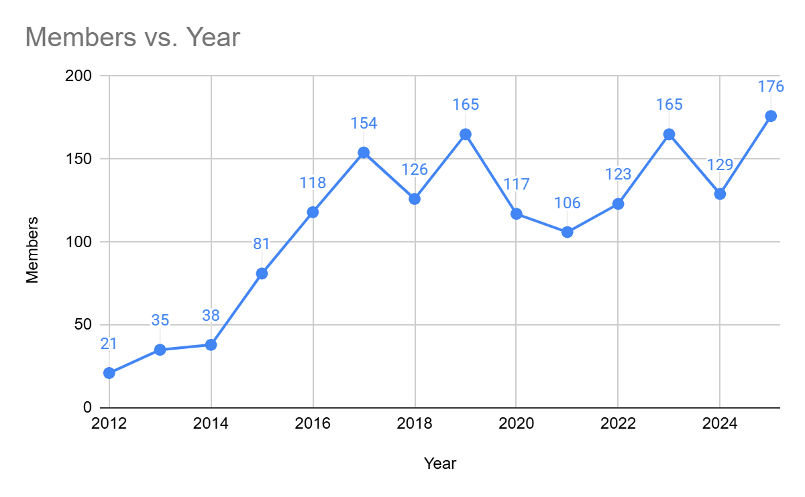

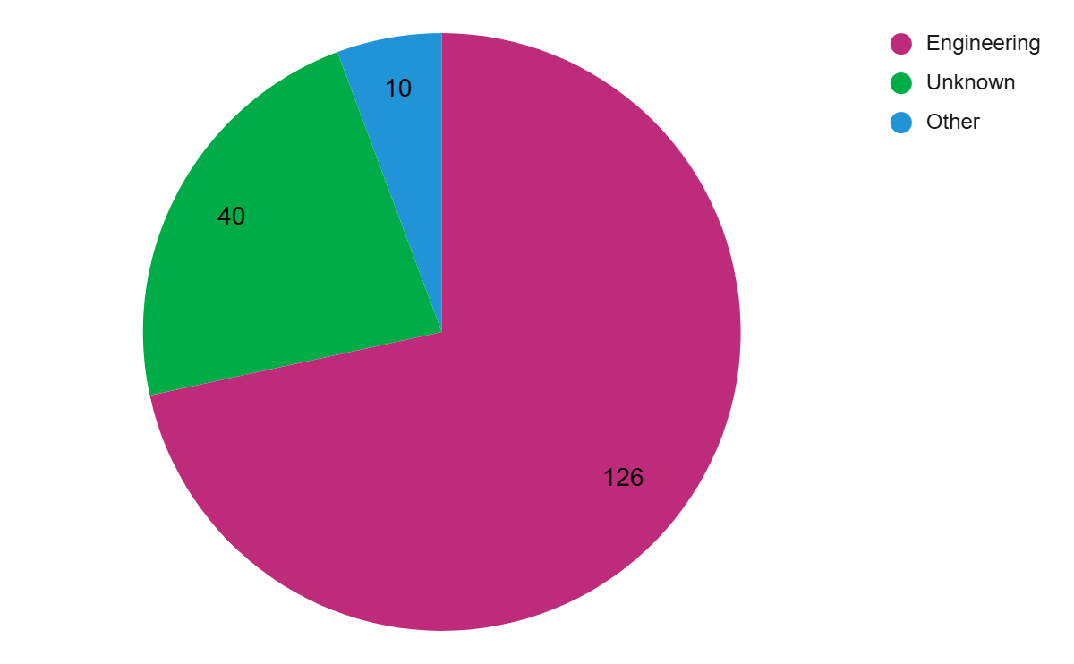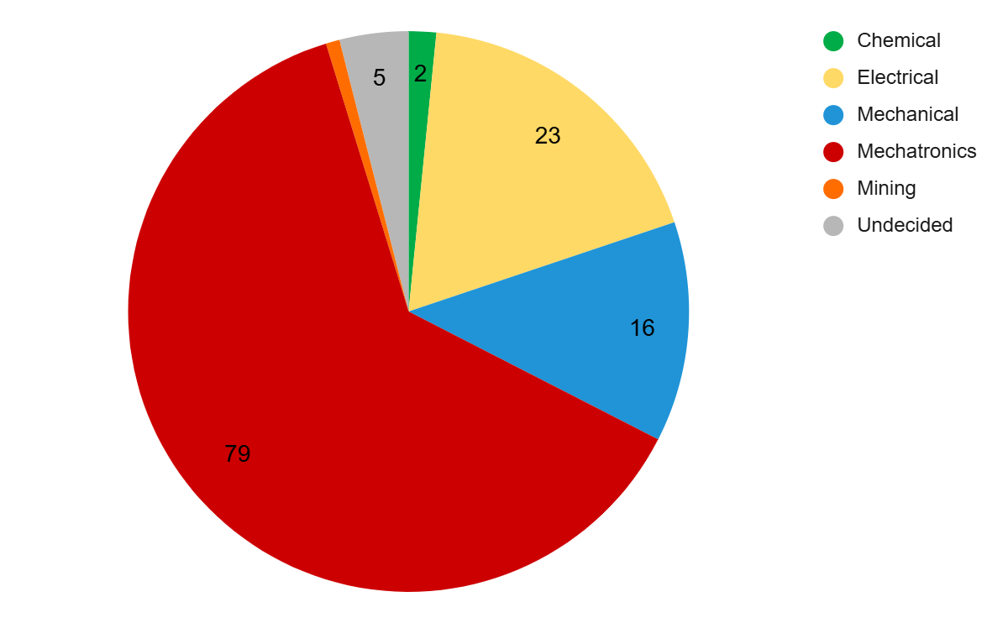

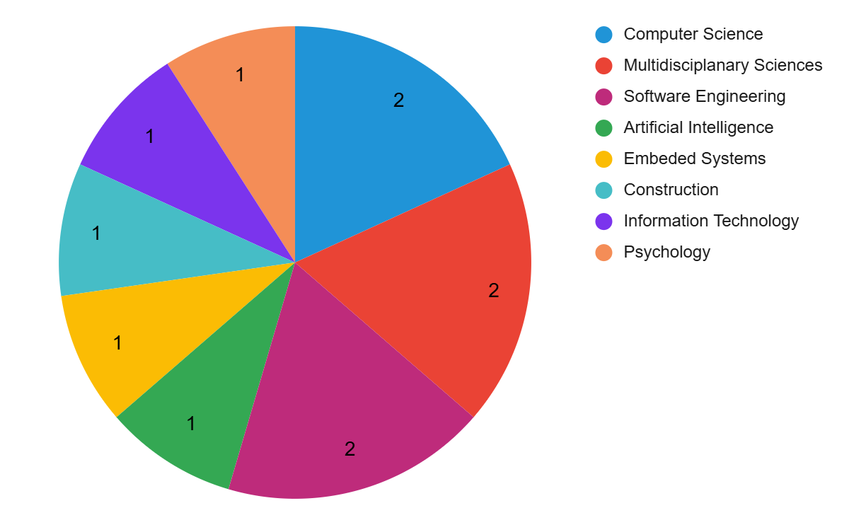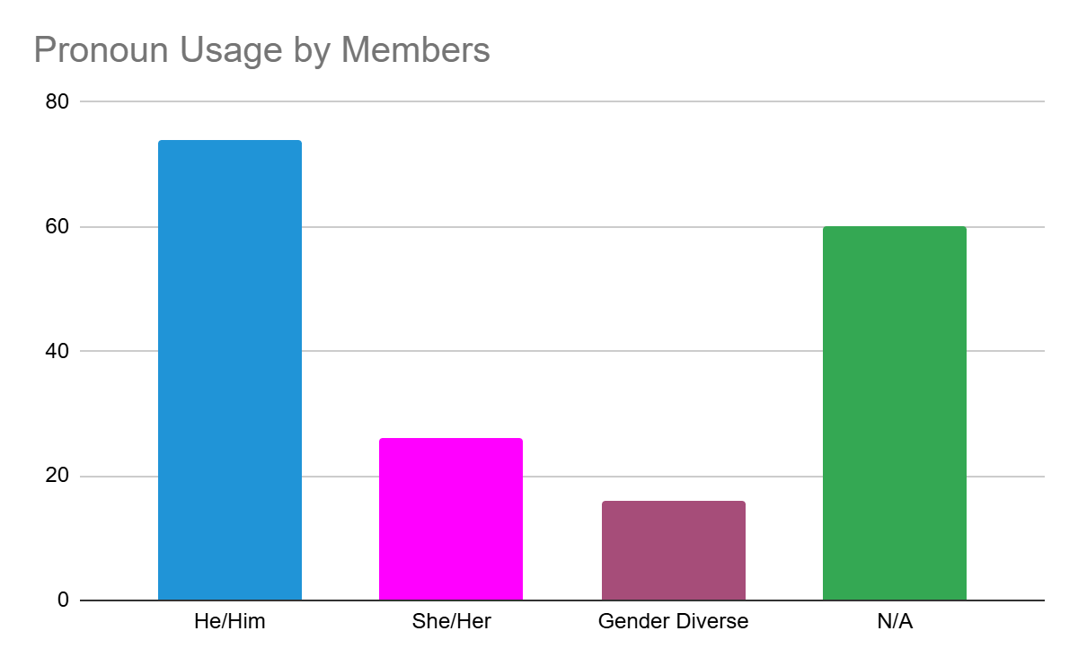

We held 27 general committee meetings and 2 executive committee meetings this year, meeting quorum for all meetings with a high attendance of around 85% for each meeting with most members who were not able to attend sending in their apologies in advance. Our committee structure once again continued similar to last year, but with the additional executive roles of Marketing Administrator and Events Administrator, the responsibilities were primarily on those roles rather than on sub-committees.

The significant decisions made this including the modification of our general committee, with Rhys, Devlin and Claire removed as general committee members and Caitlin, Angus and Connor added as general committee members. Other decisions included collaborating with the UWA Robotics Club for Hackathon and the Curtin Engineers Club on Ready Steady Build which turned out to be very successful. We voted to do a Bunnings BBQ as a fund raiser this year but unfortunately with our commitments this fell through. The club also decided to send 30 robotics kits to high schools in Papua New Guinea halfway through the year and have agreed to send another 30 over the summer holidays. And for events yet to occur, the club has agreed to receive a robotic dog as a donation from a club member and to attend Robopalooza this weekend.

My main recommendation for next year is to plan events early like we have the last few years. We did that this year and it led to a lot of success, with most of our events being locked in prior to the commencement of each semester. Another recommendation is to maintain scope of everything we do. This year we had some really great events and projects and the club ran really well with a few things run and organised quite poorly. Because of this it may be beneficial to cut back on the scope of the club in a few places, whether that's the number of events or how large our events are, to allow us to focus on a high quality rather than quantity. My final recommendation is just to maintain a paper trail regarding apologies for meeting absence. If people cannot attend an event or meeting it would be beneficial for that information to be sent through an official channel rather than word of mouth so everyone is informed.