Meeting Subject: Student Club Committee Meeting
Meeting Date: 5/02/2024 1:00 PM
Location: Boardroom 613.425
Link to Outlook Item: click here
Invitation Message
Participants
Emad Al-Hemyari (Student) (Meeting Organizer)
Leander Erbe King (Student)
Rajanayake Mudiyanselage Aruni Nilupa Rajanayake (Student)
Nikita Beloborodov (Student)
Boardroom 613.425 (Accepted in Outlook)

Agenda
- Introduce committee members and roles.
- Guild tasks for 2024 registration of guild club
- Guild tasks for club onboarding
- Affiliations, collaborations and potential activities
- Discussion of membership
- Discussing finances (ABN and bank account)
- Outreach events at Curtin:
  - O-day
  - SAE 1st year Expo
  - High level discussion of potential events
- Sponsors
- Volunteers
- Slides with details
- Guild training

Minutes
- This was the first face-to-face meeting to be held in 2024, all committee members were reintroduced and roles were discussed.
- 2024 registration of guild club
  - Formal decision on bank account signatories:
    - All committee collectively agreed to authorise the opening of the bank account with the President and Treasurer as signatories.
- Affiliations - student sections reactivation
  - SEG 2023 report submitted on 30 Jan 2024 to reactivate the chapter
  - EAGE Chapter establishment application was submitted on 31 Jan 2023
- Potential collaborations
  - ASEG WA branch is keen to be involved
  - IADC YP expressed interest in collaborating
- Discussion of membership
  - Membership is set to be free for all members to encourage participation and expand the outreach to a wider range of students.
- ABN was created for "Curtin Geoscientists and Engineers Club" on 31 Jan 2024
  - ABN: 81691062408
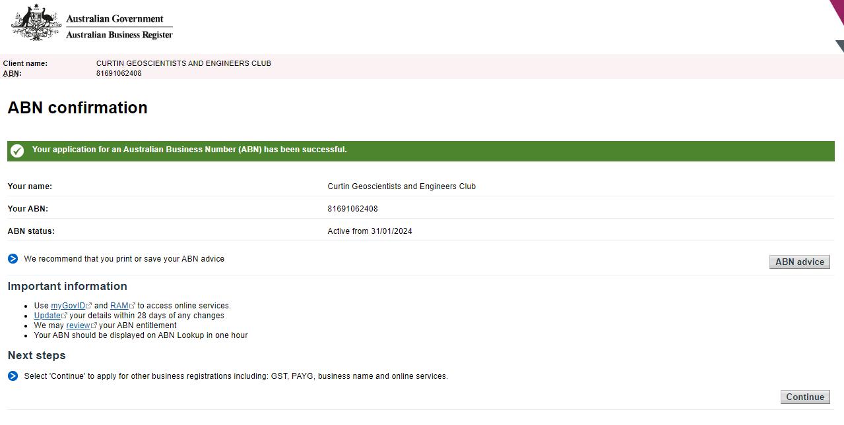
- New Task Comment on Finances - Review Settings in Registration Update 2024
  - Bank appointment (preferably Commonwealth bank):
  - All intended signatories to arrange a meeting with the new bank to open the club account (a Society Cheque Account. To help you prepare for your meeting with the bank, follow these steps and bring the following to your meeting:
    - a copy of the meeting minutes showing the formal decision was made to open the account & intended signatories
    - Signatories to bring valid ID.
    - Request an Opening Statement showing: Club Account Name (Curtin Geoscientists & Engineers Club), bank account number & BSB and opening balance (which will likely be zero unless you deposit cash while you're there.
- Outreach events at Curtin:
  - O-day participation subject to completion of Guild onboarding and 2024 registration tasks:
    - Registration form was filled after the deadline through a phone request on 31 Jan 2024.
    - Nikita & Emad will represent the club
  - SAE 1st year Expo:
    - Expression of interest was submitted via email on 5 Feb 2024
    - Leander & Emad will represent the club
- High level discussion of potential events
  - SEG Asia Pacific is keen on discussing potential activities and support
- Sponsors
  - President and VP to work on an invitation letter to sponsors with few sponsorship packages
  - Include benefits to sponsors and student members
- Volunteers
  - A suggestion was made to collect a list for volunteers when holding activities like O-day, etc.
- Secretary and President to work together on updating the club info slides
- All committee members were encouraged to take part in the mandatory Guild training and seek information on online training if they can't attend.

Actions
- Treasurer and President to arrange for bank account opening before 15 Feb 2024
- President and VP to work on sponsorship packages
- All committee members to look out and recruit student volunteers for upcoming events
- President to prepare materials for upcoming exhibitions
- President and Secretary to work on club information slides
- President to share gmail account details

