123456-XX-00000-XXXXX-001
Revision Number A

Orange Mountain Bike Club
Glenwood Forest Precinct

5-Year Trail Development Strategy (2026-2031)
May 2026
May 2, 2026

Revision Status
Revision | Date | Description | Author |  | Approver
Revision | Date | Description | Name | Position Title | Name | Position Title
A | 2ND May 2026 | Draft for review at Club AGM | Campbell Haines | Vice President

Table of Contents
1 Plan Purpose 4
2 Plan Objectives 4
3 Glenwood Precinct Vision: 2026 – 2031 4
4 Glenwood Precinct Objectives: 2026 – 2031 5
5 Strategy Implementation 5
5.1 Trail Growth 5
5.1.1 East Boree Creek Expansion 6
5.1.2 West Boree Creek 6
5.2 Event development 6
5.3 Rider skills and participation 7
5.4 Event centre and supporting infrastructure 7
5.5 Funding and commercial sustainability 7
5.6 Stakeholders and engagement 8
5.7 Maintenance and stewardship 9
6 Implementation Roadmap 9
7 Strategy document items (deliverables register) 10

No table of figures entries found.
Figure 1 - Glenwood Precinct Plan, 2026-2031 6

No table of figures entries found.

Plan Purpose
This plan seeks to define the strategy (“Strategy”) to set out Orange Mountain Bike Club’s (OMBC) priorities for trail, event, skills and supporting infrastructure development within the Glenwood Forest precinct over the next five years (2026–2031).
The plan is intended to align volunteer effort, funding applications and stakeholder engagement within a working forest context, while reducing over-reliance on any single trail and building a sustainable maintenance model for the network.

Plan Objectives
This plan provides a concise, shared direction for developing trails, events, rider skills and supporting infrastructure within Glenwood Forest. It is intended for use by OMBC, land managers and key partners as the reference point for prioritisation, funding bids and annual work programs.
The objectives of the plan are to:
- Provide a concise summary of trail development, event development and rider skills development objectives within Glenwood trails
- Inform key stakeholders of the clubs intentions within Glenwood over the next 5 years
- Provide strategic pillars to focus club efforts over the medium term

Glenwood Precinct Vision: 2026 – 2031
Over the next five years, OMBC aims to elevate Glenwood Forest to a nationally recognised mountain bike destination by delivering event-ready cross-country, downhill and enduro offerings, strengthening rider development pathways, and investing in a resilient ‘hub and spoke’ precinct centred on the event centre located on Boree creek (33°19'51.43"S 148°57'03.40"E).
A key outcome is to diversify rider engagement so the precinct is less reliant on any single marquee trail, while establishing a sustainable maintenance model (paid and volunteer) that keeps the network safe, rideable and compliant within a working forest environment.
The guiding principles that the club rely on to support the vision are;
- Sustainability: build and maintain trails to minimise erosion, manage water, and reduce whole-of-life costs, consistent with recognised trail guidelines.
- Safety and risk management: clear trail difficulty grading, signage, event risk controls and incident response planning.
- Quality riding experiences: purpose-built trails that match terrain, deliver flow, and provide variety across user groups.
- Inclusivity and access: provide options for juniors, new riders, adaptive riders and visitors, with supportive skills facilities and information.
- Partnership: proactive, transparent engagement with Forestry Corporation of NSW, Orange City Council, Cabonne City Council and AusCycling and the community.

Glenwood Precinct Context

Glenwood State Forest is located approximately 15 km west of Orange and is predominantly a radiata pine plantation adjacent to the Mount Canobolas Conservation Area. OMBC operates dedicated mountain bike trails within the forest under an access permit arrangement with Forestry Corporation of NSW. The precinct includes an established event centre and a growing network of trails that must co-exist with forestry operations, including harvesting, haulage and exclusion zones that can cause temporary closures and re-routing. Safety is non-negotiable, OMBC supports and enforces all closure, exclusion zone and signage requirements during forestry operations.

Glenwood Precinct Objectives: 2026 – 2031
There are four defined objective pillars within the current five year plan.
- Event Hosting: Annually deliver at least one AusCycling gold level event. Annually deliver an inclusive participation event, nominally ‘Juice Jam’.
- Hub & Spoke Model: Develop the existing event centre into a central hub with appropriate support infrastructure, including water, shade, and secure club asset storage.
- Rider Engagement: Diversify the network to reduce reliance on TOA by adding intermediate (Blue) and advanced (Black) progression trails west of Mitchell’s Way.
- Sustainability: Establish a maintenance strategy combining paid contractor services (e.g., Iconic Trails) and volunteer "dig days." Raise at least 50,000 AUD per annum for paid professional trail maintenance.

Strategy Implementation

SWOT Analysis
The following SWOT analysis guides this strategy:

Strengths | Weaknesses
- Excellent terrain with significant vertical drop (~400m).  - Engaged club with >$500k raised for development.  - Proven track record hosting state/national downhill and enduro races since 2023.  - Existing purpose-built gravity event centre. | - Harvest cycles limit established forest access.  - High maintenance costs due to strong weed growth.  - Single point of failure: heavy reliance on the "Trail of Awesomeness" (TOA).  - Lack of infrastructure at the event centre (water, storage, shade).
Opportunities | Threats
- Ongoing funding requests for infrastructure.  - Strong club balance sheet as of 2025.  - Development of XCO loops for national events.  - Proposed new trails between Boree Rd and Mitchells Way.  - FCNSW logging finishing in 2025, providing 10Y of uninterrupted riding. | - Forestry Corporation lease up for renewal (2026).  - Potential negative views from FCNSW due to unauthorized trail use during logging.  - No defined long-term revenue stream for maintenance.  - TOA trailhead remains at risk of logging in the next 5 years.

Trail Growth
Trail growth supports delivering on all precinct objectives. Growth must be sustainable first and foremost, with trail growth targeting on diversifying the network to reduce reliance on TOA. Interaction with forestry during harvesting will become unsustainable if the trails remain constrained to West Boree Creek. Diversification to the precinct east of boree creek is essential for a continued sustainable relationship between OMBC and forestry corporation of NSW (Figure 1). Trail growth will be guided by the following principles;
- Network planning: confirm a concept plan showing the ‘hub and spoke’ structure, primary climb routes, gravity corridors, and cross-country (XCO) loops.
- Trail diversity: deliver a mix of green/blue progression trails, gravity/enduro stages, and all-weather connectors to spread rider load.
- Introduce XCO capability: design and build a modular XCO loops (short/medium/long) suitable for state-level events with a pathway to national-level hosting.
- Adaptive and inclusive options: identify and formalise at least one adaptive-suitable loop (where feasible) with appropriate trail characteristics and information.
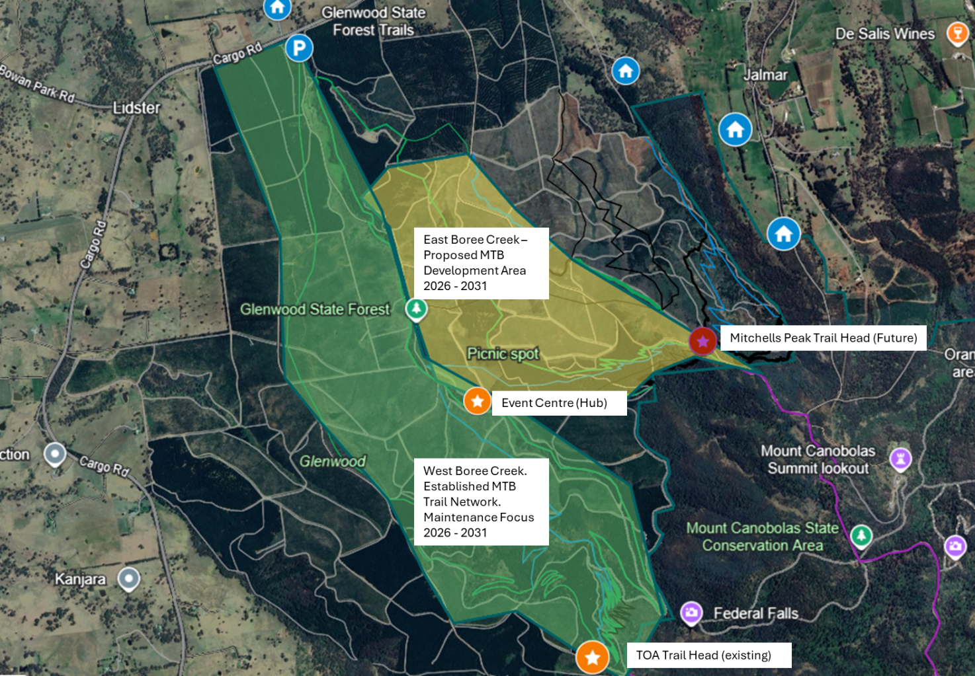
Figure 1 - Glenwood Precinct Plan, 2026-2031

East Boree Creek Expansion
Focus construction between Boree Rd and Mitchells Way in blocks logged in 2024-2025. Trail development will focus on network balance (beginner to advanced), route redundancy, and event-ready loops. A priority is to reduce over-reliance on Trail of Awesomeness (TOA) by creating alternative signature experiences and multiple access options so closures in one area do not shut down the precinct.

West Boree Creek
Focus on the existing trail network will be upon maintenance, within limited growth objectives. This is driven by the already 30km of established trails built over the period 2021 – 2025. Forestry corporation of NSW are expected to close the trail head area to perform harvesting within the period of this plan. This will significantly impact the trail network. The club objective is to provide an alternative trail network which is east of boree creek within the period of this plan.

Event development
Event development will be planned as a pathway: grow reliable annual local events, maintain a calendar of state/national-level gravity races, and progressively develop the venue, course options and operations capability to bid for national-level XCO and enduro events.
- Develop an annual local event (Juice Jam) as the key club fund raising initiative. Target delivery on the October long week end annually.
- Develop an event-ready XCO venue configuration (course, marshalling, timing/logistics, medical access, spectator areas) and submit at least one bid to host a National XC event within the strategy period.
- Maintain and expand enduro stage options and submit a bid pathway for a National Enduro within the strategy period.
- Establish standard operating procedures (SOPs) for event delivery, including stakeholder notifications, forestry interface, traffic management, and environmental controls.
- Obtain club owned SI timing infrastructure to facilitate club run events.

Rider skills and participation
- Progression: provide a clear on-ground progression from beginner loops and skills features to intermediate trails and advanced gravity riding.
- Programs: build a repeatable annual program (juniors, women’s rides, skills clinics, volunteer trail days) with trained ride leaders and safety controls. Focus on Juice Jam as the key delivery pathway
- Information: improve wayfinding, difficulty grading and online trail information so visitors can self-select appropriately.

Event centre and supporting infrastructure
Infrastructure investment will prioritise the event centre as the hub for trail access and event operations, including amenities that improve safety, comfort and event capability.
Essential supporting infrastructure:
- Storage: secure club storage for tools, signage, timing equipment and event assets – [scope/cost to be defined].
- Wayfinding and safety: trailhead information, emergency location signage, and consistent trail difficulty markers.
- Access and parking: manage vehicle movement, shuttle routes (where used), and event-day traffic arrangements with land manager requirements.

Preferrable supporting infrastructure:

- Water: potable water supply at the event centre (temporary and permanent options) – [scope/cost to be defined].
- Shade / shelter: all-weather shade structures for registration, marshalling and recovery – [scope/cost to be defined].
- Facilities: toilets (portable-to-permanent pathway), waste management, and accessibility considerations – [scope/cost to be defined].

Funding and commercial sustainability
- Grants: maintain a rolling 12–24 month pipeline of grant applications for trails and infrastructure, aligned to the staged roadmap. Aggressively pursue Office of Sport Regional Sport Facility Funds and Council Sports Facility Partnership Programs
- Sponsorship: package sponsorship opportunities tied to club, events, trail adoption and infrastructure assets. Build on event packages developed for the 2025 National Downhill.
- Maintenance funding: establish a defined revenue stream to fund baseline maintenance (e.g., membership allocation, event surplus, sponsorship allocation, donations) and a policy for when paid contractors are used. Reinvest surpluses from state and national rounds into the ongoing maintenance fund.
- Asset lifecycle: maintain an asset register (tools, signage, structures) and a renewal plan to avoid “boom-bust” replacement costs.

Stakeholders and engagement
Key stakeholders include riders and volunteers, OMBC committee, Forestry Corporation of NSW, NSW Rural Fire Service, AusCycling, Orange City Council and other relevant councils, and NSW National Parks & Wildlife Service (as applicable to adjacent lands).
- Land manager relationship: scheduled annual check-ins of the club executive with Forestry Corporation of NSW representatives. Maintain an operational connection to Forestry through the club ‘trails manager’ to facilitate pre-works approvals and post-works close-out for each project/event.
- Operational communications: clear and timely rider communications regarding closures, exclusion zones and alternative routes, consistent with land manager requirements.
- Club Community: Foster a club culture built on engagement and participation through an ongoing program on events, social rides, ‘dig days’ and volunteer rewards programs.
- Partners: maintain alignment with AusCycling requirements and calendars for events and officiating needs.

Stakeholder | Engagement Goal
Club Members | Positive club relationship. Support club events through race entry and/or volunteer efforts. Renewed AusCycling membership
General public (Riders/Walkers/Trail runners) | Positive experience within the Glenwood forest trail precinct
Forestry Corporation NSW (FCNSW) | Lease renewal (December 2026) and harvest cycle alignment.
NPWS | Access and boundary management for State Conservation Areas.
Local Council (Orange & Cabonne) | Infrastructure grants and access road maintenance (Mitchells Way).
AusCycling | Event sanctioning, insurance, and national/state series alignment.
RFS & Emergency Services | Fire safety signage and maintenance of emergency locating points.

Maintenance and stewardship
A sustainable maintenance strategy is essential to protect prior investment and keep trails open. OMBC will implement a planned maintenance model combining volunteer effort with paid trail services for high-priority works, peak growth periods (post-harvest regrowth), and specialist tasks. All trail maintenance will be performed in strict compliance with the Report on Environmental Factors (REF).
The maintenance strategy is to;

- Restore: 10km of trail annually, prioritizing machine-built flow sections to meet high user expectations.
- Vegetation Management: Bi-annual clearing of 20km corridors, utilizing cost-effective trimming combined with licensed herbicide application where approved by FCNSW.
- Directed Volunteer efforts: managed through routine, planned ‘Dig Days’ performed within the precinct under the direction of the trails manager of their delegate.
- Undirected Volunteer efforts: Create a methodology for safe, controlled maintenance within the trail network. Focused on vegetation management. Provide the knowledge, tools and procedures to an approved list of persons known to the club so that they are endorse to conduct safe vegetation control outside of directed efforts on behalf of OMBC.
- Roads: Amend access agreement with Forestry Corporation of NSW to include annual grading of key arterial roads used by club members. Including as a minimum the following roads within the areas marked in Figure 1;
  - Alf Meyers Way
  - Boree Road
  - Federal Falls Road
  - Mitchells Way
  - Old Goat Road

Implementation Roadmap

Year | Primary focus and key actions
Year 1  (2026) | - Confirm lease renewal pathway with Forestry Corporation of NSW and refresh operating protocols.  - Complete concept plan, staging plan, and trail classification register for East Boree Precinct. Lobby local council and state members to support grant submissions and funding.  - Define baseline maintenance program and budget; trial paid/volunteer blended model.  - Scope event centre infrastructure packages (water/shade/toilets/storage) for grant submissions.  - Design XCO loop options and identify required upgrades for state-level hosting.
Year 2  (2027) | - Deliver first staged trail expansions to diversify riding options and reduce TOA dependence (based on funding success)  - Implement priority infrastructure works (based on funding success).  - Run an enhanced calendar of local events and at least one state-level target event.
Year 3  (2028) | - Complete XCO course build-out to a national-ready standard (course flexibility, logistics, spectator experience).  - Expand enduro stage options and refine shuttle/traffic plans.  - Submit bids for national-level events (XCO and/or enduro) aligned to AusCycling calendars.  - Review maintenance model and increase contractor use where volunteer capacity is insufficient.
Year 4  (2029) | - Deliver next-stage trail links/loops and redundancy routes to maintain continuity during forestry works.  - Consolidate infrastructure to support multi-day events (operations areas, storage, signage).  - Host a major XCO event (state or national) and/or enduro national event and conduct a full post-event review.
Year 5  (2030) | - Achieve ‘steady-state’ operations: routine maintenance funding, stable volunteer program, and regular event calendar.  - Confirm next 5-year strategy based on performance, forest operations outlook, and community needs.  - Update all controlled documents and re-baseline the concept plan.

Strategy document items (deliverables register)
The following document items are required to support implementation of this Strategy. These may exist as separate documents or controlled appendices to this Strategy.

Item | Description | Owner | Target timing
Trail network concept plan | Map-based ‘hub and spoke’ network plan showing proposed trails, classifications, access points and staging. Estimated cost based on historical pricing. | OMBC Trails Manager (Jack) | Year 1
Trail classification & naming register | List of trails, difficulty grade, intended users, key features, and naming conventions. | OMBC Trails Manager (Jack) | Year 1
Maintenance plan | Inspection cadence, seasonal work program, volunteer/contractor split, and annual budget. | OMBC Trails Manager (Jack) | Year 1 (then annual refresh)
Undirected Maintenance Facilities | SOPS, Training, approval tracking | OMBC VP? | Year 1 - 2
Event development plan | Event pathway, calendar, operational SOPs, and venue requirement and define revenue stream for maintenance. | OMBC Sec. ? | Year 1–2
Event centre infrastructure plan | Scope options for SI timing equipment, water, shade, toilets, storage, parking/traffic and signage. | OMBC VP? | Year 1
Funding strategy | Grant pipeline, event sponsorship packages. Seek local council direct funding. | ??? | Year 1 (then quarterly review)
Grant Submissions for East Boree Precinct | Grant writing and submissions based on trail network concept plan |  | Year 2
Stakeholder map & engagement plan | Stakeholder list, objectives, contact cadence, and communications templates (closures, works, events). Active networking with MP’s | OMBC Pres? | Year 1
Working forest (harvest cycle) interface plan | Harvest cycle map, known constraints, contingency riding/maintenance plans, and approval workflow. | OMBC Trails Manager | Year 1–2 (update as required)
Risk register | Key risks, controls, responsibilities and review frequency. | OMBC Committee | Year 1 (then 6-monthly)
Monitoring | Measures for trail condition, usage, volunteer hours, incidents, and financial sustainability. | OMBC Sec. ? | Year 2

