July Financial Report
Expected incoming – fees for the summer season & uniforms
Expected outgoings – Winter Windup costs

2025 winter FIFO players (not available for CSA, Fri ladies & VETS)
Listd FIFO players:
Div 5 – Blake Horsley
Div 6 – Nil
Div 8 – David (Ra) Mosen, Lindsay Davies
Full time player conversion completed recently – Marc Hooper, Rhys Beattie, Nathan Wooders, Blake Wojcicki

2025/26 KidSport – Voucher due for Summer:
Bella Wooders – $140 owing for summer (Fri Nights)
Shaela Wooders – $140 owing for summer (Fri Nights)

See other page for breakdown

All Kidsport funded for the winter season

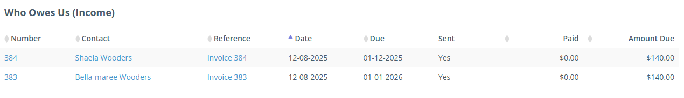

See attached reports for the monthly accounts.
July Financial Overview 01/07/2025 – 31/07/2025

