November Financial Report
Expected incoming – fees for the summer season & uniforms
Expected outgoings – SEMSA Team affiliation costs
24/25 Tax Return – completed in October (see attached report)
2025/26 KidSport – Voucher due for Summer:
All Kidsport funded for the summer season

2025 summer FIFO players (not available for CSA, Fri ladies & VETS)
As mentioned this is an area that I’ll keep on the summary sheet to keep an eye on player and game numbers (as it’s not automatically picked up on the website). Listed FIFO players:
SEMSA C Grade – Hilda Muncey, Rachel Rawlins, Jocelyn Whitmore
SEMSA B Grade – Janie Aryes, Lilly Baldwin, Kelli Scari
Full time player conversion completed recently – Gemma Bratley, Amber Beattie, Shari Hibbitt-Murray, Gabby Hooper

Proposed Fees for 2026 going forward (decided in Sept committee meeting) :
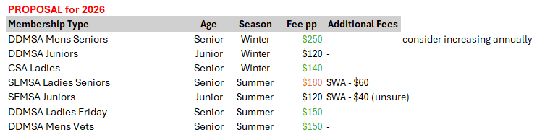

Credits & Payment Plans
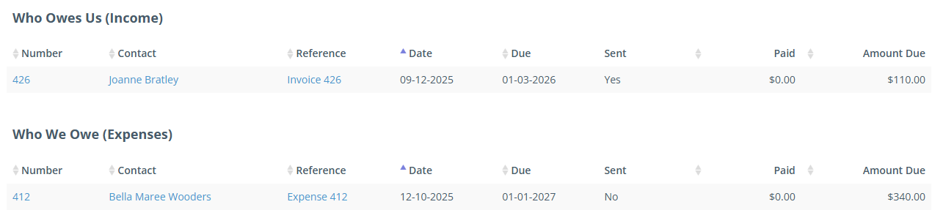

See attached reports for the monthly accounts.

November Financial Overview 01/11/2025 – 30/11/2025
