September Financial Report

Expected incoming – fees for the summer season & uniforms
Expected outgoings – Winter Windup costs & Team affiliation costs

2025/26 KidSport – Voucher due for Summer:
Recently paid - Bella Wooders & Shaela Wooders
All Kidsport funded for the summer season

Proposed Fees for 2026 going forward (decided in Sept committee meeting) :
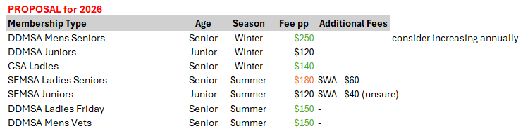

See attached reports for the monthly accounts.

Sept Financial Overview 01/09/2025 – 30/09/2025
