August Financial Report
Expected incoming – fees for the summer season & uniforms
Expected outgoings – Winter Windup costs & Team affiliation costs

2025 winter FIFO players (not available for CSA, Fri ladies & VETS)
Listd FIFO players:
Div 5 – Blake Horsley – 9 games played (Paid)
Div 6 – Nil
Div 8 – David (Ra) Mosen, Lindsay Davies

2025/26 KidSport – Voucher due for Summer:
Bella Wooders – $140 owing for summer (Fri Nights)
Shaela Wooders – $140 owing for summer (Fri Nights)

Vouchers submitted to Kidsport, awaiting payments to bank account. See other page for breakdown

All Kidsport funded for the winter season

Membership fee review
As it’s the close to the 2025 winter season, I’d like to conduct a membership fee review to ensure our expenses are not exceeding the estimate per player costing. This is a good time to review next year’s fee before registration time in 2026.
Breakdown is on the appendix of this report.

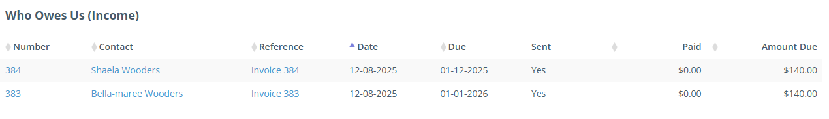

See attached reports for the monthly accounts.
August Financial Overview 01/08/2025 – 31/08/2025

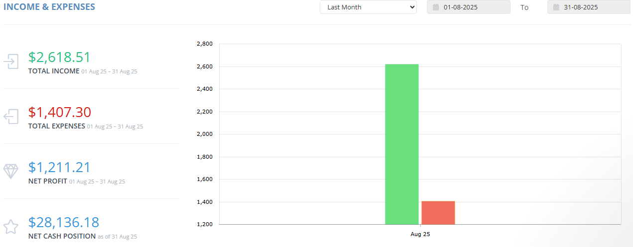
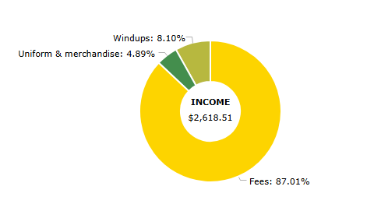
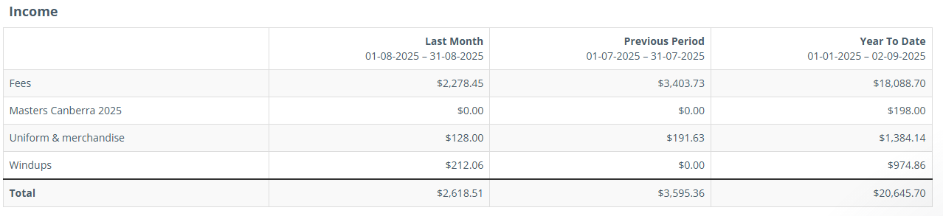
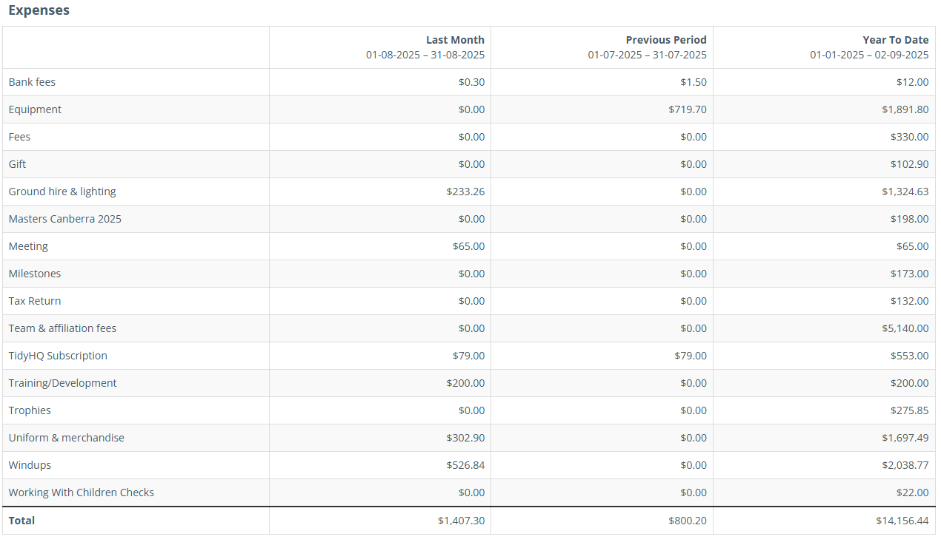

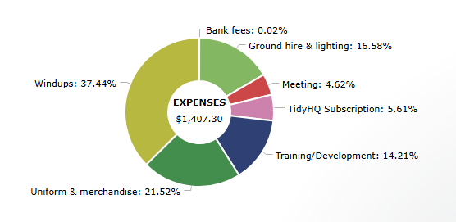

Membership Fees & Club Costings
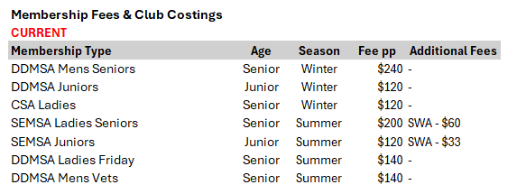
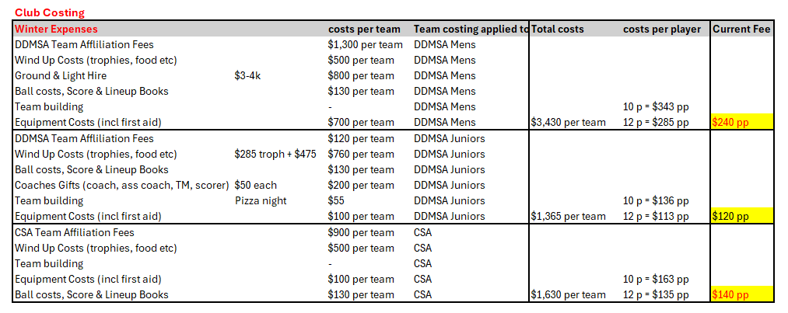
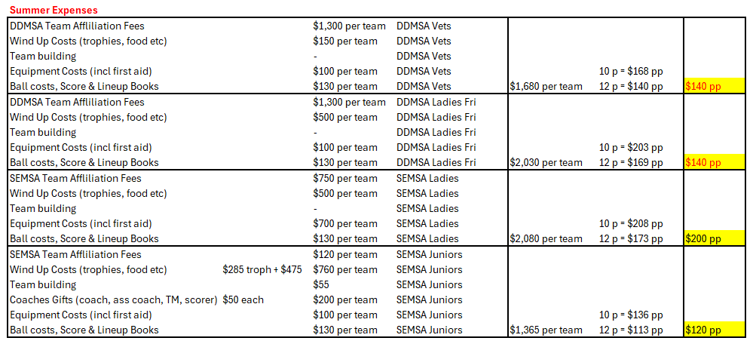

Proposed Fees for 2026 going forward:
