June Financial Report
Expected incoming – fees for the summer season & uniforms
Expected outgoings – N/A

2025 winter FIFO players (not available for CSA, Fri ladies & VETS)
Listd FIFO players:
Div 5 – Nathan Wooders (pending payment in july), Blake Horsley
Div 6 – Blake Wojcicki (pending payment in july)
Div 8 – David (Ra) Mosen, Lindsay Davies
Full time player conversion completed recently – Marc Hooper, Rhys Beattie

2025 KidSport – Voucher due:
Jaxon Wooders - $110 owing for winter (applied in July, pending payment)
Ky Thompson - $120 outstanding for winter (no voucher registered)
Ricco Thompson - $120 outstanding for winter (no voucher registered)
Bella Wooders – $159 owing for summer (applied in July, pending payment)

See other page for breakdown

Kidsport recently funded for the winter season – Shaela Wooders, Jye Gossage, Jaxon Wooders, Bella Wooders, Reagan Draper, Logan Draper, Hunter Draper.

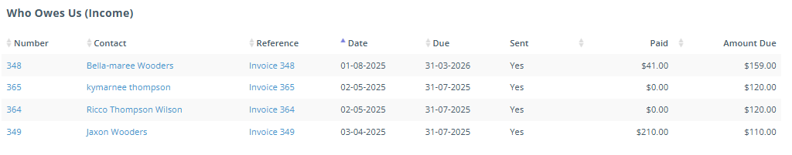

See attached reports for the monthly accounts.
June Financial Overview 01/6/2025 – 30/6/2025
