Seattle Pups and Handlers  1122 E Pike St. #693  Seattle, WA 98122  Sponsors@seapah.org | 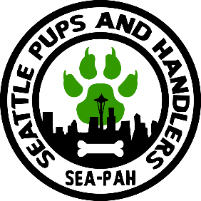

Greetings,

I am with Seattle Pups and Handlers (SEA-PAH) and I am reaching out to you in regards to an exciting sponsorship opportunity for 2023. This year, SEA-PAH is proud to be hosting their 6th Camp K9 (August 24-27th) which has grown to be our largest fundraising event drawing 150+ attendees from all over the world.

In the previous year with the help of our sponsors we were able to raise $2,105.00 for our beneficiary Lambert House at Camp K9. That money helped supply meals, counselors, and safe spaces for peer to peer support groups to help each other. We are proud and excited to have the Lambert House back this year as our beneficiary.

The Lambert House offers a safe place for lesbian, gay, bisexual, transgender, and questioning (LGBTQ) youth ages 11-22. For more information please check out their website. http://www.lamberthouse.org

We hope you will consider becoming a sponsor with us this year. In the past, sponsors have shown support with cash donations, merchandise, and gift cards. The physical items are raffled off at Camp K9. This opportunity would give your brand exposure to a large community. No donation is too small or too large. We want the community to know your efforts to help those in need.

The benefits of Sponsorship will include:
- Your company logo will be featured prominently on our event website.
- Printed posters and online advertisements for the event will reach over 1000 folks easily within our local and extended community.
- Additionally, your company will be publicly thanked during the event, the raffle, and any other announcements.
- We will also display your logo on our sponsorship table.
- Any additional marketing material will be provided to the attendees at the event.
If you decide to benefit the lambert house and become a sponsor
- We will need a reply from you no later than June 1st with the logo you would like us to include in our fliers.
- A list of what items and value of the items. *Washington state Law requires us to have a posted list at the raffle.
- If items are being mailed out, please have them in the mail by July 1st
- I will supply you with the mailing address once you accept.
- If items are being picked up locally, we ask to have them by August 1st
- In the event Camp has to be canceled for any reason, your donation will still be used at a later date for the purpose of raising money for our beneficiary.

We appreciate your support and look forward to working with you. If you have any other questions or recommendations on how we can help the Lambert house please feel free to reach out directly.

Thank you and please feel free to let me know if you have any questions.

Nightcat
Honorary Founder of the Seattle Pups and Handlers
Sponsors@seapah.org
425-985-0977

