Q1 (Jan - March) (Unleashed – March) .
- Scarves (already in hand)
- Beanies (already in hand)

Q2 (Apr – June) .
- Tank tops or Crop top
- Hats / Leather Hat
- Pins

Q3 (July-Sept) (Camp K9 - Sept) .
- Camp K9 t-shirts (tie die @ pre-event) – preorders
- Camp K9 pins
- Camp K9 Hanky
- Plastic Water bottle (Gift?) – Paw prints
- Beach towel
- Frisbee
- Tie die kit - $1 per project (where is die being dump?)
- Rubber gloves / bands

Q4 (Oct - Dec) .
- Personalized ornaments (Glowforge - Sinn) - preorders
- Custom SEA-PAH wrapping paper with Santa Paws and puppy elves figures (maybe even some deer folk) - preorders
- Socks
- Thermos
- Stressball
- Leather wristband – NEW DESIGN

Personalized ornaments
- Sinn makes at home
- Cost to make = $ 3.00
Sell for = $12.00
Profit = $ 9.00
- Can do bulk for packs: 4 for $40 ($10 ea cost, $28 profit)
- Online pre-orders only. Easy to set up customizable ordering experience on Tidy HQ so customer can choose pup or cat, select between paw, bone or doghouse and then enter the name.
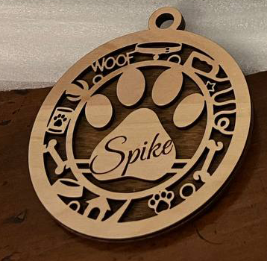
 |  |  | 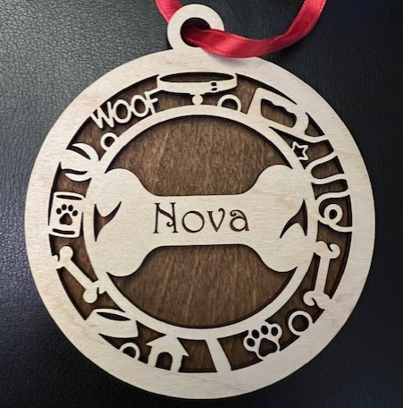 |  | 