SMART Goal for Men's Shed Pomona Social Media Strategy
Specific: Establish a dedicated social media presence to raise public awareness about Men's Shed Pomona, its activities, and community value.
Measurable: Grow the platform to at least 500 followers and achieve an average monthly engagement rate of 5% (likes, shares, comments) within the first 6 months.
Achievable: Develop and implement a content calendar with 3 posts per week (educational, event-related, behind-the-scenes), collaborate with local community pages, and use targeted hashtags to increase visibility.
Relevant: This goal supports the broader mission of Men's Shed Pomona to foster social connection, mental health, and community involvement among men, particularly retirees and seniors.
Time-bound: Launch the social media platform within 4 weeks and achieve awareness targets (followers + engagement) within 6 months.

Final SMART Goal:
"Within 6 months, establish and grow a social media presence for Men's Shed Pomona, reaching at least 500 followers and a 5% monthly engagement rate by posting 3 times per week, collaborating with local groups, and using targeted strategies to raise public awareness."

Content Pillars
:

“What We Do” – Projects & Activities Spotlight
Purpose: Show the practical, hands-on work happening at Men’s Shed Pomona.
Content Ideas:
- Weekly “Workbench Wednesday” posts showing current projects.
- Before-and-after photos of restoration or woodworking projects.
- Time-lapse videos of builds or repairs.
- Member-led tutorials or quick tips (“How to use a lathe,” etc.).
Why it matters: Builds credibility, showcases skills, and appeals to funders by demonstrating productivity and impact.

“Why We Exist” – Human Stories & Community Impact
Purpose: Highlight the emotional and social impact of Men’s Shed on individuals and the broader community.
Content Ideas:
- Member spotlights with short interviews or testimonials.
- Stories of transformation, mental health benefits, or friendship.
- Posts showing community partnerships or outreach.
- Quotes or anecdotes from visitors or family members.
Why it matters: Helps donors and the public understand the deeper social mission — fostering mental health, connection, and purpose.

“Looking Ahead” – Vision, Goals & Events
Purpose: Keep your audience informed and excited about the shed’s direction and future.
Content Ideas:
- Sneak peeks of upcoming projects or plans.
- Fundraising goals or equipment wish lists.
- Announcements of upcoming events, workshops, or open days.
- Posts that invite community input or collaboration (polls, questions).
Why it matters: Shows transparency, forward thinking, and invites others to get involved — great for donor engagement and building momentum.

“Shed in the Community” – Partnerships & Local Engagement
Purpose: Demonstrate how Men’s Shed Pomona is part of and contributes to the wider community.
Content Ideas:
- Collaborations with schools, local councils, or other sheds.
- Photos from community events, markets, or expos.
- Volunteer shoutouts and sponsor thank-yous.
- Shared posts from local partners or community groups.
Why it matters: Builds local pride and awareness, encourages partnerships, and shows that you're active and relevant.

🔁 BONUS TIP: Rotate these pillars consistently
Post 1–2 times per week from different pillars. For example:
- Monday: Project update (“What We Do”)
- Thursday: Member spotlight (“Why We Exist”)
- Next week: Event teaser (“Looking Ahead”)
- Following week: Partner post (“Shed in the Community”)
Would you like help turning these into a sample content calendar or creating a few starter post captions?

Content Ideas for Pillars

“What We Do” – Projects & Activities Spotlight
These posts show your shed’s hands-on work and daily activities, making it clear what Men’s Shed Pomona actually does.
- Before & After Photos of recent woodworking or restoration projects.
- Time-Lapse Video of a full build (e.g. garden bench or cubby house).
- “Tool of the Week” Feature: Highlight tools, how they’re used, and who’s using them.
- “Behind the Shed Door”: A visual tour of the workshop space.
- Mini Tutorial Video: How to fix a chair leg, use a lathe, or sand timber properly.
- Weekly Workbench Post: Showcase what the group is building every Wednesday.
- Throwback Project: Highlight a beloved past project and how it helped the community.
- Photo Series: “Hands at Work” – Close-ups of hands crafting, repairing, and building.
- Recycled Materials Spotlight: Projects built with repurposed materials.
- Mini Interviews with members explaining their role in a project (e.g. "I made the birdhouse because...").

“Why We Exist” – Human Stories & Community Impact
These ideas highlight mateship, mental health, and the personal value of being part of the Shed.
- Member Spotlight: Profile a member’s story, journey, and what the Shed means to them.
- “Why I Joined” Series: Short quotes from members explaining what brought them in.
- Testimonial Tuesday: Share quotes from families or mental health professionals.
- “What Mateship Means to Me”: Ask members to define mateship in their own words.
- “The Shed Saved Me” – Stories about improved wellbeing, purpose, or mental health.
- Video Diary: A day in the life of a Men’s Shed member.
- “Quiet Conversations” Post: Share how informal chats support mental health.
- Feature Post: Shed & Mental Health Week: Align with mental health awareness events.
- Birthday or Milestone Celebrations: Honour members and their time with the Shed.
- Post a Poem or Quote: Reflect on mateship or mental resilience, written or chosen by members.

“Looking Ahead” – Vision, Goals & Events
Use these ideas to build anticipation, attract support, and show direction.
- “Coming Soon” Teaser: Tease a new project or renovation.
- Event Countdown: Weekly posts leading up to an open day or fundraiser.
- Poll: “What Should We Build Next?” – Invite community input.
- Wishlist Wednesday: Share tools or materials the shed hopes to acquire (link to donate).
- “Meet the Future”: Introduce a new initiative, like youth outreach or a mental health workshop.
- Behind the Scenes Planning: Show prep work or planning meetings for future events.
- Infographic: Our 6-Month Plan: Simple visual roadmap of upcoming goals.
- Volunteer Call-Out: “We need a hand with…” – Ask for help and list skills needed.
- “How You Can Help”: Share specific ways locals and donors can support the shed.
- Grant/Funding Updates: Let donors know how money is used and what’s next.

“Shed in the Community” – Partnerships & Local Engagement
These posts connect your shed to the broader community and build relationships with donors, partners, and locals.
- Community Shoutout: Feature a local business or group that supports your Shed.
- “Built for [Community Group]”: Highlight a project made for another local org (e.g. school, library).
- Sponsor Thank You Post: Include logos, names, and how they helped.
- Photo Album: Community Event: Share images from local markets, expos, or open days.
- Joint Post with a Partner: e.g. Lions Club, Rotary, Bunnings – tag them and share impact.
- “Local Legends” Series: Feature community members who contribute to the shed or broader causes.
- Civic Collaboration: Share when working with local council or health services.
- Invite a School Group: Then post photos/stories from their visit to the shed.
- “Where Our Work Lives”: Photo of a shed-built item in use at a community location.
- Call for Partnerships: Ask other local orgs to collaborate with the Shed.
Would you like a content calendar template to help schedule and rotate these ideas effectively

6 Month Social Media Content Plan

Content Pillars:

What We Do –
Projects & Activities Spotlight
  - Before & After Photos of recent woodworking or restoration projects.
  - Time-Lapse Video of a full build (e.g. garden bench or cubby house).
  - Tool of the Week” Feature: Highlight tools, how they’re used, and who’s using them.
  - Behind the Shed Door”: A visual tour of the workshop space

Why We Exist – Human Stories & Community Impact
These ideas highlight mateship, mental health, and the personal value of being part of the Shed.
  - Member Spotlight: Profile a member’s story, journey, and what the Shed means to them.
  - “Why I Joined” Series: Short quotes from members explaining what brought them in.
  - Testimonial Tuesday: Share quotes from families or mental health professionals.
  - “What Mateship Means to Me”: Ask members to define mateship in their own words.

Looking Ahead” – Vision, Goals & Events
Use these ideas to build anticipation, attract support, and show direction.
  - “Coming Soon” Teaser: Tease a new project or renovation.
  - Event Countdown: Weekly posts leading up to an open day or fundraiser.
  - Poll: “What Should We Build Next?” – Invite community input.
  - Wishlist Wednesday: Share tools or materials the shed hopes to acquire (link to donate).

Shed in the Community” – Partnerships & Local Engagement
These posts connect your shed to the broader community and build relationships with donors, partners, and locals.
  - Community Shoutout: Feature a local business or group that supports your Shed.
  - “Built for [Community Group]”: Highlight a project made for another local org (e.g. school, library).
  - Sponsor Thank You Post: Include logos, names, and how they helped.
  - Photo Album: Community Event: Share images from local markets, expos, or open days.

Parameters
Audience: community members, local businesses, local education facilities, funding donors.
Time Commitment: I have 4 hours per week to dedicate to social media planning, creating, and posting.
Location: I am based in Queensland Australia, so please include relevant events, holidays, and seasonal trends specific to my region.
Additional Considerations: [Mention specifics like campaign periods, brand voice, industry requirements, or promotional goals]
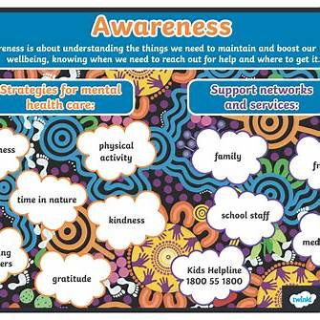
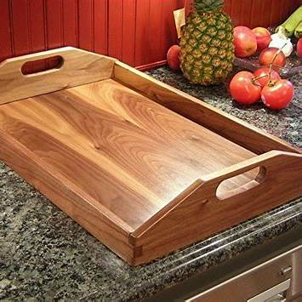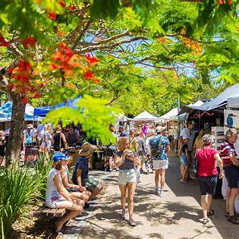
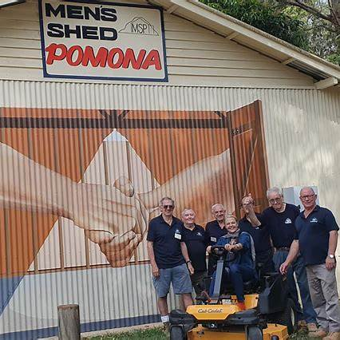
Here is a comprehensive 6-month social media content plan for Men’s Shed Pomona from January to June 2026, designed to achieve your SMART goal:

January 2026

Themes:
- New Year, New Beginnings
- Introduction to Men's Shed Pomona
- Goal Setting & Community Building

Special Dates:

- Home Brew Jazz Band Concert 2026 – Majestic Theatre, Pomona
https://www.trybooking.com/events/landing/1509564
Tickets are $25 for members and $30 for guests plus booking fee. Date. Thu 22 Jan 2026 1:00 PM - 3:30 PM
- Australia Day (26 January)

Weekly Breakdown:
- Week 1: Welcome post introducing Men's Shed Pomona, its mission, and upcoming activities. Share a video tour of the shed.
- Week 2: Highlight member stories focusing on personal growth and community impact. Post a motivational quote related to new beginnings.
- Week 3: Promote Australia Day event or activity, emphasizing community participation and cultural connection.
- Week 4: Share tips on setting achievable goals for mental health and skills development. Encourage followers to share their goals.

February 2026

Themes:
- Valentine’s Day & Self-Care
- Communication Skills
- Manual Skills Workshops
- Visitations and trips to places of interest

Special Dates:
- Valentine’s Day (14 February)
- Invite members of Cooroy Camphor Laurel Workshop to visit MSP (Date to be announced)
- 2nd Saturday morning tea (14/2/2026) – Member story (Rod MULDER)

Weekly Breakdown:
- Week 1: Post about the importance of self-care and mental health, linking to local resources.
- Week 2: Share communication tips and success stories from members improving their social skills.
- Week 3: Announce upcoming manual skills workshop, showcasing previous projects.
- Week 4: Celebrate Valentine’s Day with a message about community and connection, encouraging followers to share their stories.

March 2026

Themes:
- International Women’s Day (8 March)
- Spring Renewal & Growth
- Skills Showcase
- Visitations and trips to places of interest

Special Dates:
- International Women’s Day (8 March 2026)
- 2nd Saturday morning tea (14/3/2026) – Member story (Pat McKEOWN)
- Visit Cooroy Camphor Laurel Workshop (Date to be announced)

Weekly Breakdown:
- Week 1: Highlight the importance of gender inclusivity and community support.
- Week 2: Share spring-themed activities and mental health tips for seasonal change.
- Week 3: Feature member projects and skills developed during workshops.
- Week 4: Promote upcoming skills showcase event, inviting community participation.

April 2026

Themes:
- Autumn & Reflection
- Community Engagement

Special Dates:
- Easter (3-6 April)
- Visit Laminex Industries, Gympie (Date to be announced)
- ANZAC Day (25 April)
- 2nd Saturday morning tea (11/4/2026) – Member story (Mal HENMAN)

Weekly Breakdown:
- Week 1: As we celebrate Easter, may it bring renewed hope, peace, and happiness.
- Week 2: Post about ANZAC Day, honouring veterans and community resilience.
- Week 3: Highlight community projects and collaborations with local groups.
- Week 4: Encourage followers to participate in upcoming community events or volunteer opportunities.

May 2026

Themes:
- Men’s Health Awareness Month
- Mother’s Day (12 May)
- Skills & Hobbies

Special Dates:
- Labour Day (4 May)
- Mother’s Day (12 May)
- 2nd Saturday morning tea (9/5/2026) – Life Member story (Rudy MEYER)
- Invite members of Noosa Men’s Shed to MSP (Date to be announced)

Weekly Breakdown:
- Week 1: Launch Men’s Health Awareness Month campaign, sharing facts and resources.
- Week 2: Celebrate Mother’s Day with stories emphasizing family and community support.
- Week 3: Promote manual skills and hobbies, showcasing member projects.
- Week 4: Share success stories of mental health improvements and skill development.

June 2026

Themes:
- Winter Wellness & Mental Health
- Community Achievements
- End of Semester/Program Highlights

Special Dates:
- Mid-Year Review & Planning
- 2nd Saturday morning tea (13/6/2026) – Life Member story (Doug BETTENS)
- Visit Noosa Men’s Shed (Date to be announced)

Weekly Breakdown:
- Week 1: Focus on winter wellness tips and mental health strategies.
- Week 2: Share community achievements and milestones reached.
- Week 3: Highlight upcoming events and programs for the second half of the year.
- Week 4: Engage followers with feedback surveys and future planning ideas.

