South Eastern Multiple Birth Association
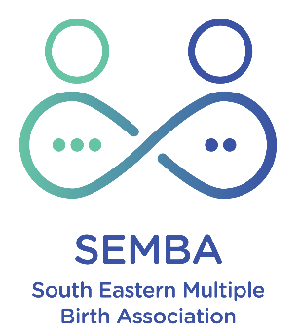

Annual Report 2025-26
Author: Anna Arkell, SEMBA President

SEMBA is a club affiliated with AMBA
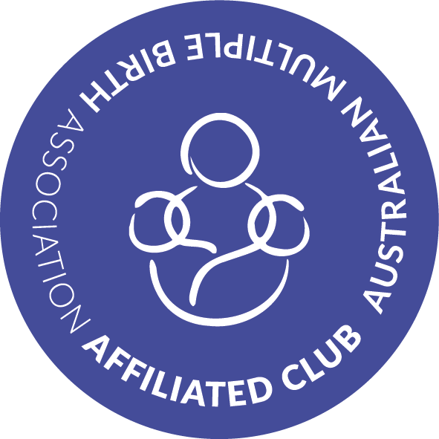

Content
Background 3
Executive summary 3
Committee 4
Finances/Treasurer’s report 6
Membership 7
Communication and social media 8
Club events and activities 9
Closing message 12

Background
The South Eastern Multiple Birth Association (SEMBA) is a support group for multiple birth families, run by parents of multiples. The club (initially as the Melbourne Mothers of Twins Club Southern District) has been operating since 1972, or 54 years, to support and connect families in the South-Eastern suburbs of Melbourne within the council areas of Kingston, Bayside, Glen Eira and parts of Port Philip. We are informally also supporting Monash as that local club closed in recent years.
The club was renamed first to Australian Multiple Birth Association – Moorabbin Branch and in 1999 to SEMBA. Making this our 27th year in its current format.
The objectives of SEMBA have historically been and continue to be:
- To provide a means of communication for sharing information on the care and raising of multiple birth children.
- To be a support group, co-operating with other community groups, to offer consistent support to multiple birth families.
- To increase awareness of the special needs of multiple birth families and improve resources available to them.
- To be a non-commercial, non-sectarian, and not-for-profit organisation

Executive summary
This report sets out SEMBA’s activities over the year from our last AGM on 2 July 2025 to this AGM on 6 August 2026. The financial reporting covers 1 April 2025 - 31 March 2026.
- Committee
  - Interest in joining the committee has changed somewhat from previously experienced low levels. While many committee members have been involved for some time and their multiples are “older” (5-12 years old), we have had some new members join. In particular, Mariona & Rohini have had a big impact during the year.
  - The committee has been bigger in the last year than in previous years which has been a welcome change. Nonetheless, the lion share of effort rests with a small number of people. A larger committee with some new people (which looks like it will be the case after the 2026 AGM) is a positive sign for the club’s future.
  - Club activity has been higher this year - we have added two new events and restarted playgroup, the WhatsApp introduction has increased communication.
  - The future committee based on interest expressed in the lead up to the AGM should allow us to serve our members even better and improve/expand our activities further.
- Finances/Treasurer’s report: Cash at bank at 31 March 2025 was $4,618 which includes $200 of equipment hire bonds held, making member funds $4,418.
During the FY SEMBA’s cash reserves have further reduced by ~19%. Cash at bank on 31 July 2026 was $4,731 which suggests more stabilised funds over the first four FY months.
While the funds are historically low, the committee has been more active and successful in fundraising and grant applications. We will continue to pursue avenues of obtaining income while reducing expenditure.
Detailed strategies will be discussed in our next committee meeting with a likely focus on grant applications.
- Membership: After several years of stable membership in the mid to high 60's, member numbers have taken a noticeable drop over the last two years - sitting at 55 at the time of writing. Actively seeking membership increases is important for the club and the community, however it needs capacity. I am hopeful that through the year as a group or via an individual acting as our Community Liaison we can address this.
- Communication and social media: With Mariona taking on the role of Social Media Coordinator about 15 months ago, some great changes have been made or are underway. The WhatsApp community is working well, we have a new website linked to TidyHQ and the first SEMBA Newsletter in a very long time has been issued just recently.
A review of new or changed comms activities for next year is probably a good idea.
- Club events and activities: We continue organising many fun and meaningful events for our members. We have added a couple of great events this year (Photoshoot Fundraiser during Multiple Birth Awareness Week in March and Winter Family Fun Day in August) that fill the gaps in our events calendar nicely.
We continue to hold information sessions that do not rely on in-person contact virtually. This makes them more accessible and easier to organise.

Committee
The SEMBA year following our AGM in early July 2025 started well.
With the joining of four new committee members in May 2025, our committee looked much healthier than it had for some time (15 members in total). As per the previous year and despite noting their reducing capacity in some cases, all previous members agreed to stay on the committee which was another positive outcome for SEMBA.
The results of the Election of the Committee of Management during last year’s AGM are as follows.
Role | 2025/26 Appointees
President | Anna Arkell
Vice-President | -
Secretary | Kelly Gordon
Treasurer | Tara Henderson
Buddy Coordinator | Rohini Chari & Jess Kendall
Equipment Hire Coordinator | Cameron Furlong
Social Media Coordinator | Mariona Diaz Benito
Grants/Fundraising Coordinator | -
Community Liaison | Nicola Dracoulis
Membership Coordinator | Mariona Diaz Benito
Playgroup Coordinator | Rebecca Mannix
Premmie Babies / Special Needs Contact | Kelly Gordon
General Committee | Belinda Connane  Catriona Lunn  Clare Hoekman  Kylie Rowe  Louise Furlong  Matt Kendall
Since the 2024/25 AGM, several changes to the committee have occurred.
- The following members have left the committee. I would like to thank them for their contributions while serving.
- Catriona Lunn
- Jess Kendall
- Matt Kendall
- Nicola Dracoulis
- Playgroup coordination did unfortunately not work out for Rebecca Mannix. Kelly Gordon was thankfully able to commence a new playgroup. Thank you Kelly - more below.
- The following members have joined the committee or communicated their interest in joining at the AGM. We greatly look forward to their future involvement and contributions.
- Alicia Berking
- Josh Pitman
- Karolina Williams
- Michelle Wan
- Sacha Harris
- Shirley Nguyen

In preparation for this AGM the following nominations have been gathered from the current committee and the general membership. Those noted with a (?) are due to confirm their continuation in the role at the AGM.
Role | Nominee
President | Mariona Diaz Benito
Vice-President | Anna Arkell
Secretary | Josh Pitman
Treasurer | Alicia Berking
Buddy Coordinator | Rohini Chari (?)
Equipment Hire Coordinator | -
Social Media Coordinator | Sacha Harris & Karolina Williams
Grants/Fundraising Coordinator | -
Community Liaison | -
Membership Coordinator | Shirley Nguyen
Playgroup Coordinator | Kelly Gordon until a new Coordinator is found (?)
Premmie Babies / Special Needs Contact | Kelly Gordon
General Committee | Belinda Connane (?)  Clare Hoekman (?)  Kylie Rowe  Cameron Furlong  Louise Furlong  Tara Henderson (?)  Rebecca Mannix (?)  Michelle Wan

This means we potentially continue searching for the following unfilled roles but can nonetheless go into the next year with a positive outlook and some new energy in the leadership team.
- Buddy Coordinator
- Equipment Hire Coordinator
- Grants/Fundraising Coordinator*
- Community Liaison
- Playgroup Coordinator

*Grant applications have been recommenced as a team effort. Should no individual want to lead the coordination, this is an approach that could continue. So far, Kelly, Mariona, Louise, Rohini and I have participated in the related activities.
More generally, the committee has functioned well in supporting our members, despite some missing positions and lower capacity in several committee members. Since our last AGM, we have seen some great developments as well as shortfalls in particular areas.
- We have applied for at least three grants and have already received, expended, and acquitted the first one.
- We have added two new events to the yearly calendar: A Family Photoshoot fundraiser during Multiple Birth Awareness Week in March and a Family Fun Day (indoors) during August.
- Specific areas like coordinated community liaison and breast-feeding support are not covered.
- Emails can remain unanswered for longer periods of time.

Finances/Treasurer’s report
Tara and Alicia have provided the data to inform this section. Thank you!

SEMBA’s financial year (FY) runs from 1 April - 31 March.
Cash at bank at 31 March 2026 was $4,618 which includes $200 of equipment hire bonds held, making member funds $4,418. During the FY SEMBA’s cash reserves have further reduced by ~19%. Cash at bank on 31 July 2026 was $4,731 which suggests more stabilised funds over the first four FY months.
While the funds are historically low, the committee has been more active and successful in fundraising and grant applications. We will continue to pursue avenues of obtaining income while reducing expenditure.
Detailed strategies will be on the agenda for our next committee meeting with further grant applications likely part of the picture.
The reduction of funds is due to several reasons.
- Reduced membership meaning reduced membership revenue of ~$2,790.
- Low equipment hire revenue of $750.
- High AMBA affiliation fees (which cover our public liability insurance, TidyHQ and similarly critical things) of $1,380.
- Ongoing high events expenditure of ~$3,910.
- Limited fundraising of $800 but a big step in the right direction from $0 in the years before.
- No grant money during the FY.

Opportunities for reducing expenditure and increasing revenue still apply, as noted last year.
- Membership drives to increase membership and associated income while reaching additional interested families and extending our support to the MB community.
- Reduce event expenses (e.g., gifts/Easter eggs/entertainment/food/drinks at events).
- Expenses for gifts/events could be self-funded or less reliant on SEMBA contributions.
- Grants applications to be continued.
- Fundraising activities to be part of the general SEMBA calendar (refer events also).

Membership
31 March 2023 66 members
31 March 2024 69 members
30 July 2024 66 members
30 June 2025 53 members
31 July 2026 54 members
As the figures above show (albeit taken at different times during the years), our membership levels have been stable in the mid to high 60's for some time and have then taken a noticeable drop over the last two years. While it is unclear what has caused the drop in membership there is opportunity to grow the membership in future.
Over the last year, Kelly has worked well with Glen Eira’s MCHN team to make them aware of our activities and this has led to some positive developments. We are however not undertaking a coordinated effort to increase our membership. Finding a new Community Liaison to address this gap in our activities and as a way to reach more multiples’ families would be wonderful.
Currently, most new members find us via web searches or word of mouth. Opportunities to be more visible and accessible are definitely there, but need some time and effort to realise which is beyond the current committee’s capacity. Anyone keen to take this scope on, would be very welcome and could potentially work with Shirley as Membership Coordinator as well as our now larger committee to address this current capacity shortfall.
For reference: Records show that the SEMBA membership was substantially higher in the slightly more distant past. The highest membership number was recorded in 2015 with 185 member families. Memberships were also much higher at the beginning of the COVID-19 pandemic with 120 at the 2020 AGM.
Also important to note that in the last few months Mariona and Kelly made some changes to the membership options. What was a Yearly or Two-Yearly Membership is now a Family Membership (the same goes for the Kids-In-Kinder versions) which allows our members to record everyone in their family and assists us in understanding the make-up of the membership group.

Communication and social media
In last year’s report, I was excited to note that “Mariona had recently taken over the Social Media Coordinator role and has been busy setting up our new WhatsApp (WA) Community. This was something we had talked about for some time due to the limited engagement on Facebook and general good uptake of similar age buddy groups on WA.”
The new Community was launched on 28 June 2025 - in lieu of the private Facebook group (FBG) - and has been a more successful comms tool with greater engagement since.
We started the Community with the following groups. For comparison, please see any new groups added in since in blue, any with low engagement in grey and a few that I am not a member of with a question mark. In the coming months, engagement with our members to determine what is working well and what could be improved, would be a great activity to get to.
- Announcements
- SEMBA Active Members
- SEMBA Committee 25/26
- SEMBA Events
- SEMBA Playgroup
- Dads of SEMBA (?)
- Hand me downs & sales
- Multilingual Multiples
- Expecting Multiples
- 0-6 months (Newborns)
- 6-12 months (?)
- 1-2 years old (?)
- 2-3 years old (?)
- 3-5 years old (Kinder)
- Primary school
- Secondary school (?)
- Bubs and Bumps morning tea

While our FBG is still online, activity has all but ceased. The public SEMBA page remains on FB but no recent posts have been added (last event published in November 2025). It is worthwhile discussing how to either close or reactivate this platform.
Like the year before, other communication (via email) has been limited to occasional newsletters focused on promoting events and other one-off comms to share information about specific topics. However, just recently, Mariona sent out the first “proper” newsletter for SEMBA in a long time. Thank you! The feedback I personally got was very positive but from a small sample of one (my husband). To be discussed what the future of newsletters might look like.
Also, very excitingly Mariona has activated a new SEMBA website via our Membership Management tool TidyHQ. This provides some clever connections to events and other functionalities that are also organised via TidyHQ. We could build on this further but it is an excellent start - https://semba.amba.community
Mariona’s enthusiasm in the social media coordinator role has been wonderful and her impact has been very noticeable and positive for the club. Thank you Mariona, excited to see what you bring to the role of President!
I am also looking forward to the ideas and inputs Sacha and Karolina will have over the coming year in the social media coordinator role. Great to have you both on board for this!

Club events and activities
We have held some great events including some new ones and organised many activities in the last year (from AGM to AGM), despite the medium committee size/limited capacity of committee members. Amazingly, we have held a total of 38 events or activities since the last AGM. In no particular order they have been:
Playgroup
After last year’s AGM, Bec was keen to initially restart a SEMBA playgroup by inviting other twin parents along to an existing playgroup (Bec attended one at St Catherine’s in Moorabbin) and then considering a more exclusive event if sufficient interest was there. Unfortunately, the stars did not align for timing and availability.
From February 2026, Kelly started a new playgroup which meets fortnightly on a Friday at Murrumbeena Maternal and Child Health Centre. This new venture has been very successful and many of our baby and toddler parents have taken up the opportunity to meet in a safe, friendly and enjoyable environment.
Another big thank you to Kelly for giving up her spare time for this regular event. It would be fantastic to find a new coordinator - potentially someone with pre-school children who can run AND participate in the playgroup with their twins.
Expectant Parents Sessions
We held three online Expectant Parents Information Sessions during the year. Most recently on 8 June 2026, and previously on 14 October 2025 and 15 August 2025.
The sessions are well received and while attendance varies, each event is considered valuable by the participants.
Opportunity for the next year could include a stronger link to AMBA. AMBA is trying to share details for Expectant Parents Sessions across the country amongst the different clubs to provide more regular opportunities for participants. If this is something one of the AGM attendees would be keen to organise/communicate (share our details and distribute other clubs’ information amongst our members), please let me know.
Dad’s Event
In the vicinity of Father’s Dad, on 27 August 2025, Cameron organised a Dad’s Night at Bad Shepherd Brewing Co in Cheltenham. Several dads attended and Cameron reported good conversations and enjoyment in the get-together.
Another Dad’s night is just around the corner on 4 September 2026 with the invite noting: “No pressure, no agenda — just a chance to meet other dads who get it.” Enjoy dads!
Dinner and Committee Meeting
To start the year after the last AGM we had an open Committee Meeting on 5 August 2025 with members welcome to join. While a small group and perhaps not hugely effective in holding the actual meeting, we had a great time.
General Committee Meetings & Grant Planning Sessions
For the record and potentially as a helpful guide for future comparison, we held Committee meetings in July, June, and February 2026 as well as November, October, September and as noted above August 2025. A total of seven meetings in 12 months.
We also met twice to discuss and apply for grants, most recently in July.
Bubs & Bumps Morning Tea
For parents during pregnancy and those with 0-12 months-olds, we held morning teas on 28 April 2026 and 3 November 2025.
These events are a great opportunity to get out of the house with newborns/small multiple babies to a safe space where support and understanding of the special situation faced by parents with twins can be found. Feedback has been very positive by those that attended.
A big thank you to Mariona for opening her house to the two groups this year!
End-of-year Event
Great as always, last year’s EOY celebration was held on 30 November 2025 at Centenary Park Playground in Bentleigh East.
As they have been for many years, the BBQ and ice-cream/coffee van were hugely successful. Santa made a much-loved appearance. Thank you to one of our member’s Grandpa for donning the red and white costume.
Our gifts were a mix of (twin) books, sand and bath toys, and electronic drawing tablets for the older kids. On the whole these were all well-liked options and largely within our budget of under $10.
As a note to us all on the committee, it would be great to consider even more environmentally and financially sustainable gift options for this year.
Like the previous year, we engaged a face-painter who created some stunning artworks and delighted many of the children (and their parents). Toys from the toy library were a great hit for most of the kids' age groups as usual.
Like we have on several occasions, we offered a clothes swap. The donations were greater than the uptake but Kelly was kind enough to drop the remainder at “Our Village” and no doubt other families will enjoy them this way.
The event ended slightly early when dramatic wind gusts indicated a storm. I am delighted to say that as usual, many hands made light work and everything was packed up in record time. Great team work!
Last but not least, member Ed took some beautiful photos of the event that he later shared with the community. Thanks Ed!
SEMBA Trivia Night: Twins, Trivia & Tacos
We participated in a Trivia Night at the Bentleigh Social on 24 February 2026. The turn out was low but those who were able to attend enjoyed themselves immensely. While our trivia success was mid-range, some good conversations were held.
MBAW - Family Photoshoot Fundraiser
During Multiple Birth Awareness Week on Saturday 21 March, we introduced a new event to the SEMBA calendar that has been a fantastic success. Thanks again to Kelly for starting it off by engaging with Vision Portraits who have a fundraiser option within their service offering.
As such, we celebrated MBAW by capturing beautiful memories with many SEMBA families - which everyone loved. The booking fee of $30 paid by each participating member family went to SEMBA and the photographer did not charge a fee for the day. Vision Portraits makes its money from the images bought after the event and we were extremely happy with the funds raised - which earned SEMBA $800.
In addition to this nice cash injection, we were also successful with a grant application for the catering/hosting of the event. Our sincere thanks goes to Bayside City Council for their generous financial support helping us with this event in beautiful Basterfield Park. The grant paid for play equipment, pastries, food, juice and coffee as well as sausages on the BBQ.
In my mind, this is an event to add to the ongoing SEMBA calendar with much positive feedback received.
SEMBA Merch
Not only did Kelly drive the event above but she also started a line of SEMBA merchandise. These are for sale at Products | South Eastern MBA | TidyHQ and we currently have a medium and large tote bag as well as a SEMBA stubby holder on offer.
Kelly is in the process of adding Twin dad caps to the offer in time for Father’s Day. Watch this space!
Information Sessions
After limited activity in the previous year/years, we have been quite busy in relation to providing meaningful info sessions for our members. We had two online sessions on food and nutrition with the second one more impactful/useful than the first.
- Fueling After Your Baby on 31 March 2026
- Feeding Kids & Twins Nutrition on 30 June 2026
We also held two online sessions regarding sleep and settling for different age groups. Feedback was positive on those also.
- Sleep & settling for babies on 23 April 2026
- Sleep & settling for toddlers on 7 May 2026
Easter Picnic
Another fun day was had at the Easter Picnic on 19 April 2026. This event is a favourite of many members (and the committee) and the turn-out over the years suggests it is valued by a large proportion of the membership.
We repeated the more recent location of Centenary Park Playground in Bentleigh East. It worked really well with a great playspace, bathrooms, plenty of grass to sit on etc. The weather was kind and everyone enjoyed a day out in the sunshine.
In addition to the Easter egg hunt, hot cross buns, sausages, coffees, ice-creams, and most importantly the opportunity to meet and exchange with other members, we offered SEMBA facepainting. Kelly and several older kids created some beautiful art works on the children’s faces with Kelly's facepainting kit - making this a very cost effective option in comparison to hiring a professional face painter.
We offered a clothes swap again like at the EOY event. This one was again reasonably successful but also relied on Kelly to drop off the remaining donations at “Our Village”. Thanks Kelly!
A note for next year: we had reduced the amount of Easter eggs bought for the hunt due to budget pressure. This led to a slightly shorter, less fun egg hunt and we should increase to around 800 eggs again for next year’s event.
Mother’s Day High Tea
Big thanks to Louise who again organised another great event for the SEMBA mums on Sunday 17 May 2026 at The Bay Road Cafe in Sandringham. We had a good turn-out with about 13 mums participating.
SEMBA subsidised the cost of the high-tea with tea/coffee of choice by $10 with each member paying the remaining $25. The event worked really well for more in depth conversations (like the year before) and the afternoon was much enjoyed. The service was okay as was the food and the setting was nice. Maybe we try one other location before we find our long-term option?
Mother’s Day gifts
Based on our financial situation, we attempted to repeat the much liked Pinch-a-Poo Mother’s Day cosmetics packs from last year and some previous years. Unfortunately, despite initial advice that SEMBA would be provided with sufficient packs, the correspondence with Pinch-a-Poo broke down and we did not receive any.
As the gifts were nice to have rather than essential we went ahead with the event but not the gifts. Hoping for better luck in 2027.
Family Fun Day
On Sunday just gone, 2 August 2026, we held a new winter Family Fun Day to help close our calendar gap between Easter and EOY.
The day was lovely and attendees enjoyed what was on offer at Alma Rd Community House. The venue has a small park at the back and due to the nice weather this was a success. We offered food and drinks from Costco and some fresh fruit which aligned with a tighter budget but were nonetheless very enjoyable.
We had engaged two entertainers for face-painting and balloon-twisting which everyone loved.
On reflection, we did not advertise the event enough - the turn-out was lower than expected and it appeared as if some people had simply forgotten.
The idea for the event is great though and we could think about a specific highlight to add (like Santa at EOY and egg hunt at Easter) - maybe an entertainer’s show or a treasurer hunt. To be considered in time.
Look Ahead
This report is being written for our AGM on 6 August 2026.
As noted above, invites to the next Twin Dad’s Catch-up have gone out for 4 September. Other events planned are (some have been published some will be shared with our community soon):
- Ambulance Victoria presentation + Member Lunch on 12 September 2026
- SEMBA End Of Year Celebration on 29 November 2026
- Sleep and Settling for babies and toddlers thanks to our friends at NIMBA on 24 September and 8 October 2026
While writing this report, I believe we are due to also schedule some or all of the below.
- An Expectant Parents Information Session
- A Bubs & Bumps Morning Tea
- A Grants Teamwork Session
- A Planning session for 2027
- Maybe more regular Committee Meetings (up to our new President Mariona)

Closing message
As your SEMBA president in my third and final year, I would like to finish this report with a few thank yous! As always, firstly, by thanking my twins Arlo and Millie for everything that through them, SEMBA has brought to me and my family.
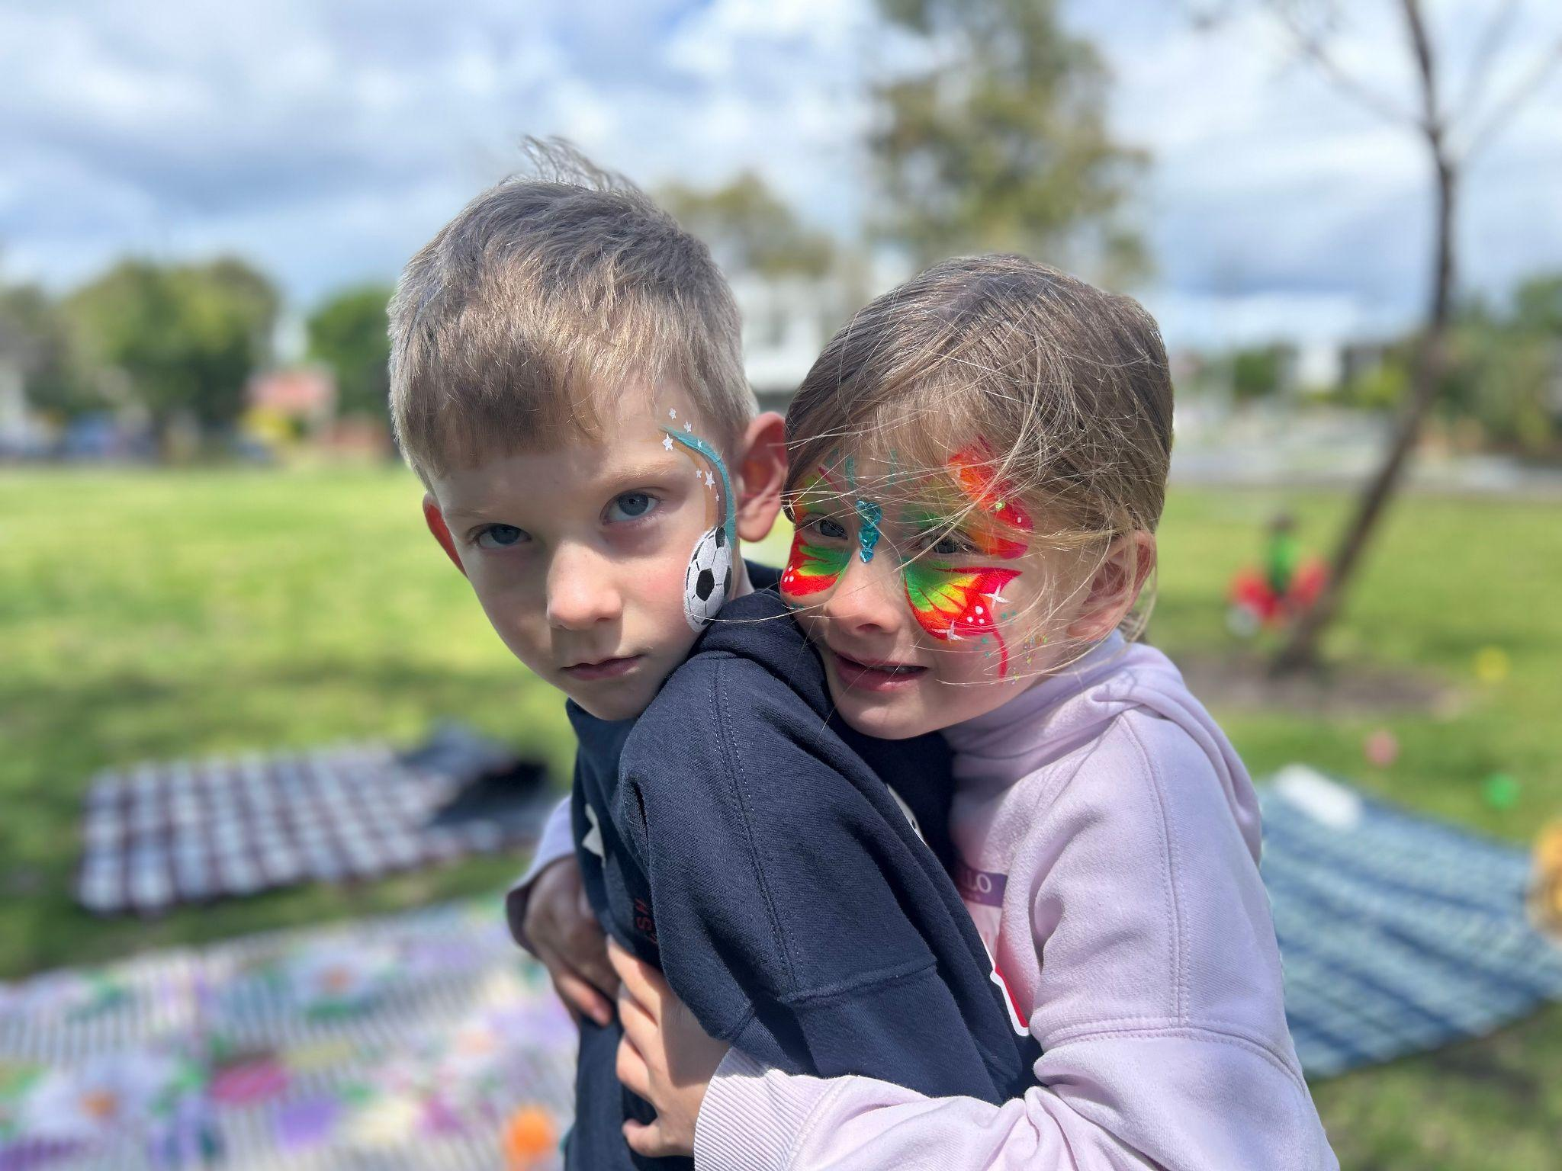
Arlo & Millie Arkell - SEMBA EOY Picnic 2025
I think the SEMBA community of twin parents and families is absolutely wonderful. Through all of you, I have learned countless things and have grown so much as a parent and as a person. I have made some great friends that I know will be in my life for the long term.
Some key perks of the role with SEMBA are and have been.
- Meeting the wonderful committee members I have the pleasure of spending time with (semi-) regularly.
- Providing support to parents of younger/other twins, knowing that a small piece of advice or word of comfort can be so important when you are sleep-deprived and overwhelmed.
- Organising fun events.
- Thinking beyond my day-to-day and achieving greater perspective.
- Feeling a sense of connection to people I would have not otherwise met.
With these points in mind, a massive thank you to any of the committee members that may step down at this AGM. Your commitment and service to SEMBA is nothing other than outstanding. You will be sorely missed!
Thank you in any case (stepping down or continuing) to those that have been here for many years - Belinda, Kelly, Kylie & Tara. You are the “Aunties of SEMBA” (term to be trademarked) and have done so many wonderful and selfless things for this club. Despite this debt SEMBA owes to you, I am hoping you are sticking around for a bit longer. Thank you to all four of you for the laughs and the friendship.
With Kelly and Tara stepping down from their long-held positions of Secretary and Treasurer, I’d like to thank these two specifically. With busy lives and some particular health challenges for Kelly in the last 12 months your unwavering input, support and energy does not go unnoticed. A big thank you on behalf of everyone at SEMBA!
Cameron & Louise, you are part of “the old guard” now and it has been great getting to know you and taking onboard your experiences and ideas from your previous club in NZ. Your joining came at a critical time, your input and the new events you have added to the calendar are great additions to our club.
Clare & Bec, it’s great to have more members with younger twins involved and your contributions are very valuable. It would be great if you can stay involved and as your twins grow up, you can be the Aunties for the next generation of SEMBA members.
Rohini, you have done a lot for SEMBA over the last year - thank you! - and I appreciate that you are keen to stay involved despite your previous club closing. The long travel must be annoying, so I am hopeful we can venture out in your direction a bit more in future.
Last but certainly not least, Mariona, you have made a big difference through your positive energy and can-do-attitude. I love that you are now the new SEMBA President and cannot wait to see how you will impact the club.
Happy twin parenting! Anna

