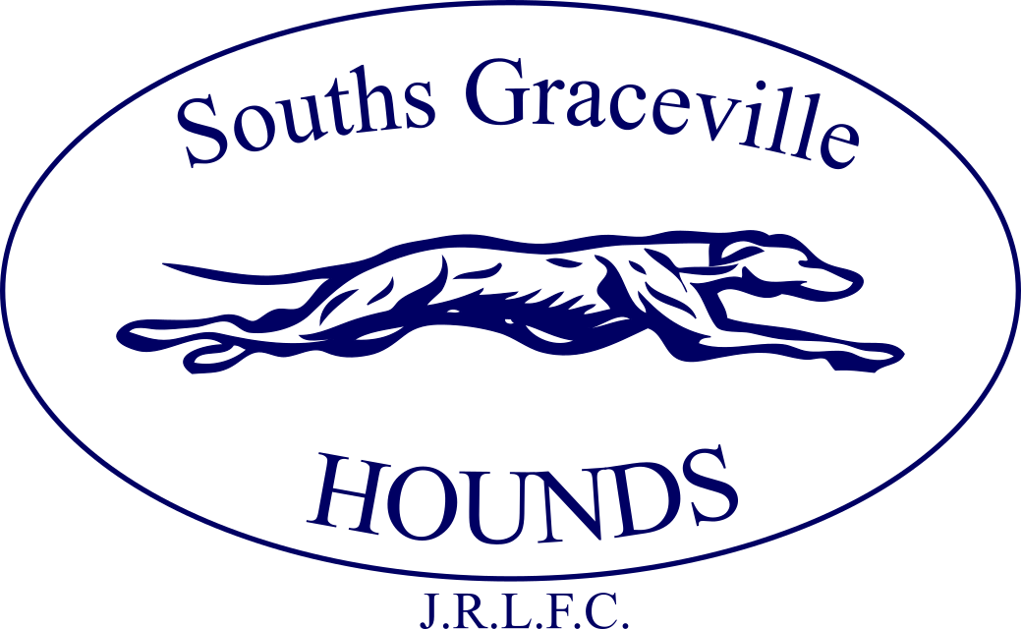

Souths graceville hounds JRLFC INC.
annual report
2024
The annual report and audited statements of the Souths Graceville Hounds Junior Rugby League Football Club Incorporated 2024 financial year.
Contents
Presidents Report 1
Audit Overview 2
Committees Report 3
Income & Expenditure Statement 4
Notes to the Financial Statements 5
Statement of the Members of the Committee 7
Audit Report to the Members 8
Contact Information 9

PRESIDENT’S REPORT 2024

Here’s to 2025!!!

Audit Overview
September 30, 2024
For the Member’s Consideration

Souths Graceville Hounds Junior Rugby League Football Club Inc
247 Graceville Ave,
GRACEVILLE QLD 4075

Please find attached the Financial Statements

Committees Report
Your committee members submit the financial accounts of the Souths Graceville Hounds Junior Rugby League Football Club Inc for the financial year ended 30 September 2024.

Committee Members

President Shaun Leat
Treasurer Scott Watson
Secretary Helen LeLoux
Registrar Paul Joseph
V. President Paul Joseph

Principal Activities
The principal activities of the association during the financial year were: Junior Rugby League Football Club

Significant Changes
No significant change in the nature of these activities occurred during the year.

Operating Result
The profit/ (loss) from ordinary activities after providing for income tax amounted to

Year ended | Year ended
30 September 2023 | 30 September 2024
$ 116,243 | $ 30,631.46

Signed in accordance with a resolution of the Members of the Committee.

President Treasurer

Dated
09/11/2024

Brisbane

Income & Expenditure Statement
Profit and loss report
Souths Graceville Hounds Junior Rugby League Football Club Inc
247 Graceville Ave, GRACEVILLE, QUEENSLAND, 4075
Cash mode
01 Oct 2023 - 30 Sep 2024
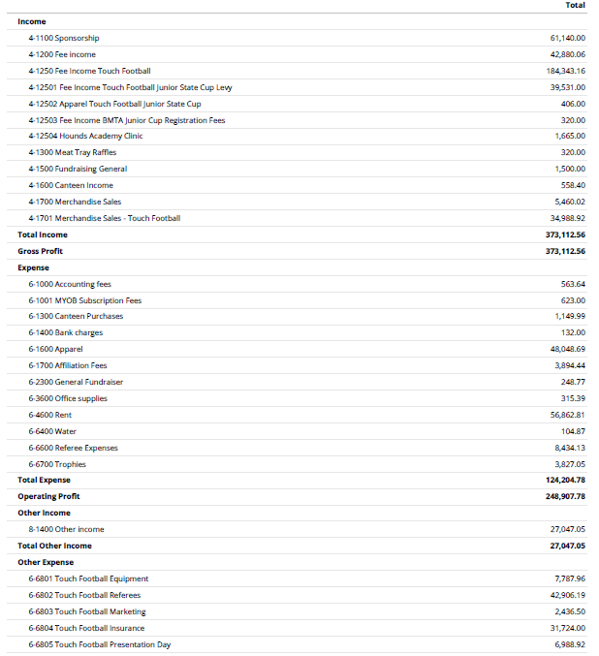
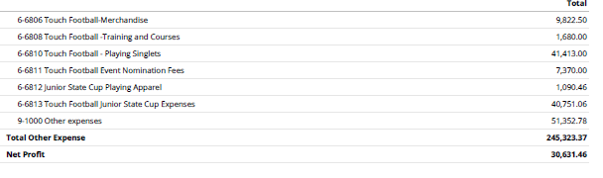

Notes to the Financial Statements
Note 1 – Statement of Accounting Policies

This financial report is a special purpose financial report prepared in order to satisfy the financial reporting requirements of the Associations Incorporation Act Queensland. The committee has determined that the association is not a reporting entity.

The financial report has been prepared on an accruals basis and is based on historic costs and does not take into account changing money values or, except where specifically stated, current valuations of non-current assets.

The statements have been prepared in accordance with the requirements of the Associations Incorporation Act Queensland, and the following Accounting Standards:

AASB110 Events after the Reporting Period

No other applicable Australian Accounting Standards, Urgent Issues Group Interpretations or other authoritative pronouncements of the Australian Accounting Standards have been applied.

The financial report has been prepared on an accruals basis from the records of the association. They are based on historic costs and do not take into account changing money values or, except where specifically stated, current valuations of non-current assets. The accounting policies are consistent with the previous period, unless otherwise stated.

Property, Plant and Equipment

Each class of property, plant and equipment is carried at cost or fair value less, where applicable, any accumulated depreciation.

Assets carried at Fair Value
List of Club Assets

Assets carried at cost
All other non-current assets are carried at cost less accumulated depreciation.

Balance sheet report
Souths Graceville Hounds Junior Rugby League Football Club Inc
247 Graceville Ave, GRACEVILLE, QUEENSLAND, 4075
Cash mode
30 Sep 2024

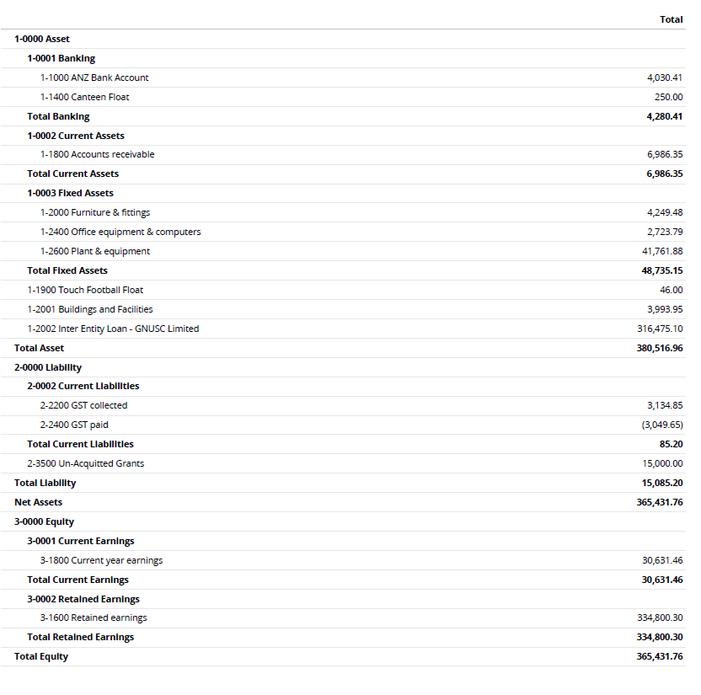

Statement of the Members of the Committee
The committee has determined that the association is not a reporting entity and that this special purpose financial report should be prepared in accordance with the accounting policies outlined in Note 1 to the financial statements.

In the opinion of the committee the accompanying financial report:

Presents a true and fair view of the financial position of Souths Graceville Hounds Junior Rugby League Football Club Inc as at 30 September 2024 and its performance for the year ended on that date.

At the date of this statement, there are reasonable grounds to believe that the Souths Graceville Hounds Junior Rugby League Football Club Inc will be able to pay its debts as and when they fall due.

This statement is made in accordance with a resolution of the committee and is signed for and on behalf of the Committee by:

President Treasurer

Dated
09/11/2024

Brisbane

Audit Report to the Members
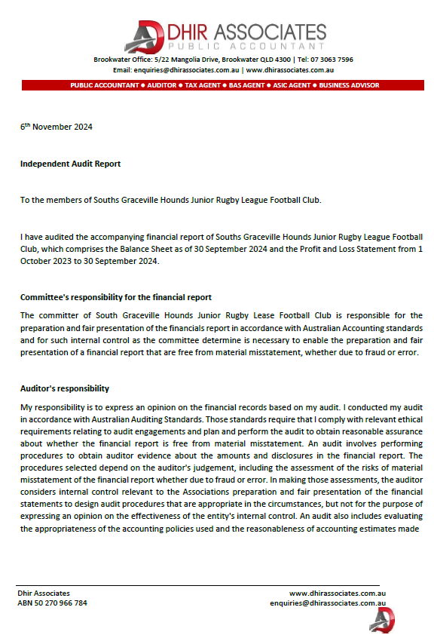
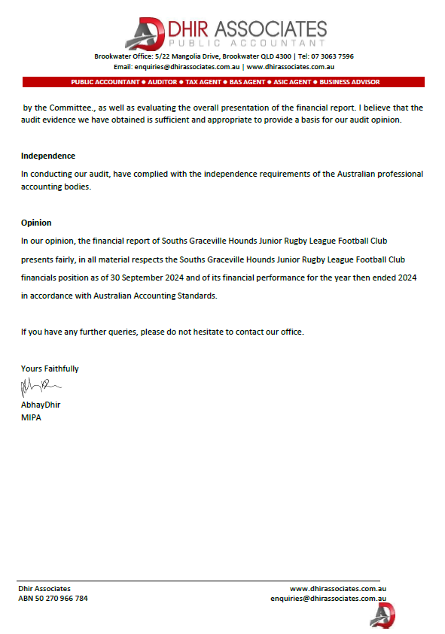

Contact Information
Souths Graceville Hounds Junior Rugby League Football Club Inc.
247 Graceville Ave,
GRACEVILLE, QLD, 4075

Email southsgraceville@houndsrlfc.com
www.houndsrlfc.com/juniors

