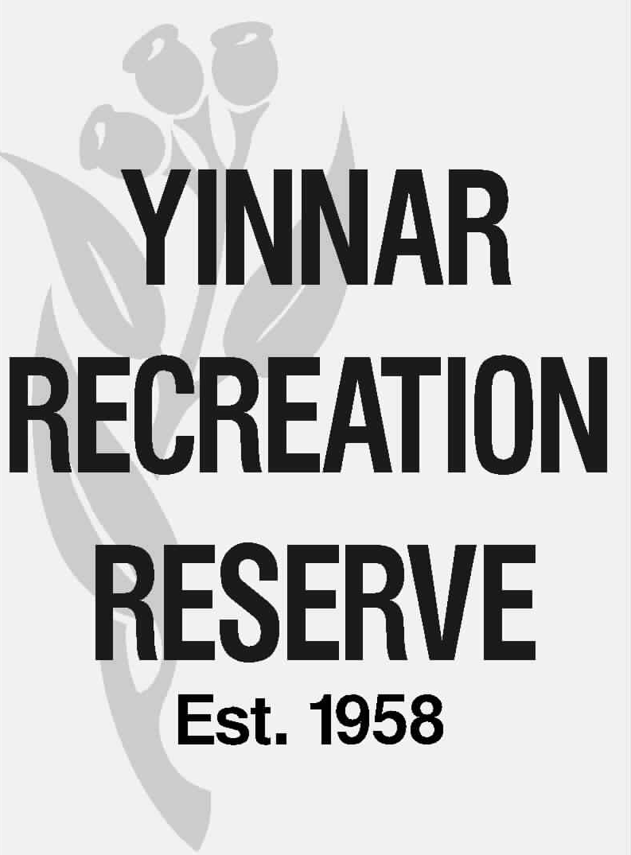

COMMITTEE OF MANAGEMENT REPORT

Meeting date: | 14 April 2026
Matter for: | Discussion
Item #: | 6.1
Subject: | Potential future oval mower - discussion on mower type
Author: | Kevin Burrows
Recommendation: | That the Committee:  - Notes the report.  - The matter of a new oval mower be referred for consideration to the 2026-27 budget process.

- Background

Eastern oval has been refurbished over the past 3 years which has resulted in a 90% Couch Grass coverage. This grass cover allows for a better playing surface for all sports played on the oval. It also reduces the amount of mowing required during the heavy growing months as well as reduces the amount of irrigation required.

An additional benefit is a reduction in chemicals required to keep the “Foreign Grasses” at bay.

The current mower used on the Eastern Oval is unsuitable for the Refurbished Surface because of the following:

- Surface is not level enough for the existing mower
- Grass cannot be cut short enough during the summer sports months
- Grass cover is not improved with the current mower type (circular rotation)

- Proposed Solution

Purchase a “Reel” type mower as recommended by Latrobe City, Hendos Turf Solutions and Mirboo North Curator.

Price of the Reel Mower New $100,000

Price for second hand Reel Mower $25,000

- Options for Raising Funds

- Latrobe City Funding (Type of Application?)
- Sport Organisations (Cricket Victoria?)
- User Groups and Reserve CoM
- Commercial Loans (Bendigo Bank etc)
- Private Loans (several private persons)
- Specific Fund raising (Special Events, Car Show etc)
- Combination of all the above
- How much can Rec Reserve CoM commit.
- Based on the completion of the Tractor Loan repayment can the CoM continue this expenditure to purchase the Reel Mower assuming a Second Hand Mower is purchased?

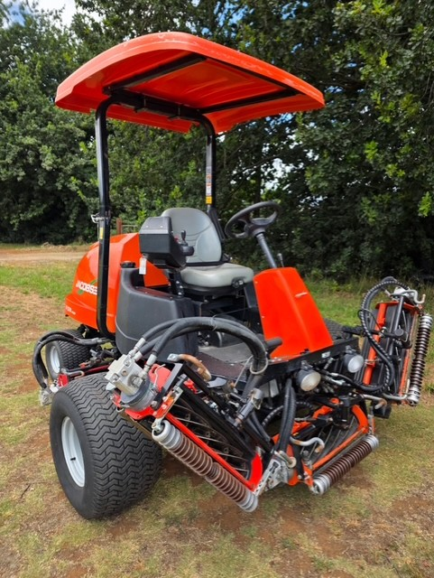
Available 2nd Mower from Metro Turf Machinery (Hendos Turf Solutions and Mirboo North Curator Steve Bickerton). $22,500

