PRESIDENT  Kevin Burrows  0412 193 631‬  84-144 Jumbuk Road  PO Box 165 Yinnar VIC 3869 | 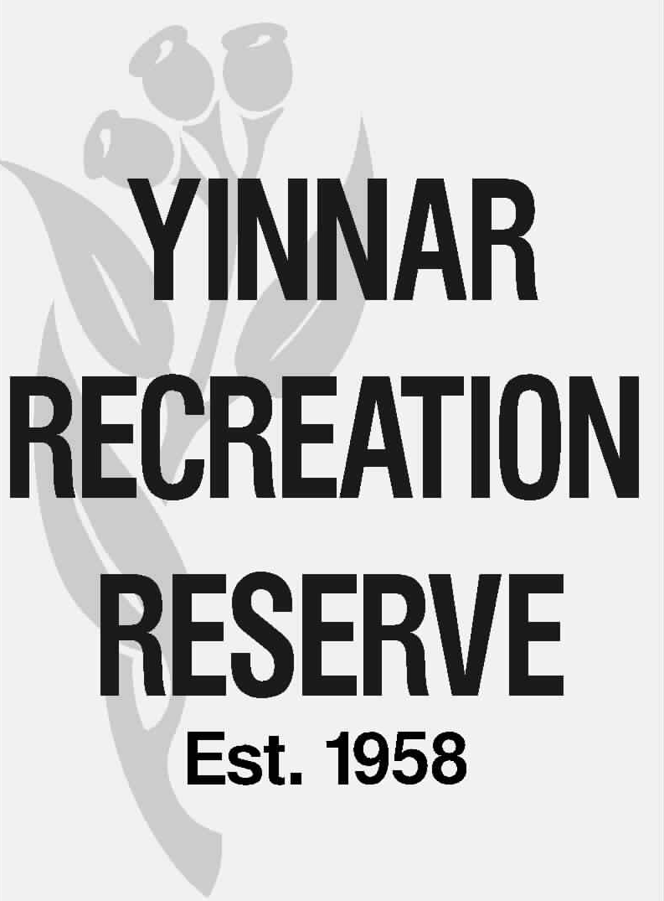 | SECRETARY  Peter Quigley  0499 600 334  e: yrr@mail.tidyhq.com  w: yinnarfnc.tidyhq.com

23 February 2026

Ms Joanne Bedford
Recreation & Open Space Planner
Latrobe City Council
141 Commercial Road
Morwell VIC 3844

Via email: Joanne.Bedford@latrobe.vic.gov.au

Dear Jo

YINNAR RECREATION RESERVE & USER GROUP PRIORITY PROJECTS – LCC RECREATION NEEDS ASSESSMENT

Thank you for the opportunity to submit the following Expressions of Interest for Council’s Recreation Needs Assessment process.

The YRR CoM undergoes an annual capital planning process whereby all user groups consider and agree on project priorities. These priorities also include projects to be submitted to Council as part of its Recreation Needs Assessment process.

There are two projects from the previous RNA process which remain priorities for the CoM, which we have been advised (by JR) do not require a new EoI for submission, these are:

- Western Oval Multi Use Female Change Room & Public Utility Facilities Project – detailed design by LCC in progress.
- Western Oval Active Playing Area Automatic Watering System Project – not as yet funded however still a high priority project for the CoM.

There are two new projects for submission and consideration by Council through the RNA process, these are:

- Eastern Oval pavilion change room modification – provision of female friendly change amenities
- Eastern Oval pavilion stage 2 works - support amenities.

Expressions of Interest are attached for these two new projects.

These four projects clearly articulate the CoM & user groups fundamental approach to development of our facilities, development of our clubs and the stewardship of the respective sporting codes and recreation opportunities with the Yinnar & District Community:

- All facilities will maximise opportunities for use by our community & aim to increase participation across all user groups.
- Equity is important – hence we do not have a #1 or #2 oval nor a junior oval or senior oval. It is our aim to have two ovals and the supporting infrastructure that enables the best possible conditions for sport and recreation and therefore high participation levels in the various sports conducted at each venue.
- Reducing the workload of our volunteers – making it easier to become involved ‘off the field’ for members of our community.
- Thinking, planning and building for the long term – not short-term quick fixes that ultimately will not serve our community or Council well nor provide long term solutions to current day challenges.

Yinnar is a rapidly growing community with a 100% increase in population over the past 10 years. The community needs the RNA projects to be funded urgently to ensure it keeps up with and hopefully keep ahead of the sporting and recreation needs driven by this increase in population.

We look forward to discussing these important Yinnar community recreation projects with you in the near furfure as they progress through the assessment process.

Should you require any further information on any of the projects, please do not hesitate to contact myself on 0412 193 631, or YRR CoM Secretary Peter Quigley on 0499 600 334 / yrr@mail.tidyhq.com.

Yours faithfully
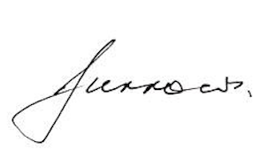
Kevin Burrows
PRESIDENT

