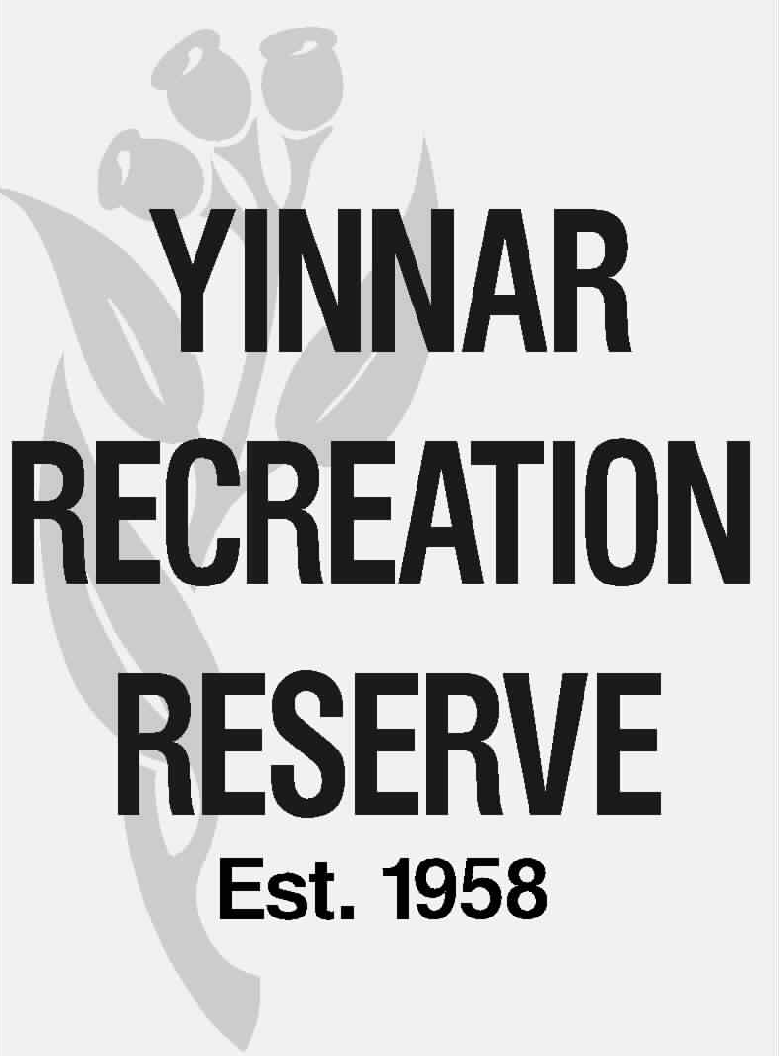

COMMITTEE OF MANAGEMENT REPORT

Meeting date: | 15 October 2026
Matter for: | Discussion
Item #: | 5.1.1
Subject: | LCC RNA Projects - Update
Author: | Peter Quigley, Secretary / Treasurer
Recommendation: | That the Committee:  - Notes the report.  - Considers any changes to the current insurance cover to better address insurable risks for the Committee of Management (none advised by Broker).

- PURPOSE

The purpose of this report is to table the outcome of the recent LCC RNA process and determine a way forward.

- BACKGROUND

Future LCC recreation works projects are determined by a process undertaken every 3 to 4 years named the Latrobe City Council Recreation Needs Analysis.
YRR CoM submitted its priority projects to Council in February 2026.

Council has now advised the outcome of the most recent RNA process, refer attached email and attachment.

- MATTERS FOR NOTING / CONSIDERATION

The four projects submitted by YRR and the rankings assessed by Latrobe City are detailed in the table below:

Project | Status / rating
Western Oval Multi Use Female Change Room & Public Utility Facilities | Detailed design by LCC in progress.
Western Oval Active Playing Area Automatic Watering System Project | 13/28
Eastern Oval pavilion change room modification – provision of female friendly  change amenities | 8/21
Eastern Oval pavilion stage 2 works - support amenities. | 12/21

The CoM would be well placed to understand any delivery time implications for these projects through arranging a meeting with the appropriate LCC officers.

