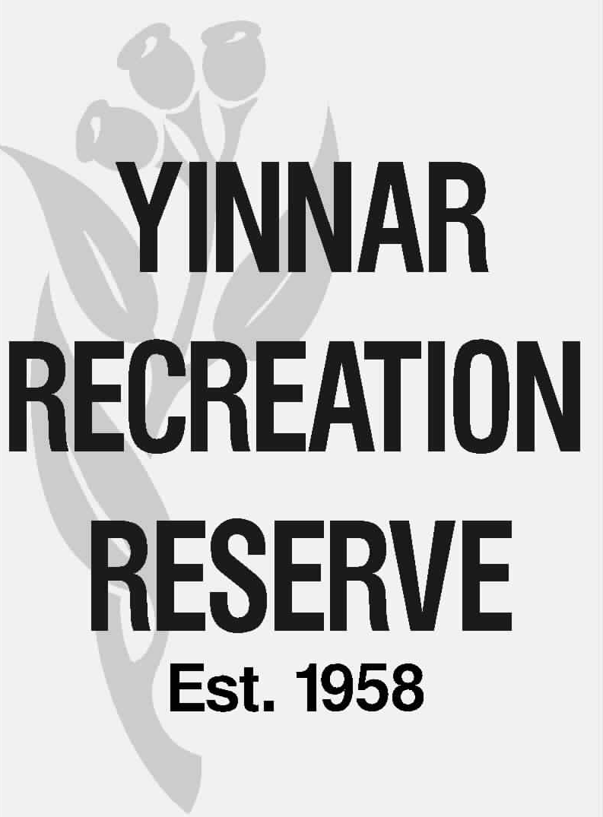

ANNUAL PLANNING CALENDAR

MONTH | ACTION / EVENT
Jan | CoM meeting
Feb

March | Summer facility handover to winter user groups (must be done by 30/03)
April | CoM meeting  BAS due
May
June

July | CoM meeting  Annual General Meeting & user groups to nominate 2 x reps each  Acquit LCC annual maintenance grant  BAS due  Budget set – OPEX & CAPEX
Aug | Annual user group fee invoices sent (post budget setting)  Annual financial statement & AGM report to Corporate Affairs
Sept | Winter facility handover to summer user groups (must be done by 30/09)  BAS due
Oct | CoM meeting  Annual insurance program report to CoM  Facility Handover report to CoM
Nov

Dec

