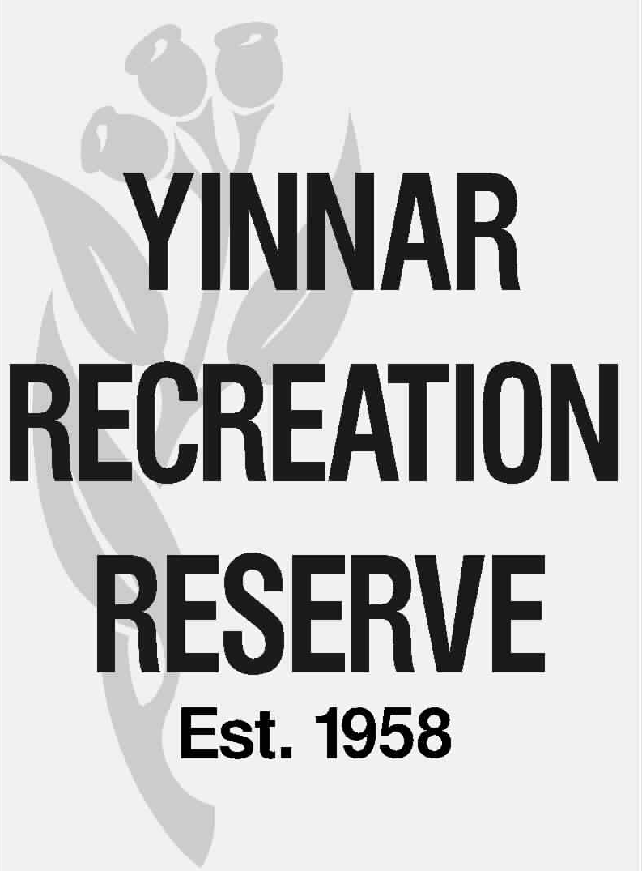

COMMITTEE OF MANAGEMENT REPORT

Meeting date: | 15 October 2026
Matter for: | Noting
Item #: | 3.1
Subject: | Insurance program & user group public liability coverage
Author: | Peter Quigley, Secretary / Treasurer
Recommendation: | That the Committee:  - Notes the report.  - Considers any changes to the current insurance cover to better address insurable risks for the Committee of Management (none advised by Broker).  - Notes the YFNC CoC must be provided before the Club can conduct any further physical activity at the Reserve.

- PURPOSE

The purpose of this report is to:
- table the portfolio of insurance cover for the 2026/267 financial year and for the COM to consider enhancements or any change appropriate to better address insurable risks.
- Confirm user groups public liability insurance cover

- BACKGROUND

The CoM has determined that an annual check of insurance cover be undertaken to ensure our insurances reflects our operational needs at an appropriate lever of cover.

Is a governance requirement of Latrobe City to ensure all CoM user groups have an appropriate level of public liability cover. Failure to have this type of Insurance would lead to a user group being prohibited from using Council facilities.

- MATTERS FOR NOTING / CONSIDERATION

The YRR CoM currently has a range of insurances in place to mitigate risks that may arise due to its operation and maintenance of the Reserve (see table below).

As a Latrobe City Council Committee of Management, we benefit from our buildings and public liability cover being included in Councils insurance portfolio. However, we are required to insure for theft / contents and any registered vehicles / plant & equipment. This is a requirement prescribed in the license agreement between Council and the CoM.

Risk | Insured
Public liability | Included in LCC’s insurance portfolio.  Refer Attachment
Building | Included in LCC’s insurance portfolio.  Excess $10k  JLT JMAPP scheme
Property damage – contents  Theft - contents | Insured $30k  Insured $30k  $500 excess  CGU Insurance, Business Insurance Policy  Cover period 15/07/2025 – 15/07/2026  $995 per annum
Motor vehicle - 2022 Kubota tractor 1XM7XP | Insured $60k or market value  4 in 1 bucket: $14k  Commercial Motor Vehicle Insurance  Policy number: 152A760920MVA  Policy Period: 04/03/2025 - 04/03/2026  QBE Insurance (Australia) Limited  $925 per annum
Motor vehicle – front deck mower 2AG70G | Insured as an addition to tractor policy – insured for market value

The CoM are asked to consider:

- the level of insurance cover compared to the value of the insurable assets and advise any suggested change for discussion with our brokers (none advised).
- Any other risks that are insurable but not currently part of our cover (none advised).

User groups have been requested to provide evidence of public liability cover to the CoM Secretary. Certificate of Currency have been provided by:

User Group | CoC provided
YDJC | Yes
YTC | Yes
RCC | Yes
YFNC | No

The outstanding YFNC CoC must be provided before the Club can conduct any further physical activity at the Reserve (this is a LCC governance requirement).

ATTACHMENT – PUBLIC LIABILITY COVER

