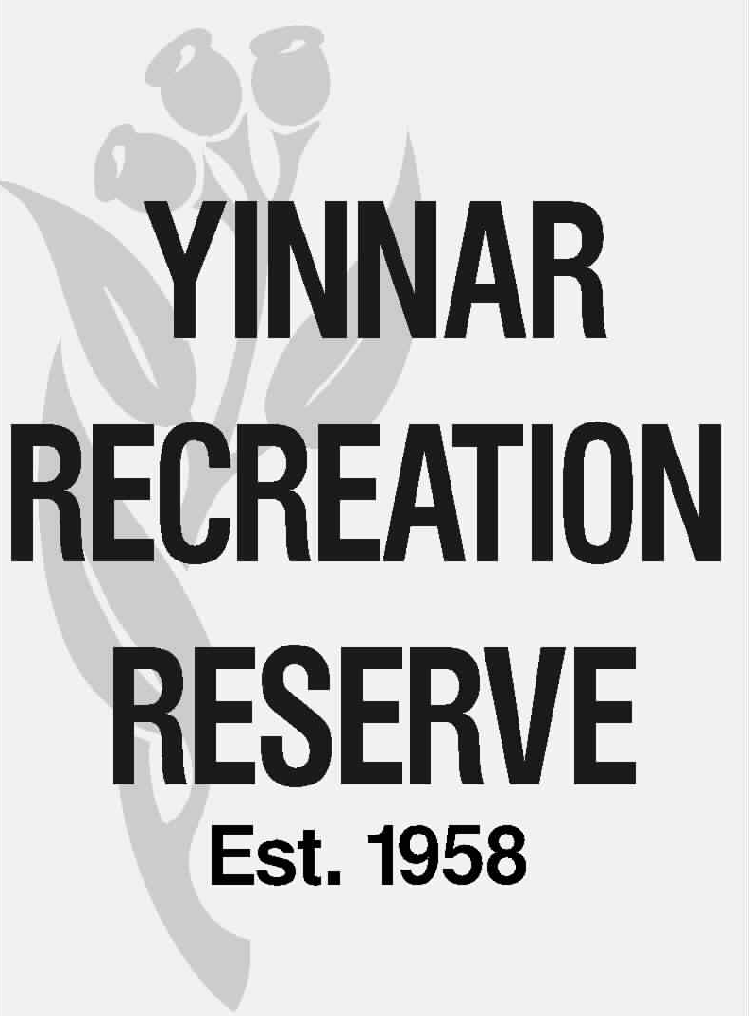 | WASTE, RECYCLING & CONTAINER DEPOSIT SCHEME OPERATION  Information sheet: #5  Date published: June 2025  Approval / delegate: CoM | 5

This information sheet explains operation of the waste, recycle and container deposit scheme systems within the Reserve.

Services the CoM & user groups are required to deliver under the LCC operating grant aim to ensure the following objective is met:

- Always ensuring the reserve and its facilities (internal and external) are kept clean, tidy, free of hazards and commensurate with the standard applicable to Latrobe City Council buildings, facilities and recreation / public open space / sites.

The waste, recycling and container deposit systems are necessary to ensure the Reserve remains free of litter and always presents well – together with meeting the expectations of key stakeholders such as the community and Latrobe City.

The Committee of Management provides the infrastructure for these systems, including lockable bin stands and the 120 L and 240 L wheelie bins.

User groups are responsible for the week-to-week operation of these systems, including collection of waste and recyclables and ensuring they are ready for collection by the Latrobe City contractor.

This also includes responsibility for collection of any loose rubbish around the Reserve and placement into the waste and recycling bins. This is an important function as we are surrounded by dairy farms and any rubbish escaping the Reserve ends up polluting these farms as well as the nearby Middle Creek waterway. If this occurs is likely fines will be imposed by Latrobe City and the EPA.

User groups are also responsible for ensuring the cleanliness of the bins which may include high-pressure cleaning from time to time.

- WASTE & RECYCLING SYSTEM
The red waste bins are general waste that goes to landfill. These are collected on a weekly basis.

The yellow recycle bins complied miscellaneous recyclable material, not including bottles and cans eligible for the Victorian Container Deposit Scheme. The yellow bins are collected every second week.

Collection day is early every Thursday morning.

Some important and handy tips and tricks in respect to the waste and recycling systems:

- The smaller 120 L bins are for inside use only.
- The 240 L bins are mainly for external use however they can be used internally should the waster / recycling volumes require larger bins.
- All external bins can be secured through a bin stand locking mechanism. It is important to always ensure that bins across the Reserve are secured as they are popular item for thieves.
- Keys to operate the locking mechanisms are in the eastern oval and western oval cleaners’ cupboards. In addition to these keys several Committee of Management members also have them on hand.
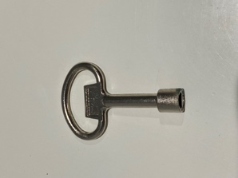

- When putting bins out for collection by the Council contractor, bins should be at least half full and if necessary lesser quantities should be decanted into other bins.
- Following the Council contractor emptying bins every Thursday morning, they should be put back and locked in position that day to avoid potential theft. Please DO NOT leave the bins at the collection point empty nor leave them stacked against a building – ensure they are put back in place at the appropriate lockable stand. Should bins be found to be unsecured (this occurs most often after a collection day) and subsequently stolen, the user group responsible for leaving bins unsecured shall be liable for the cost of replacement.
- From time to time and for various reasons, Councils contractor may miss collection of either the red bins the yellow bins and on rare occasions, both red and yellow bins. If this occurs the user group is to immediately phone Cleanaway direct on 03 5133 6872‬ - advise of the collection that has been missed and request that it be picked up that day.‬‬
- Should any bin be damaged and require repair to make serviceable and back in operation, immediately phone Cleanaway 03 5133 6872‬ - they will attend site and complete repairs. Damaged bins are to be left for Cleanaway at the usual collection points.
- There are two designated bin collection points as follows:
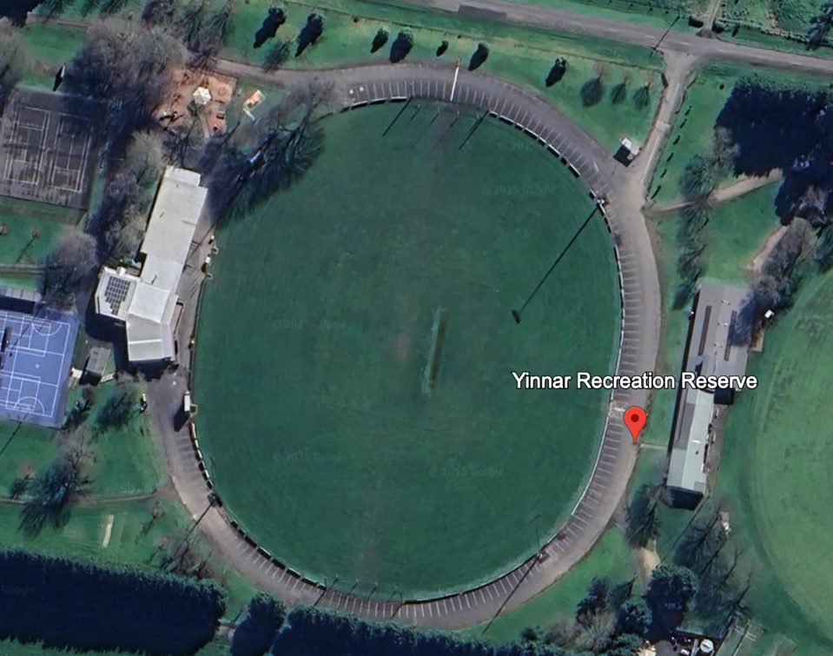
WOO
EO

- WO at southern end of pavilion, rock hard stand area back of designated parking bays
- EO next to bollards on west side of pavilion abutting internal roadway

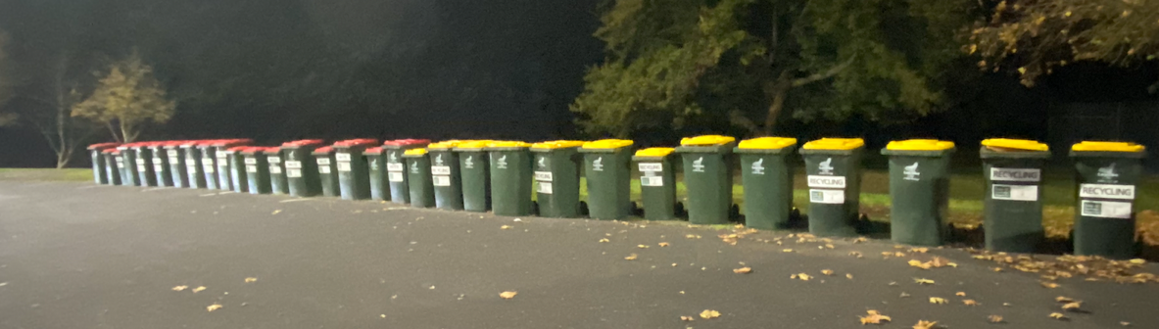
An example of bins that haven’t been decanted, most have little waste or recycling in them. Following them being decanted, there was approximately half the number of bins for collection.

- CONTAINER DEPOSIT SCHEME (CDS)
The CDS provides user groups with the opportunity to generate revenue through the collection and cashing in of cans and bottles under the Victorian Government scheme.

There are 3 key parties involved with operation of the CDS at YRR, these are:

- The Committee of Management – who has paid for and installed CDS infrastructure of bin stands, 240 litre bins with coloured blue tops with rosettes and CDS specific signage.
- YRR user groups – who manage the cans and bottles, the bins and collection on a fortnightly basis. The revenue generated from the CDS remains with user groups.
- Our collection partner ‘Your Own Way’ who pick up and transport the CDS materials for processing on a fortnightly basis. This is at no cost to the CoM or user groups.

The CDS bin locations have been determined by the Committee of Management and user groups to maximise the capture of cans and bottles suitable for the CDS scheme – refer attachment.

The external locations of the CDS bins are fixed and designed for all year-round use. The four internal CDS bins located in the Eastern and Western Oval pavilions can switch between either pavilion to suit both summer and winter users and demand.

It is the user groups responsibility to manage the day-to-day capture of cans and bottles and the management of the CDS bins ready for collection by Your Own Way on a fortnightly basis.

The pickup points where CDS bins are ready for pick up by Your Own Way are:

- Eastern Oval – underneath the timekeeper’s box staircase
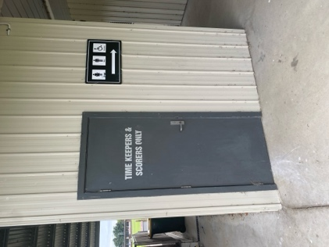

- Western Oval – in the cool room compound between the social rooms and the netball courts
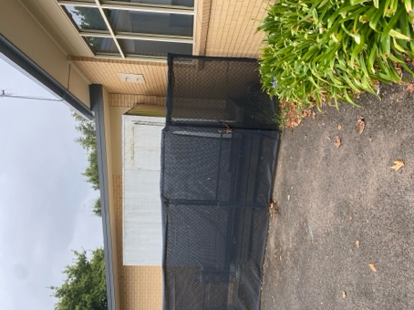

Both locations are accessible using a YRR # 10 padlock key which has been provided to Your Own Way.

CDS proceeds are payable as follows:

Eastern Oval – summer 1 October to 31 March | Raiders Cricket Club | C2000039567
Eastern Oval – winter 1 April to 30 September | Yinnar Football & Netball Club | C2100305531
Western Oval – summer 1 October to 31 March | Yinnar Tennis Club | C2000042115
Western Oval – winter 1 April to 30 September | Yinnar Football & Netball Club | C2100305531

Key contacts:

- Your Own Way, Tanya Tutin 0478 171 862‬‬‬‬‬‬‬
- Raiders Cricket Club, TBA
- Yinnar Football & Netball Club, Dean Vandermeer 0429 696 072‬‬‬‬‬‬‬
- Yinnar Tennis Club, Kim Walsh 0409 973 789‬‬‬‬‬‬‬

- COST SHARING
Latrobe City Council invoices the CoM on an annual basis for the provision of the waste and recycling services. Payment of the Invoice is shared between the Committee of Management and user groups on the following basis. These percentages were determined by the Committee and user groups based on an estimate of the volumes of waste and recycling generated by each group.

GROUP | % SHARE OF LCC CHARGE AS PER YRR & USER GROUP COST SHARING FRAMREWORK
YFNC | 60%
MTYCC | 25%
YTC | 5%
YRR CoM | 5%
YDJC | 5%

