**CURTIN ECONOMICS SOCIETY**

**Annual General Meeting Minutes**

**To be held at 1:00 pm on November 30, 2023, Online via a Zoom meeting**

1. **Acknowledgement of the Traditional Owners:(1:15 PM)**

*“We wish to acknowledge the traditional custodians of the land we are meeting on, the Whadjuk people. We wish to acknowledge and respect their continuing culture and the contribution they make to the life of this university, city and this region”*

1. **Attendance:**
   1. **Ordinary members present**

Angelo Tinoco 20594677

Addison May 20314985

Arabella Haythorpe 20562247

Akaash Singh 20572482

Aakash Neupane 20157782

Mitchell Griffin 19139184

Gavin Muir 20214849

* 1. **Other staff or associate members present:** None
  2. **Others present:** None

1. **Disclosure of any potential or perceived conflicts of interest**   
   No issues were raised.
2. **Minutes of the previous AGM**The minutes of the previous AGM were presented for acceptance.

**Motion 1**‘That the minutes of the 2022 Annual General Meeting be accepted’

**Moved:** Angelo Tinoco  
**Seconded:** Mitchel Griffin  
**CARRIED** – Majority vote in favour of motion

**Reports from the outgoing committee**

**5.1 President report** – Appendix 1

**5.2 Vice President’s Report –** Appendix 2

**5.4 Treasurer's report & financial statement** – Appendix 3

1. **Constitution:**
   1. The Constitution was not amended and a unanimous vote in favour of the motion.
2. **Elections for 2024 committee:**
   1. **Returning officer**

**Nominations:** Angelo Tinoco

**Nominated by:** Angelo Tinoco  
**Seconded:** Arabella Haythorpe

Angelo Tinoco was elected unopposed as Returning Officer.

The Returning Officer took the chair and declared all committee positions vacant.

* 1. **President**

**Nominations:** Arabella Haythorpe  
  
**Nominated by:** Arabella Haythorpe   
**Seconded:** Aakash Neupane

Arabella was elected unopposed as President.

* 1. **Vice President**

**Nominations:**   
  
**Nominated by:**   
**Seconded:**

was elected unopposed as Vice-President.

* 1. **Secretary**

**Nominations:**   
  
**Nominated by:**   
**Seconded:**

was elected unopposed as Secretary.

* 1. **Treasurer**

**Nominations:**   
  
**Nominated by:**   
**Seconded:**

was elected unopposed as Treasurer.

* 1. **Other committee members**

Marketing Coordinator

**Nominated by:**

**Seconded:**

- was elected unopposed to the executive committee position.

**6.6.1 – Notes regarding vacant roles**

-Moving into 2024 we have struggled to fill the executive committee so this will be our main priority

-Communicate with Guild

-Advertise through lectures and tutorials

-Work with the FBL to post on social media

-Get the ESA to advertise vacant roles

1. **Bank Signatories 2024**

Changing bank signatories at Commonwealth Bank (Victoria Park branch)

|  |  |  |
| --- | --- | --- |
| **Role:** | **2023 Signatory Name:** | **2024 Signatory Name** |
| **President** | Angelo Tinoco | Arabella Haythorpe |
| **Vice President** | Arabella Haythorpe |  |
| **Secretary** |  |  |
| **Treasurer** | Aakash Neupane |  |

1. **Other Business**  
   **Events / Initiatives for Next Year**

* Attend lectures to encourage engagement
* Maintain a greater physical presence on campus
* Reach out to first and second year economic students
* Maintain a connection with Curtin tutors and lecturers to present panel events
* Continue working with WA Dept of Treasury and WA Economics Society
* BBQ fundraising including selling merchandise
* More student workshops
* Social events such as the quiz nights and sundowner
* Contact Square customer service to have the funds sent to our account
* Cover letter/resume workshops

-Job description criteria

**Membership Campaign for Next Year**

* More active notifications for members
* Collaboration with other clubs
* Buy merchandise
* Keep membership free
* Optional SMS notifications
* Email the students who expressed an interest in joining the committee
* Fill entire executive committee

**Advertising**

* Place posters around campus
* Increase publications, such as the newsletter
* Post internship opportunities, graduate roles
* Contact the “Big 4” for advertising opportunities
* Posters printed by the Guild for free

1. **Handover meeting**
   1. **Club Renewal**
      1. The club will need to be renewed between November 14th 2023 and March 26th 2024
      2. The 2023 Executive Committee can assist in the process to ensure it is completed promptly and correctly.

The old and new committee discussed the key points of the handover minutes following the conclusion of the AGM. The document will be reviewed by the new committee and will answer any questions and conduct the bank signatories at the official Handover meeting. Both the old and new committee will discuss dates and times that would be suitable to meet to conduct the handover.

**The AGM concluded at 2:10**

**The Incoming Committee sticks around to sign club Guild club renewal documents:**

* Committee contact list - [HERE](https://guild.curtin.edu.au/pageassets/clubs/renewal/Club-Committee-List-2021-Template-ID-149067.xlsx)
* Club credit application - [HERE](https://www.guild.curtin.edu.au/files/85)
* Office Bearers’ Statement - [HERE](https://guild.curtin.edu.au/pageassets/clubs/renewal/Office-Bearers-Statement-fillable.pdf)
* Club Renewal <http://guild.curtin.edu.au/clubs/forms/clubrenewalform/>

**Appendix 1 - President’s Report**

**Presidents Report for Curtin Economics Society 2023**

**Introduction**

2023 was a good year for the club. While we struggled a bit in the start getting set up, we improved moving into semester 2. We built strong connections with WA Branch of the Economics Society of Australian and The Department of Treasury and hope to build on the connections moving into 2024. I believe our most successful event was the Econometric Principles workshops. Another great event was the “Economics: Where Can it Take You” panel event with excellent guest speakers. We built strong industry connections while providing students with useful opportunities to engage with industry professionals.

I believe we can improve on our social media management and doing so will help us target more students. One of our main initiatives for 2024 is increasing student engagement.

**Social Media Management**

I believe we need increased social media management to boost membership. We were able to acquire a social media manager temporarily for our later semester events but unfortunately the role remains empty for 2024. Moving forward we hope to fill this role. This includes a few reasons such as increasing our publications, gathering community engagement, and building networks.

One example of boosting our publications is the release of an economics-based newsletter. This newsletter would include economic facts, current economic news, and spotlight Saturday which would highlight key moments in economic history.

**Reflecting on our Activities**

The first event we held was the O-Day stall during the start of 2023 in which we attracted a good degree of new members. One improvement we could make in 2024 is creating a calendar detailing the events of 2024 to give students a concrete idea of our club’s purpose.

The following event we held was the BBQ which allowed us raise funds to continue running our events. We spent $111.45 to receive $355.56 in return. Unfortunately, we were only able to run one BBQ this year and entering 2024 we will make use of both BBQ guild packages.

We followed this event with the quiz night, which while was low in members, ran smoothly and proved a good template and starting basis for next year. Fortunately, Anusha from the WA Economic Society who helped organise and advertise our events, has agreed to help us organise a quiz night for 2024. Her experience with these events in the past can help us increase our student participation.

Entering semester 2 we held the “Economics: Where Can it Take You” panel event with a vastly talented range of panellists including Sally McMahon, Professor Sherry Bawa, and Cassandra Winzar. We were very grateful for their advice and wish to continue these events.

Our next speaker was Dr Kim Nguyen, an analyst from the RBA. She gave us a detailed presentation on the roles within the RBA and the many job opportunities. Again, we were very grateful for her advice and would love to see her return.

Our final event for the year where our econometric principles workshops lead by Zack Muskat from the Department of Treasury. We provided three workshops over two weeks covering econometric principles topics to aid students. Zach provided detailed step by step in depth analysis which greatly benefited students. We hope to provide more workshops covering a range of topics including Excel literacy.

**Moving Forward**

I am very happy with the progress the club has made in 2023. I will be stepping down as President but will be more than happy to remain a helping hand in the club guiding the new committee. We built some very valuable connections this year and must work to maintain them. I have faith the club will continue to expand and grow, and I am very excited for the initiatives we have planned.

Best Wishes

Angelo Tinoco

*2023 President*

Curtin Economic Society

**Appendix 2 – Vice President’s Report**

**Vice President’s Report for Curtin Economics Society 2023**

**Focus of the club: Building relationships and fundraising**

The primary objective this year was building the necessary relationships to help elevate our club and improve our events in the future and attendance through having a more relevant well-rounded and holistic club. This year we had more of a focus on fundraising to help ensure that we have better funds for the future to hold better events. The sausage sizzle was successful in raising $200 that could help contribute to other industry events, it was most useful in contributing to the series of Econometric workshops that was run in conjunction with the ESA and the Treasury of Western Australia which helped build students' analytical skills and give them key insights into the industry that are particularly relevant to the public sector of a career as an economist. Another focus was using Industry connections such as through the Young Economist Society (ESA) and university lecturers to help enhance events and learning experiences. Most events this year were run in conjunction with the ESA and our most successful events were our series of Econometrics workshops with the Treasury and ESA and the BBQ fundraising events. Through these connections in particular our connection with the ESA we have been able to host events that are not feasible as an individual club due to financial and resource constraints, as a result, we continue to work with FBL, other commerce clubs, The Treasury and the ESA to build events that enhance employability skills, give students some fun and relaxation and a better way into the industry.

**Planning for the future**

I think our most successful event this year was the Econometric workshops run by the CES with the ESA and the Treasury of Western Australia. Sadly, though the members were mostly non-Curtin University students as they came from Industry or other Universities through the ESA. Some improvements would be to have the series of workshops run earlier in the semester so that more people can come (the late start was good so that people could get there after work) and maybe networking and food should be served beforehand so that people have time to get there and have something to eat beforehand. However, if done afterward then people get an opportunity to eat and network with the industry leaders though the industry leaders might not stay behind because of Government regulations and it being late at night (should talk to the Treasury). Other improvements would be to hire a computer lab so that it is easier to see the code and maybe add an online forum for better understanding. Should consider running the holidays around the Treasury mid-year review so that people have more time to go through the content, revise the content, and look at it and understand it better. The thing that worked well was the invitation sent through Google Drive and the relevant documents sent on Google Drive. When sending out the invites and dealing with Admin which was done by Anusha from the ESA and me, we quickly realized that not everyone has Google Drive so in the invitation email we should investigate having a statement that requires the email linked to Google Drive/ the creation of a Google Drive account (Should investigate the creation of an RSVP link). In 2024 with Zac Muscat from the Treasury and the ESA we are planning to host either another series of R training or a series of Excel training, expression of interest should be sent out at the start of the semester.

Another successful event was “where can a Degree in Economics take you”, we had an issue with attendance and dropping out of guests due to last-minute event changes and similar issues of this nature. To avoid issues like this we should make for club members and Industry leaders an RSVP link with a tentative calendar of events and details that industry partners, commerce club members (not just CES) and the ESA could express interest in and rate with an outline of events with ample time to fundraise, plan and organize. The calendar at the start of the year would increase sign-ups as students from Curtin and other relevant bodies such as the ESA (which include students from other universities with economic backgrounds and industry partners would know what to expect). If all student accounts are linked to a Google Drive, then an RSVP link could be made using Google Drive and promoted by the ESA, FBL, club support, and on lecture blackboards. Could additionally invite other clubs to boost numbers of attendance.

This year we have learned from our mistakes as a result had far fewer events this year than last, we focused on more meaningful and value-adding events that would help build career-based connections and skills while avoiding the busy periods.

The major takeaway from this year is that events that develop key industry skills and connections will be well received by the students at Curtin, other University students, and industry connections (Other University students and Industry leaders can be reached through the ESA). Additionally, better promotion and events can be achieved through collaboration with other clubs, FBL, Student Guild, Lectures, and ESA through tapping into these resources and fundraising better events can be achieved throughout the year.

**Recommendations**

The major improvements and recommendations that should be considered for the club's future include making a tentative events calendar before the semester continues, looking into cheap tote bags or pens with the club logo to fundraise/give away in competitions such as quiz night (work with the Faculty to redesign more noticeable and appropriate t-shirts), liaise with lectures to go into classrooms and speak (also recruit using flyers), consider running a cafe talking to lectures about classes, have an expression of interest form for suggested events at the guild o-day and likewise events, help promote vacant roles and events through FBL, guild, ESA?, consider bringing back the newspaper with a Joke column and the executives writing it each week considering inclusion of the ESA. In 2023 the CES should work more with the University and clubs for the provision of better events through gaining greater access to resources and funding.

I look forward to the year to come and the opportunities that it will bring.

Arabella Haythorpe

*2023 Vice President*

Curtin Economics Society

**Appendix 3 - Treasurer’s Report**

**Treasurer’s Report**

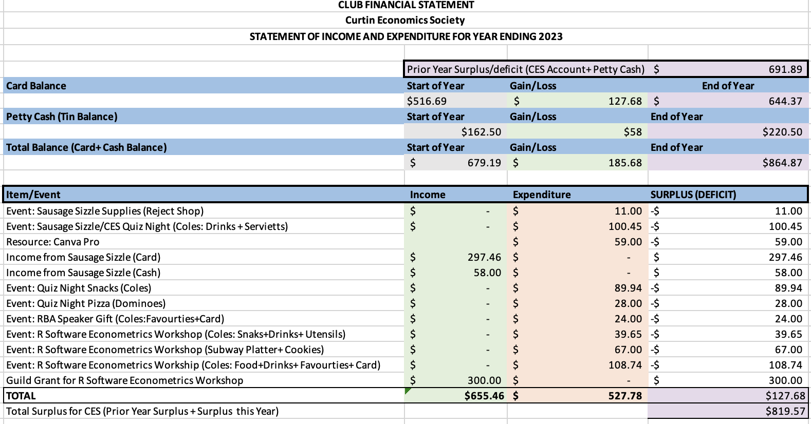

Aakash Neupane

*2023 Treasurer*

Curtin Economics Society