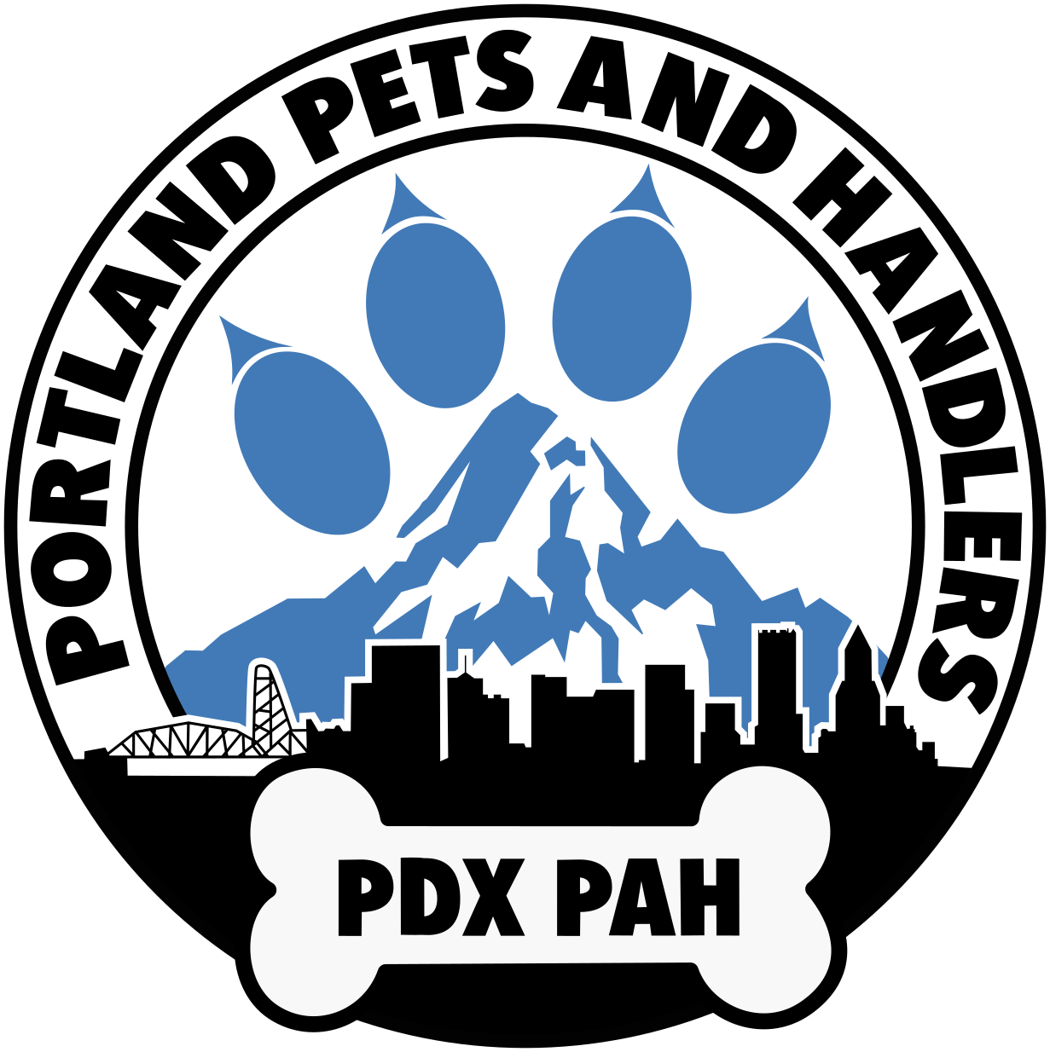
PDX PAH
[Month] Board Meeting Minutes
12th September, 2026

2026 Board of Directors:
Alty Bear, Daddy Bandit, Bigby Wolf, Puppy Bjorn, Pup Frost, Nick Knox, PupzLeo, LingusPup, Pup Lykan, Porky Grinds, Pup Rhapsody

Meeting open time: 12:06 PM

Meeting held at: Cheryl’s on 12th-

In Attendance
Board of Directors:
Leo, Frost, Lykan, Bjorn, Lingus, Porky, Bandit, Knox, Bigby (remote),

Absent:
Alty, Rhapsody

Guests Present:
Amanita, Wyx, Tai, Toshi Bear

Approval of Previous Meeting Minutes
- Changes
  - Any board chat decisions (if any), listed separately below the next heading.

- Motion to Accept: Lingus
- Second: Bjorn
- Approve: all
- Decline: 0
- Abstain: 0

Board Chat Decisions
- We are letting the Hawks situation die down for now.

Officer Reports
- Membership Report - Knox reporting
  - In the last 30 days
    - New Memberships: 0
    - Renewals: 5
  - As of today
    - Total Registered: 450
    - Active Member: 110
    - Recently Expired: 18
    - Total Expired: 344
- Sergeant-at-Paws Report - Rhapsody reporting
  - Narcan Inventory:
  - Testing Strips Inventory:
- Treasurer Report - Leo reporting
  - Cash on hand: $100
  - Camp Scholarship Fund: $2,187.37
  - OnPoint Account: $2,787.51
  - OnPoint Savings: $50
  - US Bank Account: $35.19
  - Bank Totals: $2,972.70
  - Accounts Receivable: $1,039.60
  - Undeposited funds: $0
  - Total Assets: $4,012.30
  - Accounts Payable: $175
- Web Handler Report - Knox Reporting
  - Member Tags: TBD
  - PAH Pins:
  - Birthday Pins:
  - Small Patch:
  - Large Patch:
  - Hanky:
  - Stickers:
  - Pride Stickers:
  - Keychain:

Committee Reports
- Budget Committee - Leo reporting
  - Date of last meeting:
  - Date of next meeting: TBD, reports probably end of this month

- Bylaws Committee -
  - Date of last meeting:
  - Date of next meeting:

- Camp Wolf PAH Committee - Bigby reporting
  - Date of last meeting:
  - Date of next meeting: TBD

- Education Committee - Lingus reporting
  - Date of last meeting:
  - Date of next meeting: TBD
    - reaching out to last years presenters
    - only update, as of 9/12/26 Furlandia panels are opening up, need to register
  - List of next three topics and presenters:
    - Sept 19 - Service Pets 101 - Bjorn/Wyx
    - October- holiday crafts - alty/lingus
    - November - animal movement - Sophie
    - December - pet training - tenebris
- Foreign Pawlicy Committee - reporting
  - Date of last meeting:
  - Date of next meeting:

- Fundraising Committee - Leo reporting
  - Date of last meeting:
  - Date of next meeting: Sept 17
    - Paws and Prophecies- Sept 17
- Service Committee - Rhapsody reporting
  - Date of last meeting:
  - Date of next meeting:

- Social Media Committee - Alty reporting
  - Date of last meeting:
  - Date of next meeting:

- Welcome Committee - [Bandit or Porky] reporting
  - Date of last meeting:
  - Date of next meeting: TBD
    - NEW PETS!
- Safety and accessibility?
  - Fold into board meeting
    - Motion to Accept: Lykan
    - Second: Lingus
    - Approve: all
    - Decline: 0
    - Abstain: 0

Old Business/Updates
- New Mats Idea - Lykan
  - ufc mats could be printed upon
  - spendy, fundraising very necessary
  - very durable
  - fundraising options could include special printing options
  - not very transportable, would need to be stored at CC’s
  - pricing and measurements discussion in board chat
  - Updates?
    - wesellmats.com
    - Porky to create budget for the mat costs
    - Current estimate ~2k without customization
  - Updates on mats?
    - Bigby to have group in fundraising (on hold till next Board Meeting)
  - Still waiting on a quote for pricing, current estimate accurate (as above).

New Business
- Let’s have a conversation about unconscious bias - Lingus
  - Lingus states this is not a callout, but a thing to be aware of due to the ongoing patterns
    - When we are talking to community, it feels like there’s a “blind spot” for anyone outside of cis men
    - It has come up repeatedly. We need to be aware of when we are talking/thinking about, we need to be focusing on the diversity of our community.
    - big difference between being allowed in the space vs being celebrated in the space.
  - Bjorn suggests asking questions “are we being diverse”?
  - Lykan states we cannot control the venues, but we can ask for accommodation. We are going to run into spaces that may seem accommodating to non cis-gay men.
    - We as a board may need to address the inclusivity of our events and chosen spaces.
  - Knox states membership may be impacted by the issue with not feeling very included or diverse.
    - having a form that reflects our surveys,
      - Please be honest, what can we do better, whats not working, how can we be more inclusive?
    - Frost believes the survey should be specific to inclusivity
    - Knox wants to get a temp from those who havent renewed.
      - Simpler to have during elections committee
    - Lykan states we may want to look at the annual survey, and update. have one additionally for those whom have NOT renewed to help gather info.
  - Porky addressed the question of how we came to this information on the bias
  - Perynne states that subconscious bias examples are present
    - Nobody is intending to show malicious intent
    - the pride float was going to have WANT on the chopping block. May not have been a conscious bias, but the fact that it happened is enough to draw concern. The WANT social still has attendance.
    - WANT is an open door into PDX PAH
  - Bjorn brings up the idea of bears being a consistent focus
  - Lingus brings up Seattle has a separate mosh, which may make people feel segregated.
    - Our main events should feel for everyone
  - Lykan states the necessity of focusing inclusivity into our general events, and not create a divide by focusing on specific people.
    - WANT social gives members that don’t feel seen to feel seen. (Leo) It does not cost anything to add it to the calendar. (Lykan) The camping trip should be considered and that we should be gearing towards a guarantee of inclusivity.
    - Cut events that are poorly attended that cost us money
  - Porky asks has this issue caused any major blowouts recently. has anyone walked out?
    - Lingus states that with the political situation, people may feel unsafe.
  - Frost asks on an education level, Is there any particular resources to help us improve our unconscious bias? Hard to address without specifics. Cognitive dissonance is brought up.
    - Lingus says she is aware of some resources she can track down.
  - Porky brings up that welcome pets are mainly cis-gendered. Handing someone to someone else is already a step down the wrong path. need more non cis pets to help the committee.
  - Frost brings up altering phrasing
  - Tai states that people asks if they are welcome (based on gender)
    - Tai encourages individuals to interact with the PDX PAH tools and that we are very welcoming
    - need to focus on making it apparent that we are inclusive
  - Perynne states:
    - 1. we did not have a majority of non cis on the board, previous boards were more diverse. helps address porky’s question as to what has changed.
    - 2. being on the board as a marginalized identity can be exhausting. as a board member representing a minority has a lot more challenges. POC members rarely last more than a year. If we were to build an assessment may reveal that the trans board members may last shorter than cis members.
    - Perynne says she stepped down, but was in her sixth year and the burnout was accumulative. We need to be aware. We should be courting members of minorities to run for the elections.
    - Lykan says this is an item to expand on in elections committee.
- Tidy HQ updates? - Knox
  - No updates , expansion of membership is lacking, and not enough incentive to continue forward.
  - Leo states that the new site may help drive members to be more open to joining
  - Porky says ID cards and a more reliable system may in fact increase members. We should take the gamble and use our funds to run the site.
  - Dan approached and asked how we know who is current
  - Leo states it is a significant expense, but we CAN borrow from our funds as long as we can give back. Suggests scholarship funds
    - Technically, our current fund not counting scholarship, we only have about $600.00 ish.
    - Board members need to pay their retreat costs. check emails
    - Because we are so close to the end of the year, Knox and Leo work together to handle active vs expired memberships. Perhaps an outreach?
    - Put costs into a motion in the board chat
      - Motion:
      - Second:
      - Approve:
      - Decline:
      - Abstain:
  - We have not been verifying memberships at the door, and we have refusals to buy memberships, this is creating a need to enforce the memberships to avoid people getting into the venues for free without membership.
  - Create an active member list for the venues
    - Tai suggests with the active member list add a QR for renewals in lieu of door fee
    - Announcement warning that a change in operations for Awoo
    - Does not include SEA PAH
    - for the play parties, allow SEA PAH for first timers
      - Tai states that early birds may prove difficult
    - do a head count at 9?
      - head count is not of active members
    - Suggestion of having a board member for first couple hours to check the list.

- Election committee formation
  - Motion to create the election committee with Lingus as the chair
  - joining: Bjorn, Knox, Porky, Amanita, Bandit
    - Motion: Lingus
    - Second: Lykan
    - Approve: all
    - Decline: 0
    - Abstain: 0
Special Events
- Paws and Prophecies
  - Oct 10th
    - Heads: Alty and Frost
    - Co-Coordinators or all hands on deck?
      - Co-Coordinators
    - What donations are needed?
    - What’s our budget?
  - Revive last year's chat
  - Readers? Need a call
  - Items on hand for silent auction?
  - Who wants to be the wacky inflatable annoying advertising pet to stand outside?
  - ADVERTISING: how often do we want to post about it?
  - Flyers? Social Media?
- Fruit Loop
  - Oct 24th
    - Perynne is taking head
    - Caravanning
  - Three drivers so far have volunteered (Bjorn, Wyx, Leo)
    - need a carpool chart to match drivers and riders
  - ADVERTISING: how often do we want to post about it?
    - Weekly
  - Create a chat?
    - Create a chat
  - RSVP form to be made for signing up and for “need a ride/have a ride/Can be a driver”
- Petsgiving
  - Nov 27th (Black Friday)
    - Timing?
  - What food being Brought/provided
  - Rsvp form
    - Dietary restrictions?
- Yule Party
  - Dec 12th
    - Timing
  - potluck(?)

- Grand Pet Gala
  - Dec 19th

- Anything missing?
  - No Barks & Rec planned after Fruit Loop
    - Pets invade Starlight Parade?
    - Lingus is looking into Haunted houses
- Cap aids walk next saturday, lingus to create a chat
  - Meet downtown at 10:30
  - Arrive BY 11 to walk
- Bark box
  - Lingus, Bjorn. and Knox have been the primary volunteers for this. Do the three of you want to continue being our announcers?
Open floor for member input

Meeting close time: 00:00 A/PM

2026 Board of Directors
Directors:
Alty Bear, Daddy Bandit, Bigby Wolf, Puppy Bjorn, Pup Frost, Nick Knox, PupzLeo, LingusPup, Pup Lykan, Porky Grinds, Pup Rhapsody

Officers:
President: Pup Frost
Vice President: Alty Bear
Secretary: Puppy Bjorn
Deputy Secretary: LingusPup
Sergeant-at-Paws: Pup Rhapsody
Treasurer: PupzLeo

Additional Roles:
Corporal-at-paws: Pup Lykan, Puppy Bjorn, Bigby Wolf, Daddy Bandit
Events Coordinators: Nick Knox/Puppy Bjorn
Camp Director: Bigby Wolf
Education Coordinator: LingusPup
Welcome Handler: Daddy Bandit
Welcome Pet: Porky Grinds
Webhandler: Nick Knox
Deputy Webhandler: PupzLeo
Ambassadors: Bjorn, Rhapsody, Lykan, Knox, Bigby, Porky, Bandit

Committees:
Audit Committee: Puppy Bjorn (Chair), Wyx, Lingus, Rhapsody,
Budget Committee: Leo (Chair), Wyx, Frost, Alty, Rhapsody, Bjorn
Bylaws Committee: Rhapsody (Chair), Lingus, Bigby, Kobalt, Leo, Argon
Camp Committee: Bigby (Chair), Porky, Bandit, Lingus, Bunny Bear, Frost, Alty, Leo, Bjorn, Argon
Events Committee: Bjorn, Knox (Co-Chairs), Lingus, Lykan, Bunny Bear, Bigby, Bandit, Porky, Alty, Pudding, Wyx, Leo, Ears
Education Committee: Lingus (Chair), Rhapsody, Lykan, Bigby, Alty, Frost, Porky, Bandit, Bjorn, Pudding
Fundraiser Cmte: Leo (Chair), Alty, Frost, Porky, Bandit, Bunny Bear, Ears
Safety & Accessibility: Rhapsody, Lykan (Co-Chairs), Lingus, Knox, Porky, Bandit, Bigby
Service Committee: Rhapsody (Chair), LingusPup, Lykan, Amanita, Knox, Bigby, Frost, Bjorn, Pudding
Social Media Cmte: Alty (Chair), Kronos, Ears, Toshi, Lykan, Knox
Welcome Cmte: Porky, Bandit (Co-Chairs), Knox, Lykan, Bjorn, Rhapsody, Alty
Pride Committee: Alty, Leo (Co-Chairs), Porky, Bandit, Knox, Rhapsody, Bjorn, Wyx, Lykan, Amanita

Authorized Signers:
Frost (President), Alty Bear (Vice President), Lingus (Deputy Secretary), Leo (Treasurer), Bigby (Camp Director)

